Pendragon Community Primary School

Cubs Class – Mrs Marshall
 | Early Years Foundation Stage
 | Communication and Language  - Sharing ‘All about me’ boxes  - Listening to others  - Asking questions  - Talking to each other  - Learning new vocabulary  - Following instructions  Personal, social and emotional development  - Developing independence  - Learning our school motto REACh  Respect, Effort, Achieve, Challenge  - Learning school routines and expectations  of behaviour – making the right choices  - Sharing and taking turns with others  - Exploring emotions through ‘The Colour Monster’ books  - Naming emotions, identifying our own and others emotions  Physical Development  - Travelling in different ways walking, skipping, running, jogging, hopping and marching  - Making obstacles, balancing and climbing  - Developing fine motor control through the use of tweezers, threading and building tools  - Using a variety of tools such as pens, pencils, chalk and paintbrushes to mark make  - Drawing simple lines, shapes and pictures  - Using cutlery when eating lunch |  |  | 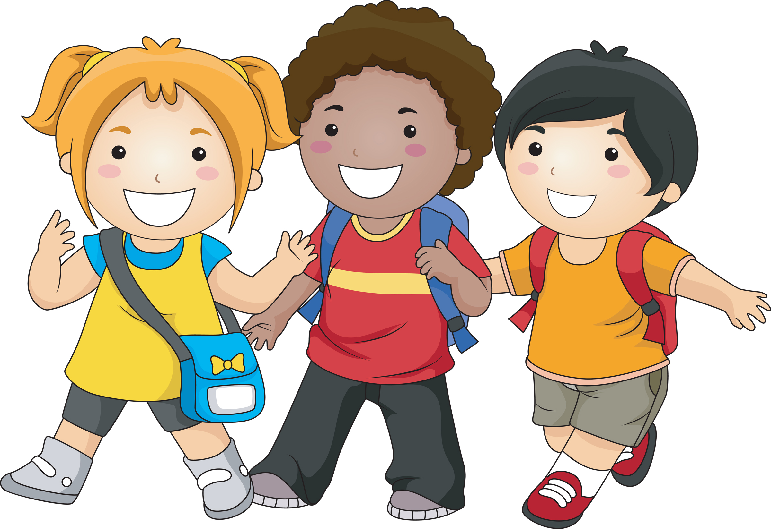  All About Me  Characteristics of Effective  Teaching and Learning  Playing and Exploring – engagement  Finding out and exploring  Playing with what they know  Being willing to ‘have a go’  Active Learning - motivation  Being involved and concentrating  Keep on trying  Enjoying achieving what they set out to do  Creating and Thinking Critically  Having their own ideas  Making links  Choosing ways to do things | Literacy  - Recognising and writing own name  - Story time phonics – phase 2  - Hearing initial phonemes  - Recognising and saying phonemes  - Oral blending  - Learning to read key words by sight  Maths  - Oral counting and chanting numbers to at least 10  - Singing number songs and rhymes  - Counting objects and giving a specific amount  - Number sense to 3  - Subitising 1 to 3 using dotty patterns (dice)  Understanding the World  - Talking about ourselves  - Talking about our families  - Finding out about people who help us – parents, siblings, teachers, friends etc  - Familiarising ourselves with the school environment and grounds  - Observing the natural world outside  - Exploring changes to matter when cooking  Expressive Arts and Design  - Using materials and other resources to design and create  - Exploring paint and colour mixing  - Moving in time to music  - Singing nursery rhymes and other songs  - Recreating stories and experiences using small world and when in the role play area
Supporting Learning at Home  - Learning Overview  An overview of learning will be sent home fortnightly, please read as this will give you a really good insight into what your child has been learning over a two-week period and how you can support at home. First overview will be sent Friday 18th September.  - Maths:  Key Instant Recall Facts (KIRFS) will be sent home to learn each half term.  Mathletics: www.mathletics.co.uk  Password and username to follow  - Reading:  Choose a book once a week from our Early Years sharing library – snuggle up and enjoy together!  School reading scheme book – on a Monday your child will bring a book home to read with you. This book should be discussed and read more than once throughout the week, it will be handed in every Friday. This will begin Monday 13th September.  Bug Club: www.activelearnprimary.co.uk  Password and username to follow  Another book that your child will access and you can read together at home.  Word wallet – your child will bring home a wallet that contains common high frequency words, some of which will be ‘tricky’ words. All words in the wallet must be learnt by sight (not sounding out). New words will be added on a weekly basis.  More information about all of the above will be sent home over the next couple of weeks. |  |  | Contact  For any queries or enquiries, please contact me using the email below:  Mrs Marshall  amarshall@pendragon.cambs.sch.uk  Please note that teachers will check their email up to 8.30am every morning, if you have an urgent message, please contact the office instead via phone or email so that they can pass the message on to the class teacher.  Entry and exit procedures.  When dropping off, please say goodbye to your child at the Foundation Stage entrance gate. On collection, once the gate has been unlocked, you will need to wait in the Foundation Stage outdoor area. Please find a space so you are socially distanced from others and avoid queuing. You will then exit via the double gates on the field. |  |  | PE Lessons  Please ensure that your child comes in to school wearing their PE kit, ready for PE on the PE days below.  PE is on Monday and Wednesday  If your child has long hair, please ensure it is tied back for PE. If your child has their ears pierced and is unable to remove their own stud earrings, these should be removed at home on PE days or micropore tape provided so they can cover them.  The Haven and wellies  Each class will have a weekly time slot to use the Haven (our environmental area) Your child will need a pair of Wellies that can stay in school during term time. Cubs will be using the Haven on Tuesdays, however we may also visit at other times during the week.  Foundation Stage also love to play in mud, splash in puddles and sledge down hills on snowy days so wellies are an essential item to have in school.  Tuesday carousel  A morning of creative and investigative activities which will always include cooking! Therefore, if your child has long hair please ensure it is tied up.  Recycling  The children are encouraged to make models and we need quite a bit of junk for them to do that, so we would be very grateful for any clean cereal boxes, small food packaging boxes and tubes to keep them going (no toilet rolls or egg boxes please).  Personal belongings in school  Your child should only come into school each day with their packed lunch (if they are not having a school meal), water bottle and reading record and book. All other resources that the children should require for their learning will be provided by the school. No water bottles in book bags please.

