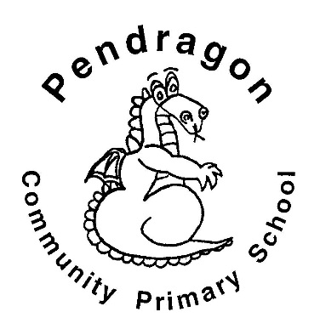 | Recommended Reading List | Year 1
The selection of books in this list are a guide for children aged 5-6 in Year 1 at school. The books are selected from a range of genres to cover all interests. If your child is a competent reader or has read many of these titles then try the books from the Year 2 list.
The Bad-Tempered Ladybird | Eric Carle
Lullabyhullaballoo | Mick Inkpen
Funny Bones | Allan Ahlberg
The Smartest Giant in Town | Julia Donaldson
The Paper Dolls | Julia Donaldson
A Bear Called Paddington | Michael Bond
A Lion in the Meadow | Margaret Mahy
Hairy Maclary from Donaldson’s Dairy | Lynley Dodd
A Kitten Called Moonlight | Martin Waddell
The Emperor of Absurdia | Chris Riddell
There are Cats in this Book | Viviane Schwarz
Katie Morag’s Island Stories | Mairi Hedderwick
Meg and Mog | Helen Nichol
Not Now Bernard | David McKee
A Dark, Dark Tale | Ruth Brown
The Trouble with Jack | Shirley Hughes
The Dark | Lemony Snicket
You Can’t Take an Elephant on the Bus | Patricia Cleveland Peck
Penguin | Polly Dunbar
You Choose! | Pippa Goodhart
Stanley’s Stick | Neale Layton
What to Do if an Elephant Stands on Your Foot | Michael Rosen
Dinosaurs in the Supermarket! | Timothy Knapman
The Cat in the Hat | Dr Seuss
Charlie and Lola | Lauren Child
Don’t Forget the Bacon | Pat Hutchins
The Princess and the Pea | Minnie Grey
The Whisperer | Nick Butterworth
The Silver Swan | Michael Morpurgo
The True Story of the Three Little Pigs | Jon Scieszka
The Grandad Tree | Trish Cooke
Where’s my Teddy | Jez Alborough
My Friend Bear | Jez Alborough
What If? | A H Benjamin
Man on the Moon | Simon Bartram
Out for the Count | Anne Fine

