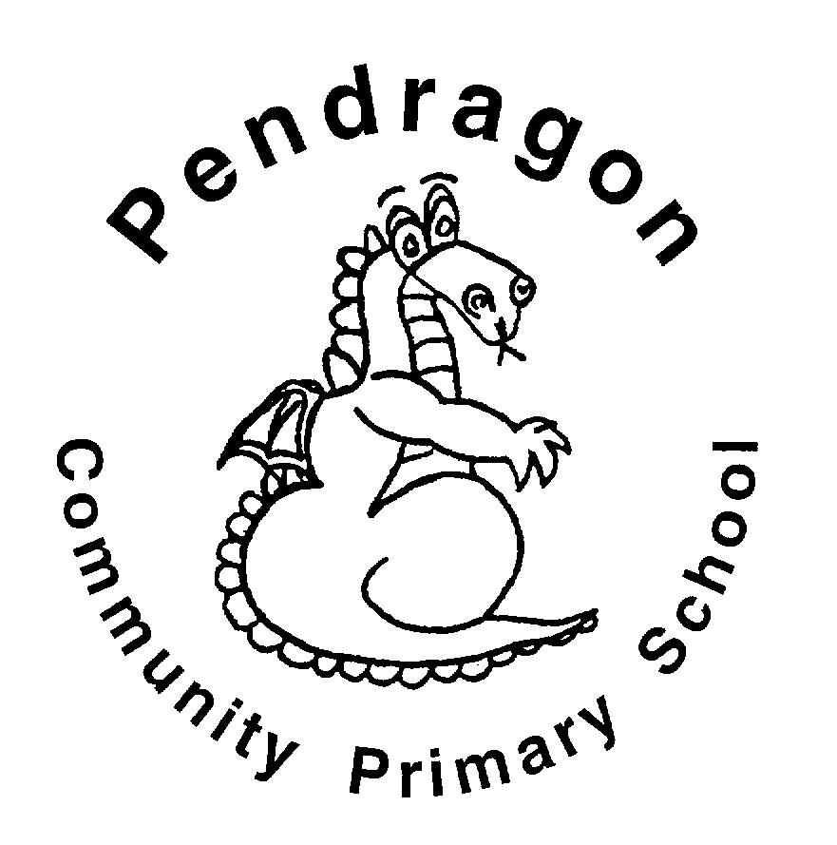 | Pendragon Community Primary School  Tiger Class – Mrs Buck & Mrs Huntley |  |  | 
National Curriculum
As Readers we will read and explore adventure stories. We will be reading “Kensuke’s Kingdom” and using this to inspire our writing. We will listen to an adaptation of ‘A Christmas Carol’ by Charles Dickens We will also be continuing to read a variety of age-appropriate extracts in our daily guided reading sessions. |  | As Mathematicians we will be learning to Multiply and divide by 10,100,1000. We will learn about prime and composite numbers, multiples and factors. We will be working on multiplying and dividing mentally. We will also be revising written methods for addition and subtraction. | As Writers we will be writing an adventure story inspired by Kensuke’s Kingdom. We will also write persuasive letters linked to ‘A Christmas Carol’. We will have opportunities to write in a variety of ways in Pendragon Writers Club.
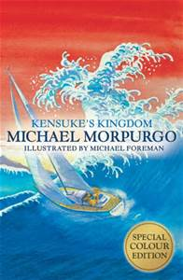 |  |  | As Scientists will be learning about Forces. We will learn that unsupported objects fall towards the Earth because of the force of gravity. We will identify the effects of air resistance, water resistance and friction, that act between moving surfaces. We will also recognise that some mechanisms including levers, pulleys and gears allow a smaller force to have a greater effect


Year 5
Autumn 2
Fabulous France!

As Geographers we will be identifying the key human and physical characteristics of France using maps, atlases and digital mapping. We will be comparing the region of Paris to Cambridge.

In Computing we will be using Purple Mash to continue developing our coding skills and learn to use spreadsheets.
As Artists we will study and take inspiration from European artist Matisse by studying his work and using this to form our own pieces. |  |  |   In RE we will continue to look at the 6 major religions and will then consider what it is like to be a Christian in different countries around the world.  In PE we will develop our skills in dance. We will also be working on our football skills (invasion games).  In PSHCE we will be considering healthy friendships, developing friendship skills, families and other special people. We will also be learning about bullying: the causes and types of bullying; how bullying can affect us; responding to bullying; supporting others and creating safer environments.
As Musicians we will be focussing on learning and rehearsing the songs that we will be performing for the Young Voices event at the O2 in January.

As Linguists, we will be learning vocabulary associated with asking for and telling the time. We will also be learning about France and its culture in our topic sessions.

Supporting Learning at Home  - Mathletics:www.mathletics.co.uk – set on Fridays and due the following Thursday.  - Maths: Key Instant Recall Facts (KIRFs) will be sent home to learn each half term.  - Times Tables Please continue to practise multiplication tables up to 12 × 12 as this was a target for the end of Year 4.  - Spelling Children will be provided with a spelling activity to complete at home. This will be sent home on Fridays and should be returned on the following Thursday.  - Reading book Ideally read daily for at least 10-15mins. Children should fill in their reading rainbow bookmark which will be checked in school weekly. To receive their bronze reading award, they need to read three chapter books from the Year 5 book list and two of their own choice.  - Bugclub: www.activelearnprimary.co.uk    School code: qkc7 | Contact  For any queries or enquiries, please contact your child’s teacher using the email below:  Mrs Buck  (Mondays, Wednesdays, Thursdays, Fridays)  cbuck@pendragon.cambs.sch.uk  Mrs Huntley  (Tuesdays)  jhuntley@pendragon.cambs.sch.uk  Please note that teachers will check their email up to 8.30am every morning, if you have an urgent message, please contact the office instead via phone or email, so that they can pass the message on to the class teacher.   | PE Lessons  Please ensure that your child comes in to school wearing their PE kit, ready for PE on the PE days below:  Tigers PE is on Thursdays and Fridays.  If your child has long hair, please ensure they have a hair band, as long hair must be tied back for PE. It is expected that all children can remove watches/earrings for PE. If your child is unable to remove their own stud earrings these should be removed at home on PE days or micropore tape provided so they can cover them.  Thank you for your support with this.  The Haven and wellies  Each class will have a weekly time slot to use the Haven. Wellies should be brought into and kept in school so that this space can be used throughout the year. Tigers will be using the Haven on Wednesdays (weather permitting).  Personal belongings in school  Your child should only come into school each day with their packed lunch, water bottle and reading book. All other resources that the children require for their learning will be provided by school.

