APPs to support Maths:

Name | Icon | Area of maths covered | Key Stage
Number Lines | 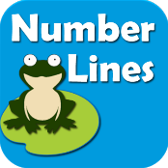 | Number & Place Value  Addition  Subtraction | EYFS  KS1  KS2
Geoboard |  | Geometry | EYFS  KS1  KS2
King of Maths | 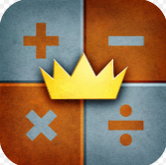 | Addition and Subtraction | KS1  KS2
Times Tables |  | Multiplication | KS1  KS2
AB Maths | 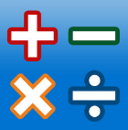 | Addition  Subtraction  Multiplication  Division | KS1  KS2
Graph | 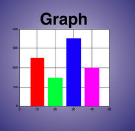 | Statistics | KS2
Number Pieces | 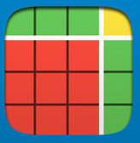 | Number & Place Value | KS1  KS2
Number Line | 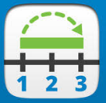 | Number & Place Value  Addition  Subtraction  Multiplication  Division | KS1  KS2
Number Rack |  | Number & Place Value  Addition  Subtraction | KS1
Fractions |  | Fractions  Division | KS1  KS2
Pattern Shapes |  | Geometry  Angels | EYFS  KS1  KS2
Number Frames | 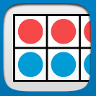 | Number & Place Value  Addition  Subtractions  Multiplication  Division  Fractions | EYFS  KS1  KS2
Maths Vocab |  | All Areas | KS2
DK Times Tables |  | Multiplication | KS1  KS2
Maths, Age 3-5 |  | All Areas | EYFS  KS1

