 | 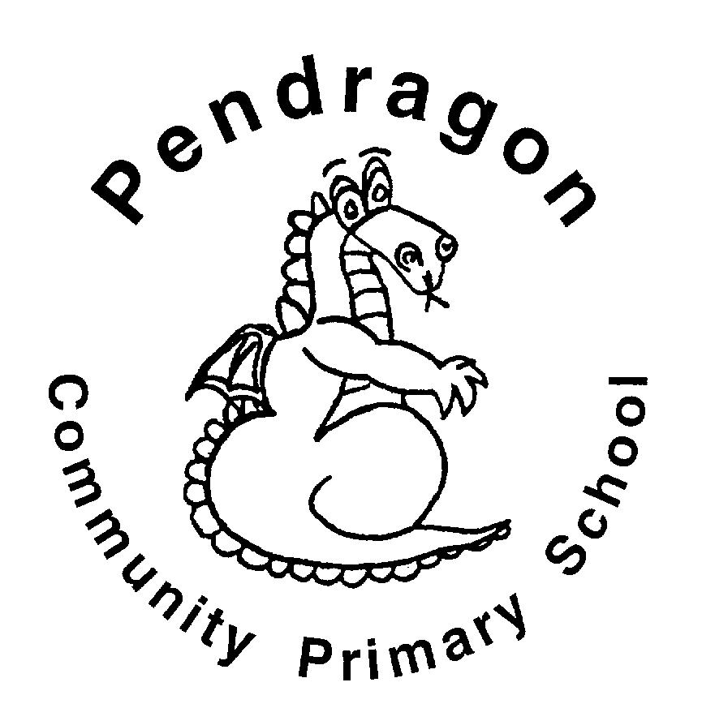  Pendragon Community Primary School  Tigers Class – Mrs Buck & Mrs Huntley  Lions Class – Miss Hart |  |  | 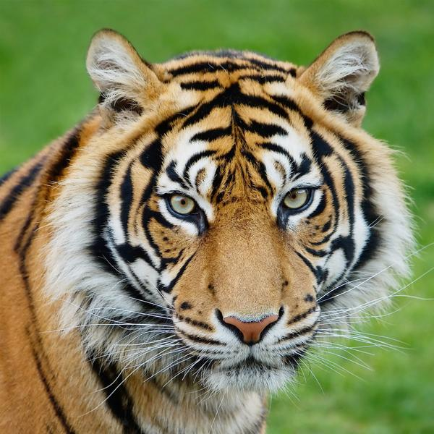
National Curriculum
As Readers we will read and explore non-fiction texts linked to our Science learning. We will read and perform poems to the class. We will also be continuing to read a variety of age-appropriate extracts in our daily guided reading sessions.  As Writers we will listen to a variety of public speakers and then write and deliver our own speeches linked to the value of education. We will have opportunities to write in a variety of ways in Pendragon Writers Club. |  | What makes our world wonderful?  Year 5 – Spring 1    Magnificent Materials  How do different materials make our lives wonderful? | As Scientists will be learning about properties and changes of materials. We will compare and group together everyday materials on the basis of their properties. We will learn that some materials will dissolve in liquid to form a solution, and describe how to recover a substance from a solution. We will use knowledge of solids, liquids and gases to decide how mixtures might be separated. We will learn to give reasons for the particular uses of everyday materials and learn about reversible and irreversible changes.
As Artists we will looking at dying fabrics with natural dyes and colour-mixing from nature  In DT we will be learning about using computer-aided design in textiles.  In Computing we will be using Purple Mash to develop our understanding of how to use spreadsheets and to create our own databases.  As Musicians we will be using the song ‘Livin’ on a Prayer’ to develop our skills of singing, composing, playing musical instruments and performing.  As Linguists, we will be learning vocabulary associated with food and mealtimes. |  |  | 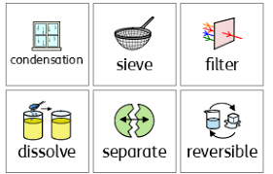
 |  | As Mathematicians we will be revising formal written methods for addition and subtraction. We will then move on to learn formal methods of multiplication and division. We will also look at fractions (equivalence, comparing and ordering, adding and subtracting fractions).  In PE we will be working on target games in outdoor PE, with a focus on golf. In our indoor PE, we will be developing our gymnastics skills. | In RE we will consider what stories and images of deities can tell us about Hindu beliefs.  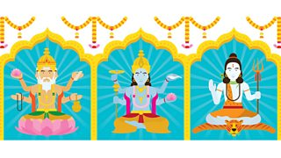  In PSHCE we will be looking at the topics of Working Together and Financial Capability.

Supporting Learning at Home  - Mathletics:www.mathletics.co.uk – set on Fridays and due the following Thursday.  - Maths: Key Instant Recall Facts (KIRFs) will be sent home to learn each half term.  - Times Tables Please continue to practise multiplication tables up to 12 × 12 as this was a target for the end of Year 4.  - Spelling Children will be provided with a spelling activity to complete at home. This will be sent home on Fridays and should be returned on the following Thursday.  - Reading book Ideally read daily for at least 10-15mins. Children should fill in their reading rainbow bookmark which will be checked in school weekly. To receive their bronze reading award, they need to read three chapter books from the Year 5 book list and two of their own choice.  Each class also has the opportunity to use the school library once a week.  - Bugclub: www.activelearnprimary.co.uk    School code: qkc7 | Contacts  For any queries or enquiries, please contact your child’s teacher using the email below:  Tigers Class:  Mrs Buck  (Mondays, Wednesdays, Thursdays, Fridays)  cbuck@pendragon.cambs.sch.uk  Mrs Huntley (Tuesdays)  jhuntley@pendragon.cambs.sch.uk  Lions Class:  Miss Hart  nhart@pendragon.cambs.sch.uk    Please note that teachers will check their email up to 8.30am every morning, if you have an urgent message, please contact the office instead via phone or email, so that they can pass the message on to the class teacher. | PE Lessons  Please ensure that your child comes in to school wearing their PE kit, ready for PE on the PE days below:  Tigers PE is on Thursdays (outdoors) and Fridays (indoors).  Lions PE is on Wednesdays (indoors) and Thursdays (outdoors)  If your child has long hair, please ensure they have a hair band, as long hair must be tied back for PE. It is expected that all children can remove watches/earrings for PE. If your child is unable to remove their own stud earrings these should be removed at home on PE days or micropore tape provided so they can cover them.  Thank you for your support with this.  The Haven and wellies  Each class will have a weekly time slot to use the Haven. Wellies should be brought into and kept in school so that this space can be used throughout the year. Lions will use the Haven on Mondays and Tigers will go on Wednesdays (weather permitting).  Personal belongings in school  Your child should only come into school each day with their packed lunch, water bottle and reading book. All other resources that the children require for their learning will be provided by school.

