 | 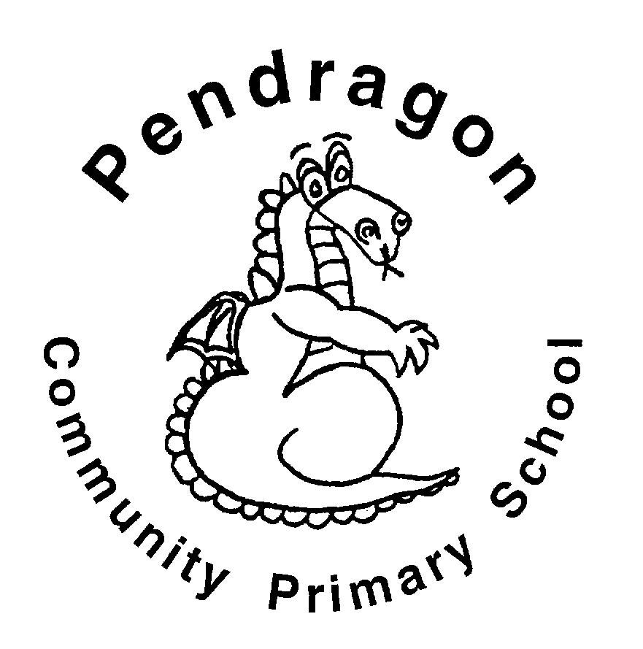 | Pendragon Community Primary School  Cubs Class – Mrs Marshall
 | Early Years Foundation Stage
 | Communication and Language  - Listening to stories, poems and non-fiction, responding to the different genres  - Talking about the books we read and answering questions to check comprehension  - Listening to others – adults and friends  - Asking and answering questions  - Talking to each other about what we do, learn and the things we make  - Learning new vocabulary linked to the theme  - Following instructions  Personal, social and emotional development  - Developing independence  - Following our school motto REACh  - Sharing and taking turns with others  - Exploring how our behaviour can affect others  - Talking about how can we look after our local environment  - Exploring the jobs of different people in our local area  Physical Development  - Travelling in different ways and combining various movements including walking, skipping, running, jogging, hopping, marching and crawling  - Using a range of equipment to make obstacles, balance and climb along, across, under and over  - Using a variety of tools such as pens, pencils, chalk and paintbrushes to draw detailed pictures and form cursive graphemes for writing |  |  | Journeys  Where will your next adventure take you?  Characteristics of Effective  Teaching and Learning  Characteristics of Effective  Teaching and Learning  Playing and Exploring – engagement  Finding out and exploring  Playing with what they know  Being willing to ‘have a go’  Active Learning - motivation  Being involved and concentrating  Keep on trying  Enjoying achieving what they set out to do  Creating and Thinking Critically  Having their own ideas  Making links  Choosing ways to do things | Literacy  - Story time phonics – phase 3 phonemes  - Phase 4 – adjacent consonant clusters, read and spell words containing these  - Blending to read and segmenting to spell words containing consonant and vowel digraphs and trigraphs  - Learning to read key words by sight  - Writing simple sentences using a capital letter to start and full stop to end.  Maths  - Recognising and ordering numbers up to 20  - Number sense to 6 including learning addition and subtraction facts for numbers up to 6  - Subitising 1 to 6 using dotty patterns  - Recognising 1 more and 1 less up to 10  - Exploring direction and position  - Copying, continuing and creating repeating patterns.  Understanding the World  - Exploring the places we live – observing natural and physical features  - Comparing and contrasting the place we live to other places in the world  - Reading simple maps and making our own  - Exploring different forms of transport  - Exploring early signs of Spring  Expressive Arts and Design  - Using materials and other resources to design and create  - Singing nursery rhymes and other songs  - Recreating stories and experiences using small world and when in the role play area
Supporting Learning at Home  - Learning Overview  An overview of learning will be sent home fortnightly, please read as this will give you a really good insight into what your child has been learning over a two-week period and how you can support at home. First overview will be sent Friday 4th March.  - Maths:  Key Instant Recall Facts (KIRFS) sent home during the autumn term and this week (also available on the website)  Mathletics: www.mathletics.co.uk  - Reading:  School reading scheme book – Every Monday your child will bring a book home to read with you. This book should be discussed and read more than once before for returning on Friday.  Every Friday, your child will choose a book from our Early Years sharing library – snuggle up and enjoy together!  Bug Club: www.activelearnprimary.co.uk  More books for your child to access. You can read one of these together at home over the weekend.  Word wallet – phase 4 words will be added once your child can read all phase 2 and the majority of phase 3. All words in the wallet must be practised and learnt by sight (not sounding out).  For more information about how to support your child at home with phonics and reading follow the link on the Foundation Stage page of the school website – Phonics slideshow for parents |  |  | Contact  For any queries or enquiries, please contact me using the email below:  Mrs Marshall  amarshall@pendragon.cambs.sch.uk  Please note that teachers will check their email up to 8.30am every morning, if you have an urgent message, please contact the office instead via phone or email so that they can pass the message on to the class teacher.  Entry and exit procedures.  When dropping off, please say goodbye to your child at the Foundation Stage entrance gate. On collection, once the gate has been unlocked, you will need to wait in the Foundation Stage outdoor area. Please find a space so you are socially distanced from others and avoid queuing. You will then exit via the double gates on the field. |  |  | PE is on Monday and Wednesday  Please ensure that your child comes in to school wearing their PE kit, ready for PE on the PE days above.  If your child has long hair, please ensure it is tied back for PE. If your child has their ears pierced and is unable to remove their own stud earrings, these should be removed at home on PE days or micropore tape provided so they can cover them.  The Haven and wellies  We will continue to visit the Haven (our environmental area) every week. Your child will need a pair of wellies that can stay in school during term time.  Foundation Stage also love to play in mud, splash in puddles and sledge down hills on snowy days so wellies are an essential item to have in school.  Tuesday carousel  A morning of creative and investigative activities which will always include cooking! Therefore, if your child has long hair please ensure it is tied up.  Recycling  The children are encouraged to make models and we need quite a bit of junk for them to do that, so we would be very grateful for any clean cereal boxes, small food packaging boxes and tubes to keep them going. (no toilet rolls or egg boxes please)  Personal belongings in school  Your child should only come into school each day with their packed lunch (if they are not having a school meal), water bottle and reading record and book. All other resources that the children should require for their learning will be provided by the school.  No water bottles in book bags please, some books have been damaged due to this!

