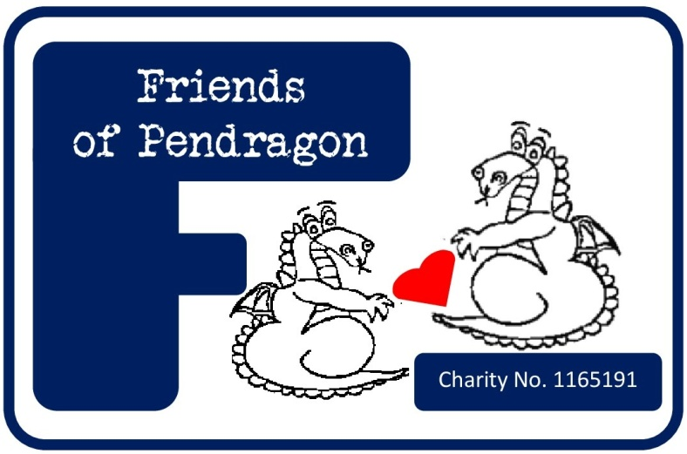

Dear Parent/Carer,

If you’re not already familiar with us, we’re the Friends of Pendragon School. We’re a registered charity run by volunteers: mums, dads, aunties, uncles, grandparents, teachers, teaching assistants, school staff and friends of the school. As a parent/carer of a Pendragon child you are already a member of the Friends’ community and are benefiting from the amazing work the Committee and Helpers do to raise both money and hold community engagement activities to enrich school life.

This year we’ve said goodbye to some long standing Committee Members and as such a new team has volunteered to run Friends; there’s some fantastic events on the horizon, but we can only run these with active Committee Members to undertake the planning and Helpers to make the events happen.

As such, please complete the following details to inform us what you can offer to help raise funds to enrich your child’s education and to allow community engagement events to take place, for everyone to benefit from! We will then contact you, via email, when we have a support requirement meeting your skill set. Your email address will be held securely on our encrypted contact list and not shared with any other organisation; and can be removed on request – if you are not happy for us to hold this information, please do not provide it.

Thank you in advance for any help you can give!

With warmest wishes,

***Friends of Pendragon School***

Registered Charity Number: 1165191

**Parent/Carer Sign Up Sheet**

|  |  |
| --- | --- |
| **Name** |  |
| **E-mail address** |  |
| **Telephone Number** |  |
| **What year(s) group(s) is/are your child(ren) in?** |  |
| **Additional Volunteers** |  |
| **E-mail addresses** |  |

Please tick the relevant statement:

|  |  |
| --- | --- |
|  | I’m already part of the awesome Friends’ team! |
|  |  |
|  | I would LOVE to be involved in the Friends’ Committee, please email me details! |
|  |  |
|  | I can’t commit to the Committee at this time, but will support Friends to meet its goals. |

**If you ticked the 3rd statement, please let us know how you are able to support Friends.**

|  |  |
| --- | --- |
|  | When possible I will offer 30 minutes of my time to help out at events. |
|  | I can help design posters/promotional materials. |
|  | I am crafty and can help make things for Friends to sell. |
|  | I am handy with a power tool and can help to improve the school environment. |
|  | I am nifty at landscaping/gardening and can help to enrich the school outdoor spaces. |
|  | I have an awesome brushstroke and can paint a wall with the best of them. |
|  | I’m happy to help set up gazebos and stalls for events, when I can. |
|  | I’m happy to help clean up after events, when I can. |
|  | I am an awesome prize hunter and would love to help source some donations |
|  | I am the best sales’ person and would love to sell tickets/raffle tickets for you. |
|  | Just call me Mary Berry/Paul Hollywood – I’d love to bake for Friends. |
|  | I am a labelling pro and would happily help label tombola prizes for events. |
|  | I am lucky to work for an awesome company who offer to “match fund” events. |
|  | My company/employer/workplace is the best and will donate................................................... |
|  | I am a whizz with words and can help complete application forms for grants. |
|  | I have/will sign up to Easyfundraising and will do my on-line shopping through it. |
|  | I can attend events/buy raffle tickets/donate gifts etc and share promotions with friends. |
|  | I have completed a Gift Aid form to earn Friends’ even more from my donations. |
|  | I have SO much to offer, but none of it is listed! I can................................................................. |