Pendragon Community Primary School

Sand Cats Class – Mrs Smart

National Curriculum
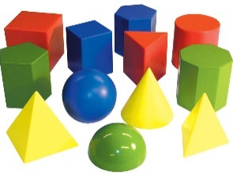  As Mathematicians we will continue to consolidate all number skills and particularly focus on problem solving for all operations. We will also learn about geometry – properties of 2D and 3D shape, symmetry, rotation and right angles. | As Writers we will write a range of texts linked to different areas of learning, including reports and letters. Based on our other learning we will plan and write texts of our own choice in Pendragon Writers Club.  As Readers we will read and enjoy poetry; read, listen to and discuss stories and information texts, giving our thoughts and opinions. | 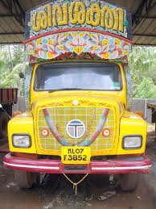  As Scientists we will develop our understanding of scientific enquiry by asking and answering our questions. We will learn to identify and name plants and animals in a seaside habitat and investigate how they are adapted to their environment. |  |  | 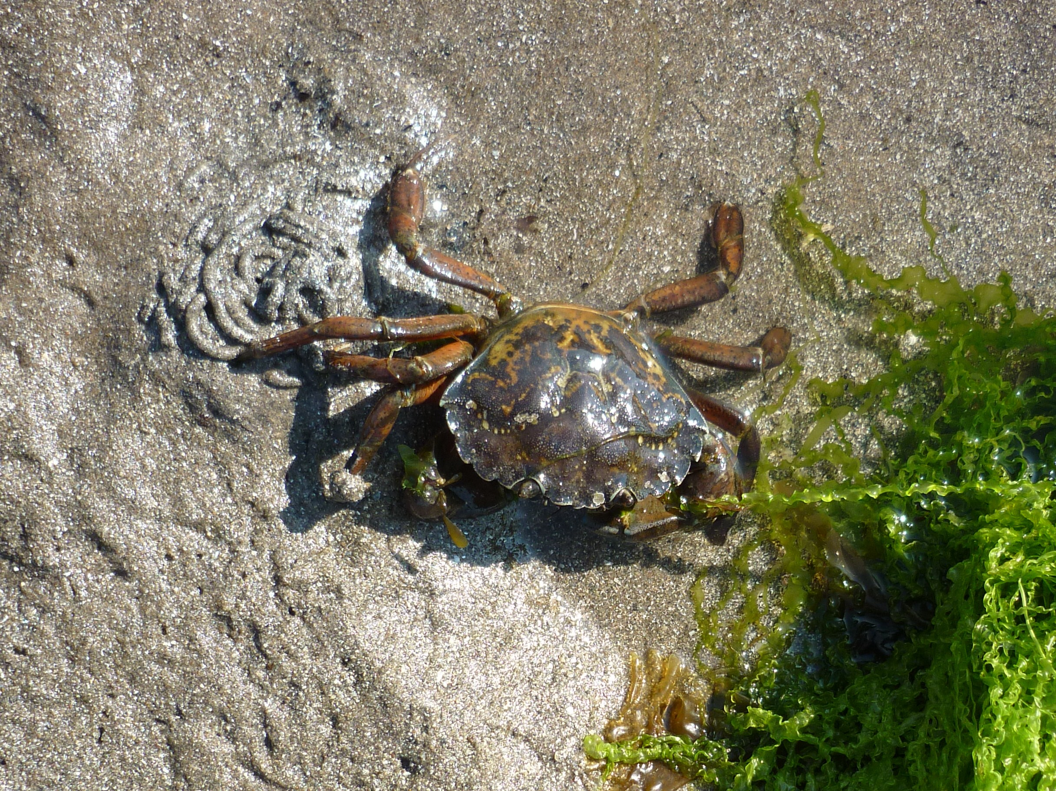
As Geographers we will use maps, atlases, books, the internet and people to help us compare the climate, landscape, clothing, food, transport, buildings and schools in Cambridgeshire and India. |  | Year 2 – Summer 2  Near and Far | As Design Technologists we will try, cook and evaluate Indian foods and design, create and evaluate vehicles with simple mechanisms.
 |  | As Historians we will find out about the lives of significant people from the history of Papworth Everard. |  | 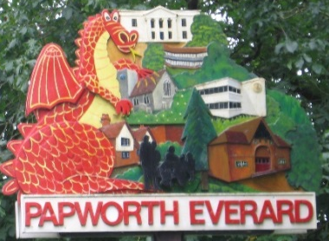
As Musicians we will be exploring timbre, tempo and dynamics. | In Computing we will learn more about e-safety (staying safe online), develop our understanding of technology, digital literacy and simple programming using a range of programmes. | . | In RE we will learn about how the Khalsa influences the lives of Sikh families.
In PE we will continue to develop our skills in running, throwing, catching and dribbling. We will also develop skills in athletics and take part in simple competitive activities. |  | In PSHCE we will think about our relationships and managing change.

 | Curriculum Drivers
 | Ambition | Community and Diversity | Emotional Awareness | Enquiry and Risk Taking
 | As people with ambition we will: | As members of a diverse community we will: | As emotionally aware people we will: | As people with enquiring minds we will:
 | - Take responsibility for our own learning and work hard.  - Think about whether we have a fixed or growth mind-set.  - Understand our strengths and know what our next steps are.  - Challenge ourselves to try new things, express our doubts and fears and learn from our mistakes. | - Think about who is in our community.  - Think about what it means to be part of a community.  - Investigate who has helped to develop our community now and in the past. | - Explore feelings of fear, nervousness and excitement.  - Consider how working together in pairs and groups makes us feel and how we can respond to this.  - Think and talk about the feelings of others | - Ask simple questions and recognise that they can be answered in different ways.  - Use our observations and ideas to suggest answers to questions.  - Gather and record data to help in answering questions.
Use of our environment and the acquisition of knowledge of the world

Supporting Learning at Home  - Weekly spelling.  - Mathletics: www.mathletics.co.uk  - Reading book or Bug Club – ideally every day – it makes a real difference. Please make a comment and sign the reading record – and remind your child to change their book when they need to.  - Bug Club: School code – qkc7  www.activelearnprimary.co.uk  Read a book online and take the quiz – It really helps the development of comprehension skills.  - Library Books - our Library session, when library books can be changed, is on Friday. | Support in Class  Please feel free to come and talk to me about any concerns you may have. You can catch me for quick questions before and after school, or make an appointment by contacting the office or e-mailing directly.  Mrs Smart  csmart@pendragon.cambs.sch.uk | PE Lessons  These take place on a Tuesday and Friday.  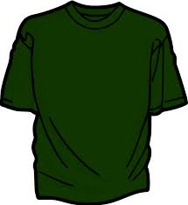  Named kit to be kept in school:  - Indoor: shorts and a t-shirt.  - Outdoors: jogging bottoms or  shorts, t-shirt and trainers.  - A hairband for tying back long  hair.  If your child has long hair, please ensure they have a hair band, as long hair must be tied back for PE.  It is expected that all children can remove watches and earrings for PE. If your child is unable to remove their own stud earrings these should be removed at home on PE days or micropore tape provided so they can cover them.  Thank you for your support with this

