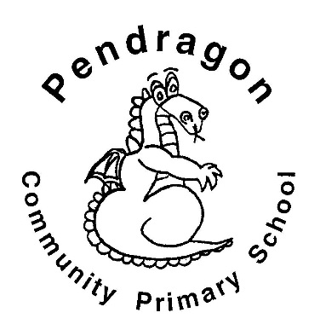 | Recommended Reading List | Year 4
The selection of books in this list are a guide for children aged 8-9 in Year 4 at school. The books are selected from a range of genres to cover all interests. If your child is a competent reader or has read many of these titles then try the books from the Year 5 list.
