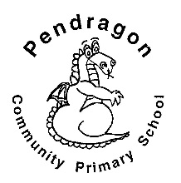 | Pendragon Community Primary School  Bobcats Class – Miss Westlake and Mrs Bardell

 | National Curriculum
 | 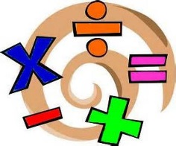  As Mathematicians we will develop our understanding of number and place value, by counting, grouping objects and exploring patterns. We will further our understanding of addition, subtraction, multiplication and division. |  |  | As Writers we will write a range of texts linked to different areas of learning, including instructions and explanations. Based on our other learning we will plan and write texts of our own choice in Pendragon Writers Club.  As Readers we will read, listen to and discuss texts about superheroes and heroes (of our choice). We will explore the effect of patterned language in poetry. We will read non-fiction texts linked to our History and Science learning and will ask and answer questions based on our reading.  Year 2 - Autumn 1  Heroes  In RE we will explore the sense of belonging and what it means to belong to different groups, including religions.  As Musicians we will explore pitch. |  | As Scientists we will learn about humans and animals. We will learn about the main parts of the human body and the senses; investigate the basic needs of humans for survival and the importance of exercise, hygiene and a balanced diet. |  |  | 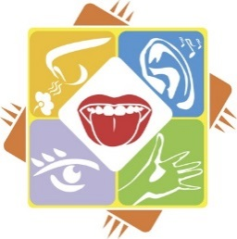
 | As Historians we will be finding out about the life of a significant person from history – Florence Nightingale. We will start by looking at modern day heroes (fire fighters, police officers etc) and then nurses and hospitals and consider the impact that Florence Nightingale (& Mary Seacole) have had. | 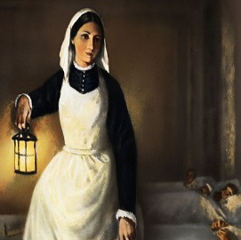 |  |  |  |  |  | As Design Technologists we will use our knowledge of healthy balanced diets to design, cook and evaluate simple dishes. We will develop our basic skills in preparing ingredients by hygienically cutting / peeling / grating and accurately weighing/ measuring amounts.
 | As Geographers we will use world maps, atlases and globes to find important places and find out more about where they are.  In Computing we will learn about e-safety (staying safe online) and use a range of programmes, including Starz, to learn, research, present and communicate our ideas. |  |  |  |  | As Artists we will use a range of paintings as first hand evidence to learn about the lives of Florence Nightingale and Mary Seacole.
In PSHCE we will develop skills in conflict resolution and consider rules and responsibilities.

In PE we will explore body shape in Gymnastics and foot control and net games in Games.
 | Curriculum Drivers
 | Ambition |  | Community and Diversity |  | Emotional Awareness |  | Enquiry and Risk Taking
 | As people with ambition we will: |  | As members of a diverse community we will: |  | As emotionally aware people we will: |  | As people with enquiring minds we will:
 | - Take responsibility for our own learning and work hard.  - Think about whether we have a fixed or growth mind-set.  - Understand our strengths and know what our next steps are.  - Challenge ourselves to try new things, express our doubts and fears and learn from our mistakes. |  | - Think about who is in our community.  - Think about what it means to be part of a community.  - Investigate who has helped to develop our community now and in the past. |  | - Explore feelings of fear, nervousness and excitement.  - Consider how working together in pairs and groups makes us feel and how we can respond to this.  - Think and talk about the feelings of others |  | - Ask simple questions and recognise that they can be answered in different ways.  - Use our observations and ideas to suggest answers to questions.  - Gather and record data to help in answering questions.
Use of our environment and the acquisition of knowledge of the world

Supporting Learning at Home  - Weekly phonics/spelling to be sent home at the beginning of each week and returned after the weekend.  - Maths: www.mathletics.co.uk - Tasks set by teacher to be completed by deadline. Maths: Key Instant Recall Facts (KIRFs) will be sent home to learn each half term  - Reading book or Bug Club – ideally every day – it makes a real difference. Please make a comment and sign the reading record – and remind your child to change their book when they need to.  - Bug Club: School code – qkc7  www.activelearnprimary.co.uk  Read a book online and take the quiz – It really helps the development of comprehension skills.  - Library Books - our Library session, when library books can be changed, is Tuesday. | Support in class  We are always happy to have helpers in the class, especially to hear children read, but if you would rather help in a different way do tell us. If you would like to help, please let us know and we can arrange a convenient time. If you cannot commit on a regular basis please do feel you can offer ‘one-off’ support too.  Please feel free to come and talk to me about any concerns you may have. You can catch me for quick questions before and after school, or make an appointment by contacting the office or e-mailing directly.  Miss Westlake and Mrs Bardell  hwestlake@pendragon.cambs.sch.uk  abardell@pendragon.cambs.sch.uk | PE Lessons  These take place on Tuesday and  Wednesday afternoons.  Named kit to be kept in school:  - Indoor: shorts and a t-shirt.  - Outdoors:jogging bottoms or shorts, t-shirt and trainers (must be a different pair from shoes worn for school).  - A hairband for tying back long hair.  It is expected that all children can remove watches and earrings for PE. If your child is unable to remove their own stud earrings these should be removed at home on PE days or micropore tape provided from home so they can cover them. If your child wears trainers to school, please ensure that they have a change of trainers for PE to prevent water and mud being brought inside.  Thank you for your support with this.

