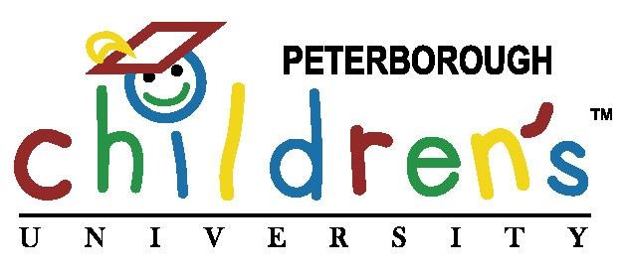

What is Children’s University?
- Children’s University is a programme that aims to improve the aspirations and attainment of pupils by encouraging, tracking and celebrating participation in learning activities beyond the normal school day.

- Local Children’s University partners support schools to provide a range of learning opportunities, such as after-school clubs, projects and enrichment activities, and work with local destinations and learning providers such as libraries, sports clubs, historic centres, museums, or anywhere that offers structured learning activities for children.

- Pupils use a ‘Passport to Learning’ and an online platform to record participation in these activities and these are rewarded by the collection of credits, certificates and graduations.

Background to this study
- In 2017, the EEF published an efficacy study of Children’s University which showed a direct link between participation in Children’s University and increased achievement in reading and Maths. Children in Children’s University schools made two additional months’ progress in reading and maths compared to children in the other schools (control group).

- Having gone on to name Children’s University a ‘Promising Project’ in 2018, the EEF are now committed to running a larger scale effectiveness trial of Children’s University to see if such positive results are evident at scale.

- Working with the Children’s University Trust, the Education Endowment Foundation (EEF) and the National Foundation for Education Research (NFER), the Children’s University has now recruited over 170 primary schools across the UK to this new EEF study. The study will run for from January 2022 through to July 2024 and will look at the impact of how being a part of Children’s University impacts pupils’ academic results as well as their wellbeing.

How will the trial work?
- Out of all the schools that signed up, half of these schools are intervention schools, which means they will access Children’s University, with the other half being control schools, which means they won’t access Children’s University. Schools were chosen randomly but we were thrilled to be chosen as an intervention school.

- This means that over the next 18months our Year 5 pupils will access everything that Children’s University has to offer. During January 2022, we had a “launch day” with the pupils when they took part in some of the activities on offer as well as learning how to use the Children’s University Online system where they will log all of their activities!

What will be measured?
- The study’s primary outcomes will be attainment in maths and reading, as measured by Key Stage (KS) 2 SATs results.
- There will also be secondary outcomes measured by a pupil survey produced by the NFER. Pupils will fill in this survey twice-Autumn term 2021/2022 and Summer term 2023. This will be looking at pupils’:
- increased motivation to learn in and beyond the classroom;
- development of a broad range of essential skills, and;
- growth in confidence and self-belief.

What will happen to my child’s information?
- All data gathered during the trial will be held in accordance with the Data Protection Act 2018 and General Data Protection Regulation (GDPR) 2016/679 and will be treated in the strictest confidence by NFER and Children’s University Trust. All personal data will be shared via an online secure data portal. The evaluation report will be published on the EEF website and the findings may also be disseminated at educational research conferences and in academic or professional journals. No school, teacher or pupil will be named in any report arising from this work.
- A Privacy Notice for the study is available at the link below: https://www.nfer.ac.uk/eecu_schools_and_CU_privacy_notice

Finding out more
If you would like to find out more about the Children’s University Trust, please visit https://www.childrensuniversity.co.uk/

