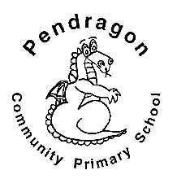 | Pendragon Community Primary School  Snow Leopards Class – Miss Jupe |  |  | 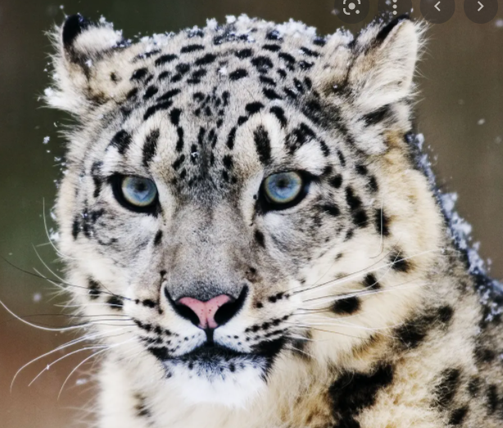
National Curriculum
As Readers we are continuing to enjoy Storm Keepers Island. We are also reading ‘Windrush Child’ by Benjamin Zephaniah to support our Black History topic from last half term. We will continue to practise SATSs style questions for our comprehension. In guided reading we will be exploring a range of fiction, non-fiction and poetry texts, including picture books.  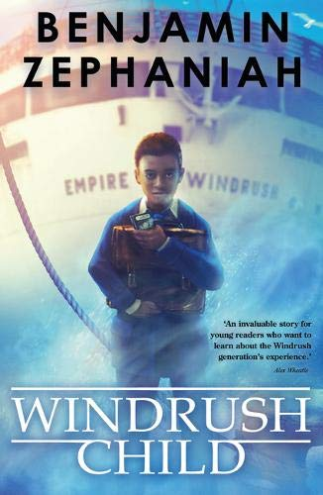  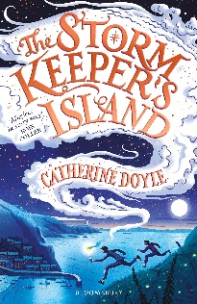  As Designers we will be exploring cultural and seasonal foods and then we will become chefs and make our own seasonal meals. Additionally, linked to our science, we will be investigating the role of yeast in bread.  As Historians we will be discovering why the Mayan civilization came to such an abrupt end.  As Musicians we will be learning and performing songs.  In PE we will develop skills in footballl and gymnastics. |  | As Mathematicians we will explore fractions, decimals and percentages. We will use fluent written methods to solve increasingly difficult problems. We will begin to use the language of algebra and classify shapes using more complex vocabulary.  Year 6  Autumn Term  Might Mayans  In Computing we will be learning about coding. During the topic, we will learn how to code our own game and debug any problems we may encounter.  In PSHE we will be thinking and talking about new friendships and falling out. We will then be learning about anit-bullying and what we can do to prevent it. | As Writers we will be writing a narrative chapter based on Storm Keepers Island. We will be using our learning to write in the same style as the author. Towards the end of the term we will be planning and writing our own poems based on the theme of Christmas.  In French we will be continuing to revise the months of the year along with naming the seasons and describing the weather. We will begin to learn how to form verbs. As well as this, we will learn the points of the compass and numbers 60-100.  In Geography we will study world maps and globes in more detail focusing on where the Mayans originated. We will be identifying different countries, continents, hemispheres and time zones.  In RE we will be learning all about Buddhism.  As Scientists we will be learning about living things, focusing on animal classification. We will discuss differences between vertebrates and invertebrates. As well as this we will learn about the three kingdoms – animals, plants and fungus.

Pendragon Community Primary School

Snow Leopards Class – Miss Jupe
Supporting Learning at Home  - Maths  Work will be provided to practise what has been learned in class as an activity in the homework book and on Mathletics:www.mathletics.co.uk  - Spelling.  Children will be provided with a spelling activity to complete at home. This will be sent on Friday and should be returned by the following Thursday.  - Reading book  Ideally read daily for at least 15-20mins.  - Bug club: www.activelearnprimary.co.uk  - KIRFs: This half term’s KIRFs are to learn times table facts up to 12 x 12 and the related division facts (e.g. if 12 x 3 is 36, 36 ÷ 12= 3). Next half term’s is to know the decimal complements of 1 (e.g. 0.4 + 0.6= 1, or 0.12 + 0.88= 1) |  |  | Hilltop  A reminder for those going to Hilltop that the dates are Monday 6th - Friday 10th December 2021.  SATs tests 2022  This year these tests take place during the week of 9th May 2022. Please try to avoid taking time off during this week.  Contact  Please note that teachers will check their email up to 8.30am every morning, if you have an urgent message, please contact the office instead via phone or email, so that they can pass the message on to the class teacher.  Miss Jupe  bjupe@pendragon.cambs.sch.uk  Entry and exit procedures  Year 6 will enter and exit school via the green gate which can be accessed from the public footpath at the bottom of the field.  Children can come into school from 8.40am and the gates will close at 8.55am. School ends at 3.15pm. | PE Lessons  Please ensure that children come in PE kit on Tuesdays and Fridays. This needs to include their school jumper or cardigan, but extra layers can be worn for PE.  All uniform and kit must be named or it is impossible to reunite it with your child if it gets muddled up! If your child has long hair, please ensure they have a hair band, as long hair must be tied back for PE. It is expected that all children can remove watches/earrings for PE. If your child is unable to remove their own stud earrings these should be removed at home on PE days or micropore tape provided so they can cover them.  Thank you for your support with this.  The Haven and Wellies  Each class will have a weekly time slot to use the Haven. Wellies should be brought into and kept in school so that this space can be used throughout the year.

