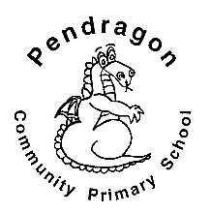 | 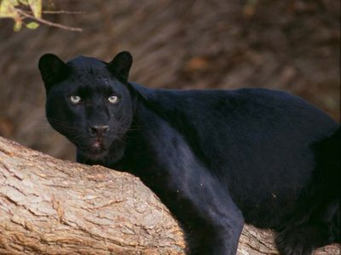  Pendragon Community Primary School  Autumn Term  Panthers and Leopards – Miss Safranek and Miss White
National Curriculum
As Readers we will be reading ‘Zelda Claw and the rain cat’ by Pie Corbett and using this to spark imagination for our own suspense story. We will focus on the effect on the reader and features that build suspense. |  | As Mathematicians We will work on our multiplication and division facts, linking to counting in multiples and times tables. We will focus on measurement, including problem solving, conversion of units and comparing, estimating and calculating. | As Writers we will be writing our own rainforest animal poetry. We will explore different examples and decide which features our poems will include. We will be looking at rhyme, rhythm, onomatopoeia, similies and metaphors.
In RE we will be looking at Buddhism and conducting an enquiry on ‘Is it possible for everyone to be happy?’ We will discuss how we can make others happy and look at how Buddha tried to achieve this. |  |  | As Scientists we will be learning about living things and their habitats. We will learn about the 7 characteristics of a living thing, classification keys and animals found in our local and wider environment.
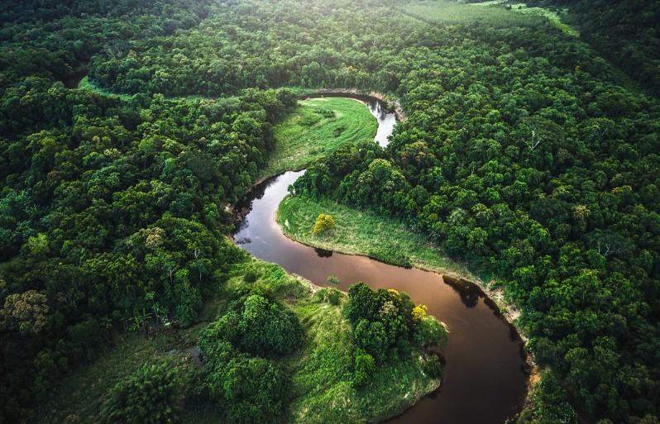

In Computing we will be using Purple Mash software to learn about online safety. We will learn about phishing, scams and fake websites. We will also learn how we can keep safe whilst browsing on the internet and what a healthy amount of screen time should be.

As Artists we will study the artist Henri Rousseau’s paintings focusing on the rainforest theme. We will look at the colours used, light and shade, size of plants and flowers, foreground and background. We will then create our own Rousseau pictures. |  |  | As Musicians we will be learning through the online music scheme ‘Charanga’. Our units of ‘Mamma Mia’ and ‘5 Gold Rings’ will involve Makaton singing, listening, appraising, as well as performing.  In PE we will develop our balance skills in Gymnastics. Our outdoor PE will focus on tag rugby, applying principles suitable for attacking and defending.  As Linguists we will be learning the French alphabet, numbers to 31, days and months of the year. We will also be learning vocabulary linked to the seasons, birthdays and Christmas.
In PSHCE we will be exploring the topics of friendship and bullying.
.

As Geographers we will be exploring the Amazon Rainforest and the importance of this wonder to us as individuals. We will be looking at the layers of the rainforest, deforestation and how we can help minimise the effects of climate change.

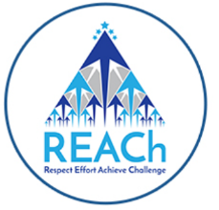

Supporting Learning at Home  - Mathletics:www.mathletics.co.uk – set on Fridays and due the following Thursday.  - Maths: Key Instant Recall Facts (KIRFs) will be sent home to learn each half term.  - Times Tables A target for the end of Year 4 is for children to know their multiplication tables up to 12 × 12. It is important for children to practise their tables regularly. Early notice, all Year 4 children will complete a statutory multiplication times table check in early June 2023.  - Spelling Children will be provided with a spelling activity to complete at home. This will be sent home on Fridays and should be returned on the following Thursday.  - Reading book Ideally read daily for at least 10-15mins. Children should bring their reading record book to school each day.  - Bugclub: www.activelearnprimary.co.uk  School code: qkc7 | Contact  For any queries or enquiries, please contact the school office using the email below:  School office:  office@pendragon.cambs.sch.uk | PE Lessons  Please ensure that your child comes in to school in their PE kit, ready for PE on the PE days below.  Panthers PE is on Mondays and Thursdays.  Leopards PE is on Thursdays and Fridays.  If your child has long hair, please ensure they have a hair band, as long hair must be tied back for PE. It is expected that all children can remove watches/earrings for PE. If your child is unable to remove their own stud earrings these should be removed at home on PE days or micropore tape provided so they can cover them.  Thank you for your support with this.  The Haven and wellies  Each class will have a weekly time slot to use the Haven. Wellies should be brought into and kept in school so that this space can be used throughout the year.  Personal belongings in school  Your child should only come into school each day with their packed lunch, water bottle and reading book. All other resources that the children require for their learning will be provided by school.

