Pendragon Community Primary School

Cubs Class – Mrs Marshall
 | Early Years Foundation Stage
 | Communication and Language  - Listening and responding to stories, poems and non-fiction text  - Talking in full sentences about the books we read and answering questions to check comprehension  - Listening attentively to others  - Asking and answering questions to clarify understanding  - Talking to each other about what we do, learn and the things we make  - Learning new vocabulary linked to the theme  - Following instructions  Personal, social and emotional development  - Following our school motto REACh  - Transition to Year 1 – Meet the teachers, story time and classroom visits  - Exploring our emotions and talking about how our behaviour can affect others  - Exploring our body and how it grows and changes as we get older.  - Talking about how can we look after our local environment and the animals that live within it  Physical Development  - Throwing and catching a beanbag and playing target games  - Consolidating all ball skills and forms of travelling in preparation for Sport’s Day  - Using a range of equipment to make obstacles, balance and climb along  - Using a variety of tools such as pens, pencils, chalk and paintbrushes to draw detailed pictures and form cursive graphemes for writing |  |  | Amazing Animals  What makes our planet amazing?  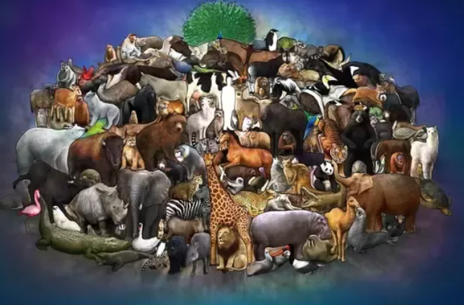  Characteristics of Effective  Teaching and Learning  Playing and Exploring – engagement  Finding out and exploring  Playing with what they know  Being willing to ‘have a go’  Active Learning - motivation  Being involved and concentrating  Keep on trying  Enjoying achieving what they set out to do  Creating and Thinking Critically  Having their own ideas  Making links  Choosing ways to do things | Literacy  - Consolidation of all phase 3 phonemes and words  - Phase 4 – continuing to read and write words that contain adjacent consonant clusters  - Using our phonic knowledge and sight word recognition to read and write sentences  - Building our comprehension skills – talking about what we read  - Writing simple sentences using a capital letter to start, a full stop to end and finger spaces between words.  Maths  - Counting objects up to 20 and beyond  - Recognising and ordering numbers up to 20  - Number sense to 10 including learning addition and subtraction facts  - Exploring odd and even numbers  - Double facts to 10 and sharing amounts equally  Understanding the World  - Exploring the natural world around us  - Comparing Africa to Papworth  - Finding out about animal habitats  - Listening to stories from different religions  - Exploring the season of Summer  Expressive Arts and Design  - Using materials and other resources to design and create  - Recreating stories and experiences using small world and when in the role play area  - Listening to music from places around the world, responding through discussion, drawing and dance
Supporting Learning at Home  - Learning Overview  An overview of learning will be sent home fortnightly, please read as this will give you a really good insight into what your child has been learning over a two-week period and how you can support at home. First to be sent Friday 17th June.  - Maths:  All Key Instant Recall Facts (KIRFS) sent home this year (also available on the website)  Mathletics: www.mathletics.co.uk  - Reading:  School reading scheme book – Every Monday your child will bring a book home to read with you. This book should be discussed and read more than once before for returning on Friday.  Every Friday, your child will choose a book from our Early Years sharing library – snuggle up and enjoy together!  Bug Club: www.activelearnprimary.co.uk  More books for your child to access. You can read one of these together at home over the weekend.  Word wallet – Please continue to practise all words in the wallet, remembering they must be learnt by sight (not sounding out).  REMINDER – We will be visiting Woburn Safari Park on Tuesday 21st June to see amazing animals close up and explore their habitats. We will not be due back to school until approximately 4.30pm. |  |  | Contact  For any queries or enquiries, please contact me using the email below:  Mrs Marshall  amarshall@pendragon.cambs.sch.uk  Please note that teachers will check their email up to 8.30am every morning, if you have an urgent message, please contact the office instead via phone or email so that they can pass the message on to the class teacher.  Entry and exit procedures.  When dropping off, please say goodbye to your child at the Foundation Stage entrance gate. On collection, once the gate has been unlocked, you will need to wait in the Foundation Stage outdoor area and exit via the same gate as you entered. |  |  | PE is on Monday and Wednesday  Please ensure that your child comes in to school wearing their PE kit, ready for PE on the days above.  If your child has long hair, please ensure it is tied back for PE. If your child has their ears pierced and is unable to remove their own stud earrings, these should be removed at home on PE days or micropore tape provided so they can cover them.  The Haven and wellies  We will continue to visit the Haven (our environmental area) every week. Your child will need a pair of wellies that can stay in school during term time.  Foundation Stage also love to play in mud, splash in puddles and sledge down hills on snowy days so wellies are an essential item to have in school. You never know what the weather will do!  Summer Days  Please ensure your child brings a sun hat to school. Sun lotion can be applied before school and we will encourage them to apply again at lunchtime. These must be named and kept in your child’s book bag.  Personal belongings in school  Your child should only come into school each day with their packed lunch (if they are not having a school meal), water bottle and reading record and book. All other resources that the children should require for their learning will be provided by the school. No water bottles in book bags please, some books have been damaged due to this!

