What to do when you are isolation

Daily online lessons
Oak National Academy https://www.thenational.academy/ Free online daily lessons in all subjects.
Maths
Mathletics https://login.mathletics.com/
Mix it up with a range from:
- Learn- work set at the right level for your child
- Explore
- Play-live Mathletics to practise key maths facts
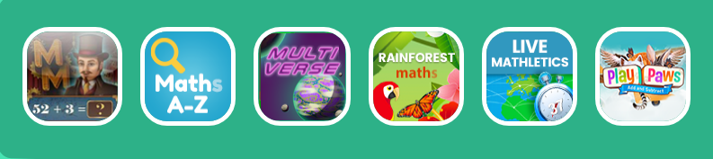
TTRock Stars https://ttrockstars.com/
Practise your multiplication tables
Wild maths https://wild.maths.org/
Maths problems to solve and think about in a fun way from the team at nrich
Sumdog https://pages.sumdog.com/
Maths and spelling activities
KIRFS
Revise all your KIRFs http://www.conkermaths.org/ https://www.topmarks.co.uk/maths-games/daily10
CBeebies numberblocks
https://www.bbc.co.uk/cbeebies/shows/numberblocks
Early maths facts for younger children
General https://www.topmarks.co.uk/
Reading
Bug Club https://www.activelearnprimary.co.uk/login?c=0 school code qkc7
A range of books set by the teacher. The books have questions to test comprehension. If you run out of books please let your child’s teacher know and they can set some new ones.
Electronic library books https://rbdigital.com/
Use your Cambridgeshire library card to sign up for free electronic books on RBdigital.
Oxford Owl https://www.oxfordowl.co.uk/for-home
Free ebooks for ages 3-11
Phonics https://www.phonicsplay.co.uk/
General
Purple Mash https://www.purplemash.com/login/
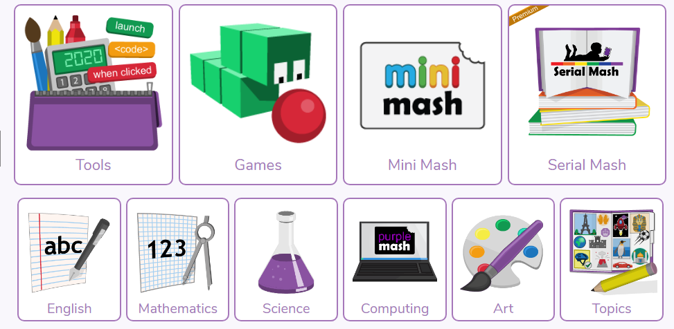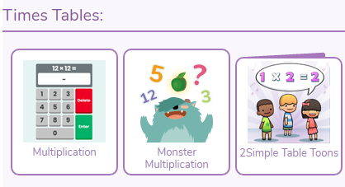
Purple Mash has a wide range of activities in all subjects.

