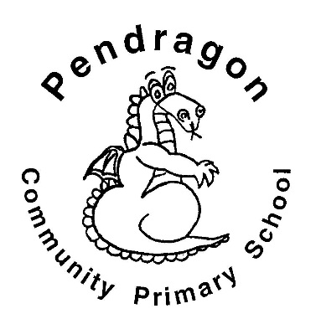 | Recommended Reading List | Year 2
The selection of books in this list are a guide for children aged 6-7 in Year 2 at school. The books are selected from a range of genres to cover all interests. If your child is a competent reader or has read many of these titles then try the books from the Year 3 list.
