 | 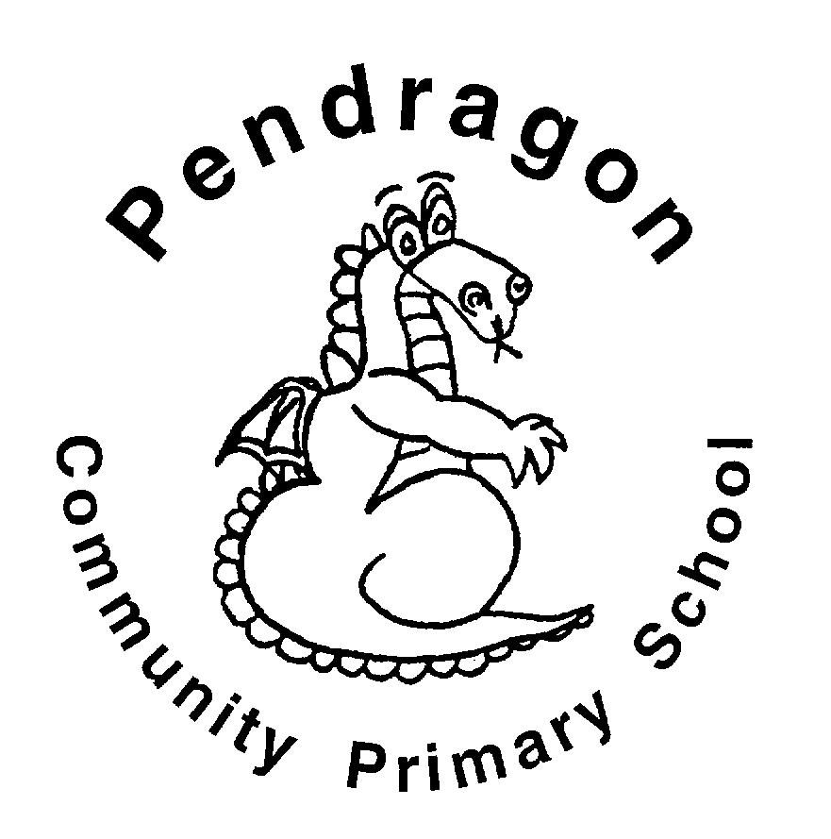 | Pendragon Community Primary School  Jaguars Class – Mrs Brown & Mr Edwards |  |  |  |  |  |  |  | 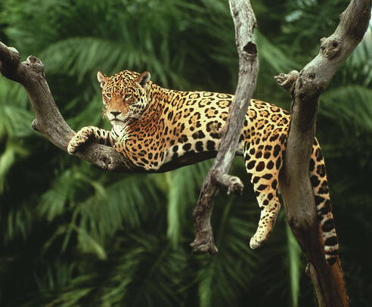
 | National Curriculum
 | As Readers we will be reading ‘Stone Age Boy’, ‘Cave Baby’ and ‘Stig of the Dump’. We will read non-fiction texts linked to learning in other subjects and will ask and answer questions based on our reading to develop our reading comprehension. |  |  |  | As Mathematicians we will be recapping place value and counting forwards and backwards before focusing on addition and subtraction.  We will also be learning and practising times tables to 12, with a particular focus on 3, 4,6 and 8. |  | As Writers we will focusing on poetry, traditional tales and fables all linked to our Stone Age theme. Based on learning in other subjects, we will plan and write texts of our own choice in Pendragon Writers' Club.
 | 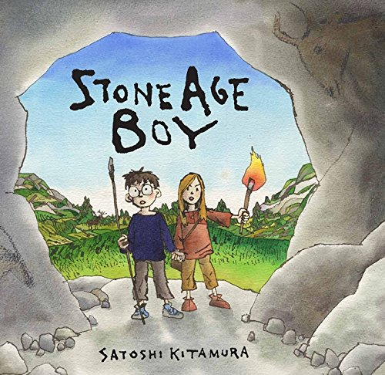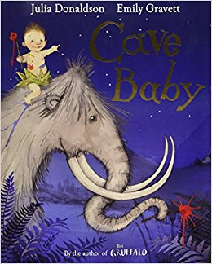 |  |  |  |  |  | As Scientists we will be learning all about rocks. We will explore how they are formed, compare different types, and understand the production of fossils. We will also learn how to conduct a fair test, make predictions and record findings in different ways.
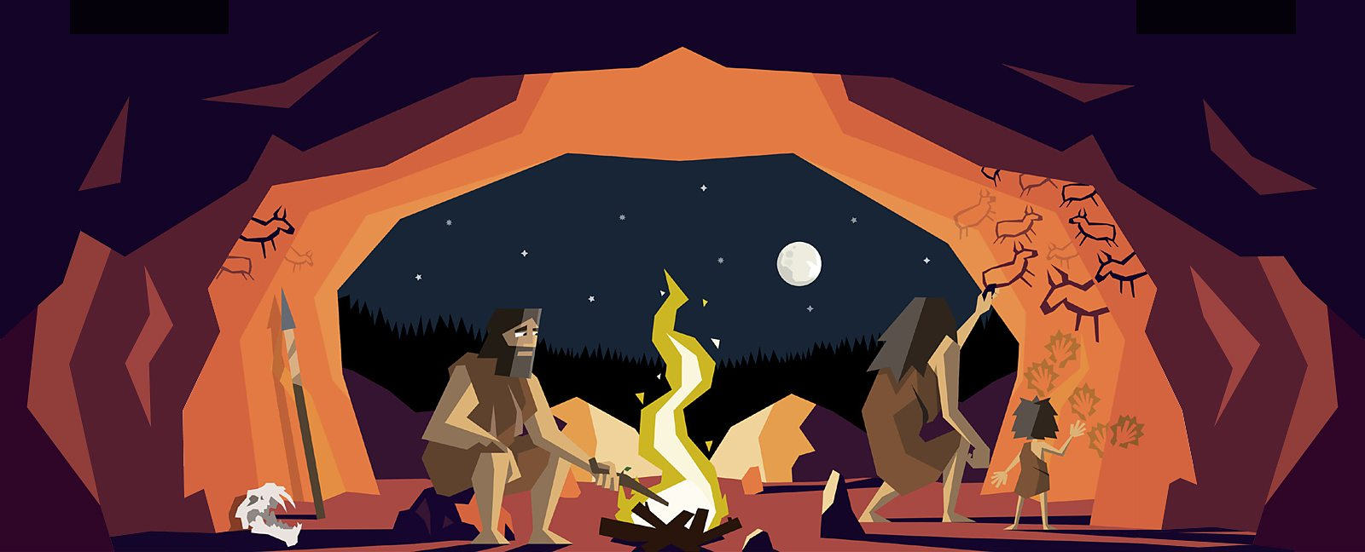
Yabadabadoo
Stone Age

As Musicians we will develop an understanding of a wide range of music and create our own compositions using instruments in groups.

In Computing we will learn about coding and how to stay safe online.
 | In Design Technology we will be exploring clothing, learning how to sew and then designing and making our own Stone Age clothing |  |  |  |  |  | In RE we will be learning about different religions and beliefs in our class before exploring religious symbols.  In PSHCE we will be getting to know our new classes, thinking about rules and responsibilities and what it means to belong to different groups in and out of school.  In PE we will be completing a dance unit focusing on machines. We will also be developing our ball handling through throwing and catching and small team games.
As Historians we will be finding out about life in the Stone, Bronze and Iron Ages. We will start by looking at daily life, jobs and roles, and compare this to our lives today. We will develop a good understanding of their rituals and beliefs by looking at artefacts, and researching using non-fiction texts.

As Geographers we will be using maps and atlases to locate settlements and develop a good understanding of how maps work.

Supporting Learning at Home  - Maths: Key Instant Recall Facts (KIRFS) will be sent home to learn each half term.  - Mathletics: www.mathletics.co.uk  - Spelling: Children will be provided with a personalised spelling activity to complete at home. This will be sent on a Friday and should be returned the following Thursday.  - Bug Club: www.activelearnprimary.co.uk  - Reading  Ideally read daily with your child, ideally between 10-15 minutes. Please make a comment and sign the reading record. |  |  |  | Library Books  Our Library session, when library books can be changed, is Tuesday.  Contact  For any queries or enquiries, please contact your child’s class teacher via the office using the email address below:  office@pendragon.cambs.sch.uk  The office will forward your message on to the class teacher. If you have an urgent message, please continue to call the office. |  |  |  | PE Lessons  Please ensure that your child comes in to school wearing their PE kit, ready for PE on the PE days below.  PE is on Wednesdays and Fridays.  If your child has long hair, please ensure they have a hair band, as long hair must be tied back for PE. It is expected that all children can remove watches/earrings for PE. If your child is unable to remove their own stud earrings these should be removed at home on PE days or micropore tape provided so they can cover them.  Thank you for your support with this.  The Haven and wellies  Each class will have a weekly time slot to use the Haven. Wellies should be brought into and kept in school so that this space can be used throughout the year. Jaguars will be using the Haven on Thursdays.  Personal belongings in school  Your child should only come into school each day with their packed lunch, water bottle and reading record and book. All other resources that the children should require for their learning will be provided by the school.

