Pendragon Community Primary School

Jaguars Class – Mrs Brown (Mon, Tue), Mr Edwards (Wed, Thu, Fri)
 | National Curriculum
 | As Readers we will be reading ‘Stonehenge, ‘Pebble in my Pocket’ and ‘Skara Brae’. We will read non-fiction texts linked to learning in other subjects and will ask and answer questions based on our reading to develop our reading comprehension. |  |  |  | As Mathematicians we will be learning new methods for written addition and subtraction and using these new skills to solve problems.  We will also be learning and practising times tables to 12, with a particular focus on 3, 4 and 8. |  | As Writers we will be focusing on Talk 4 Writing and looking at the text Poppy, Waldo and the Giant. Based on learning in other subjects, we will plan and write texts of our own choice in Pendragon Writers' Club.
 | 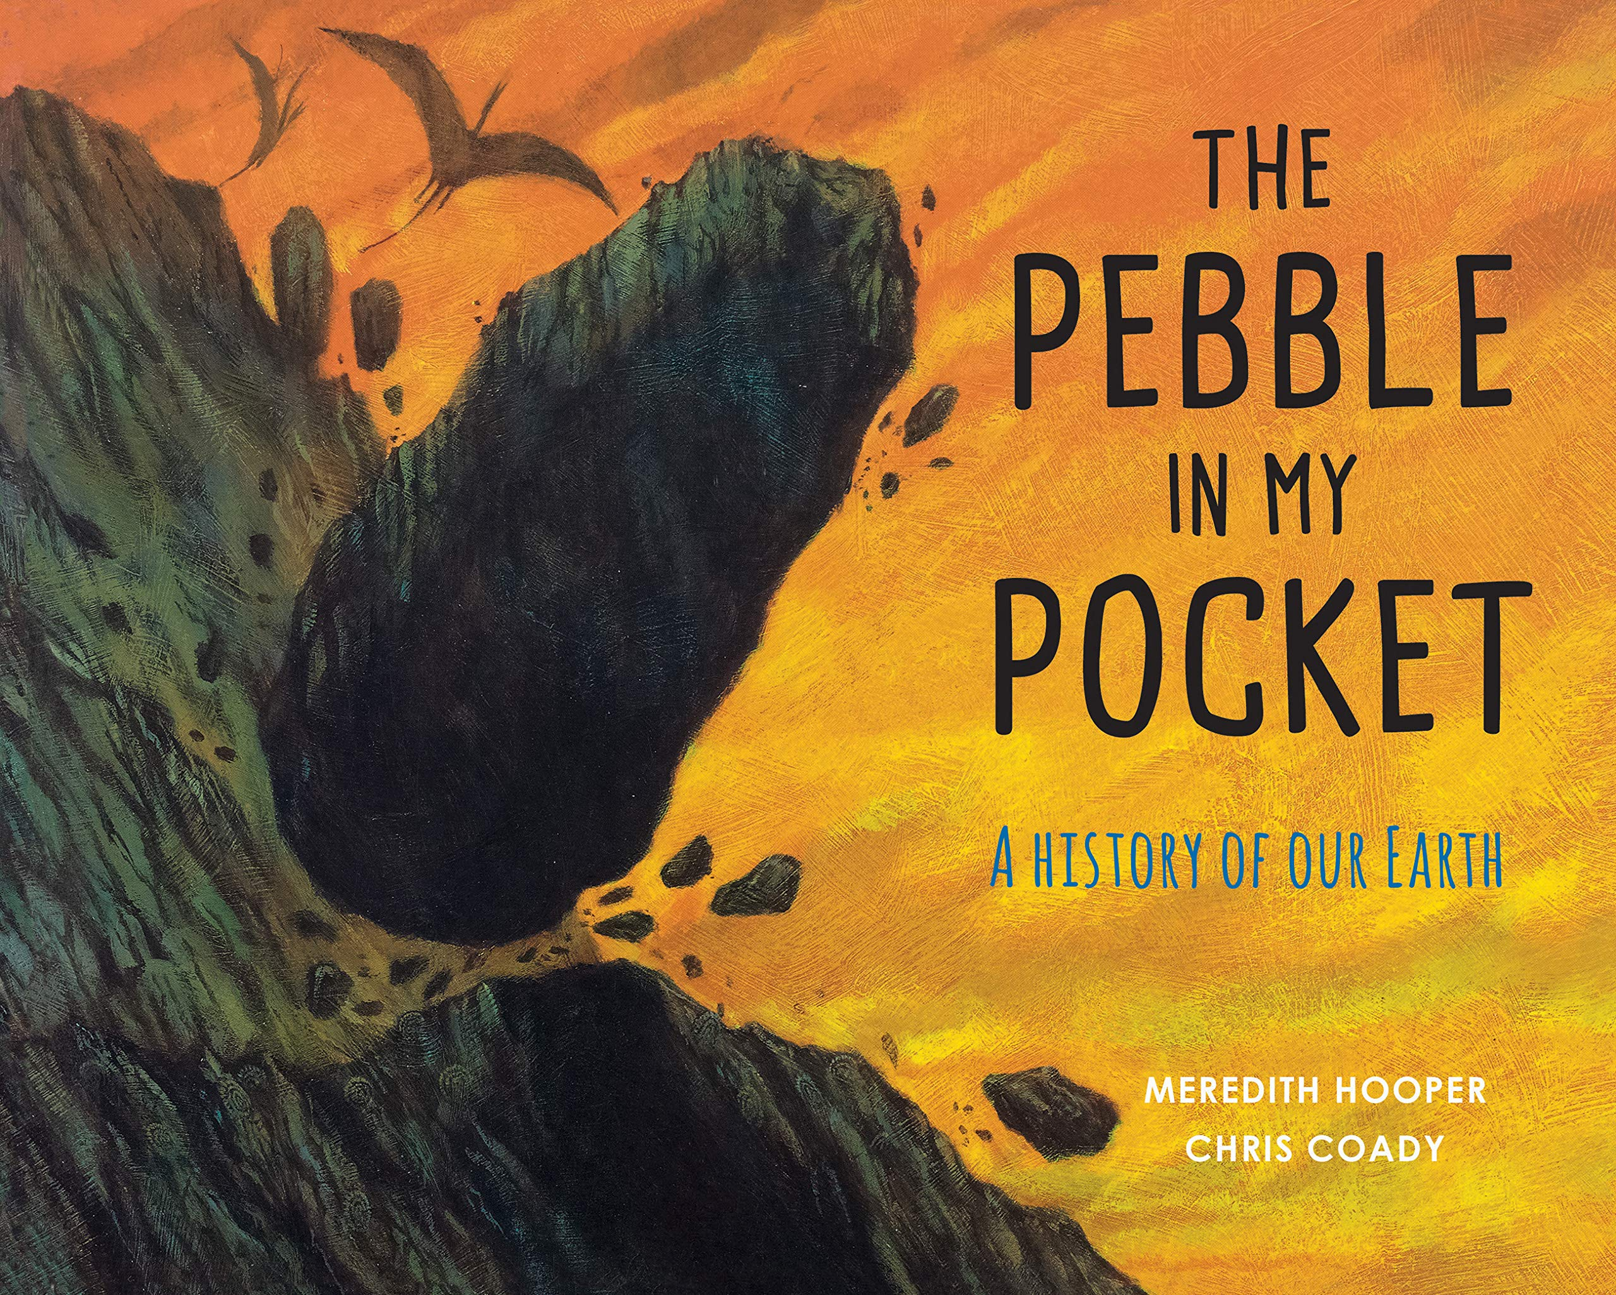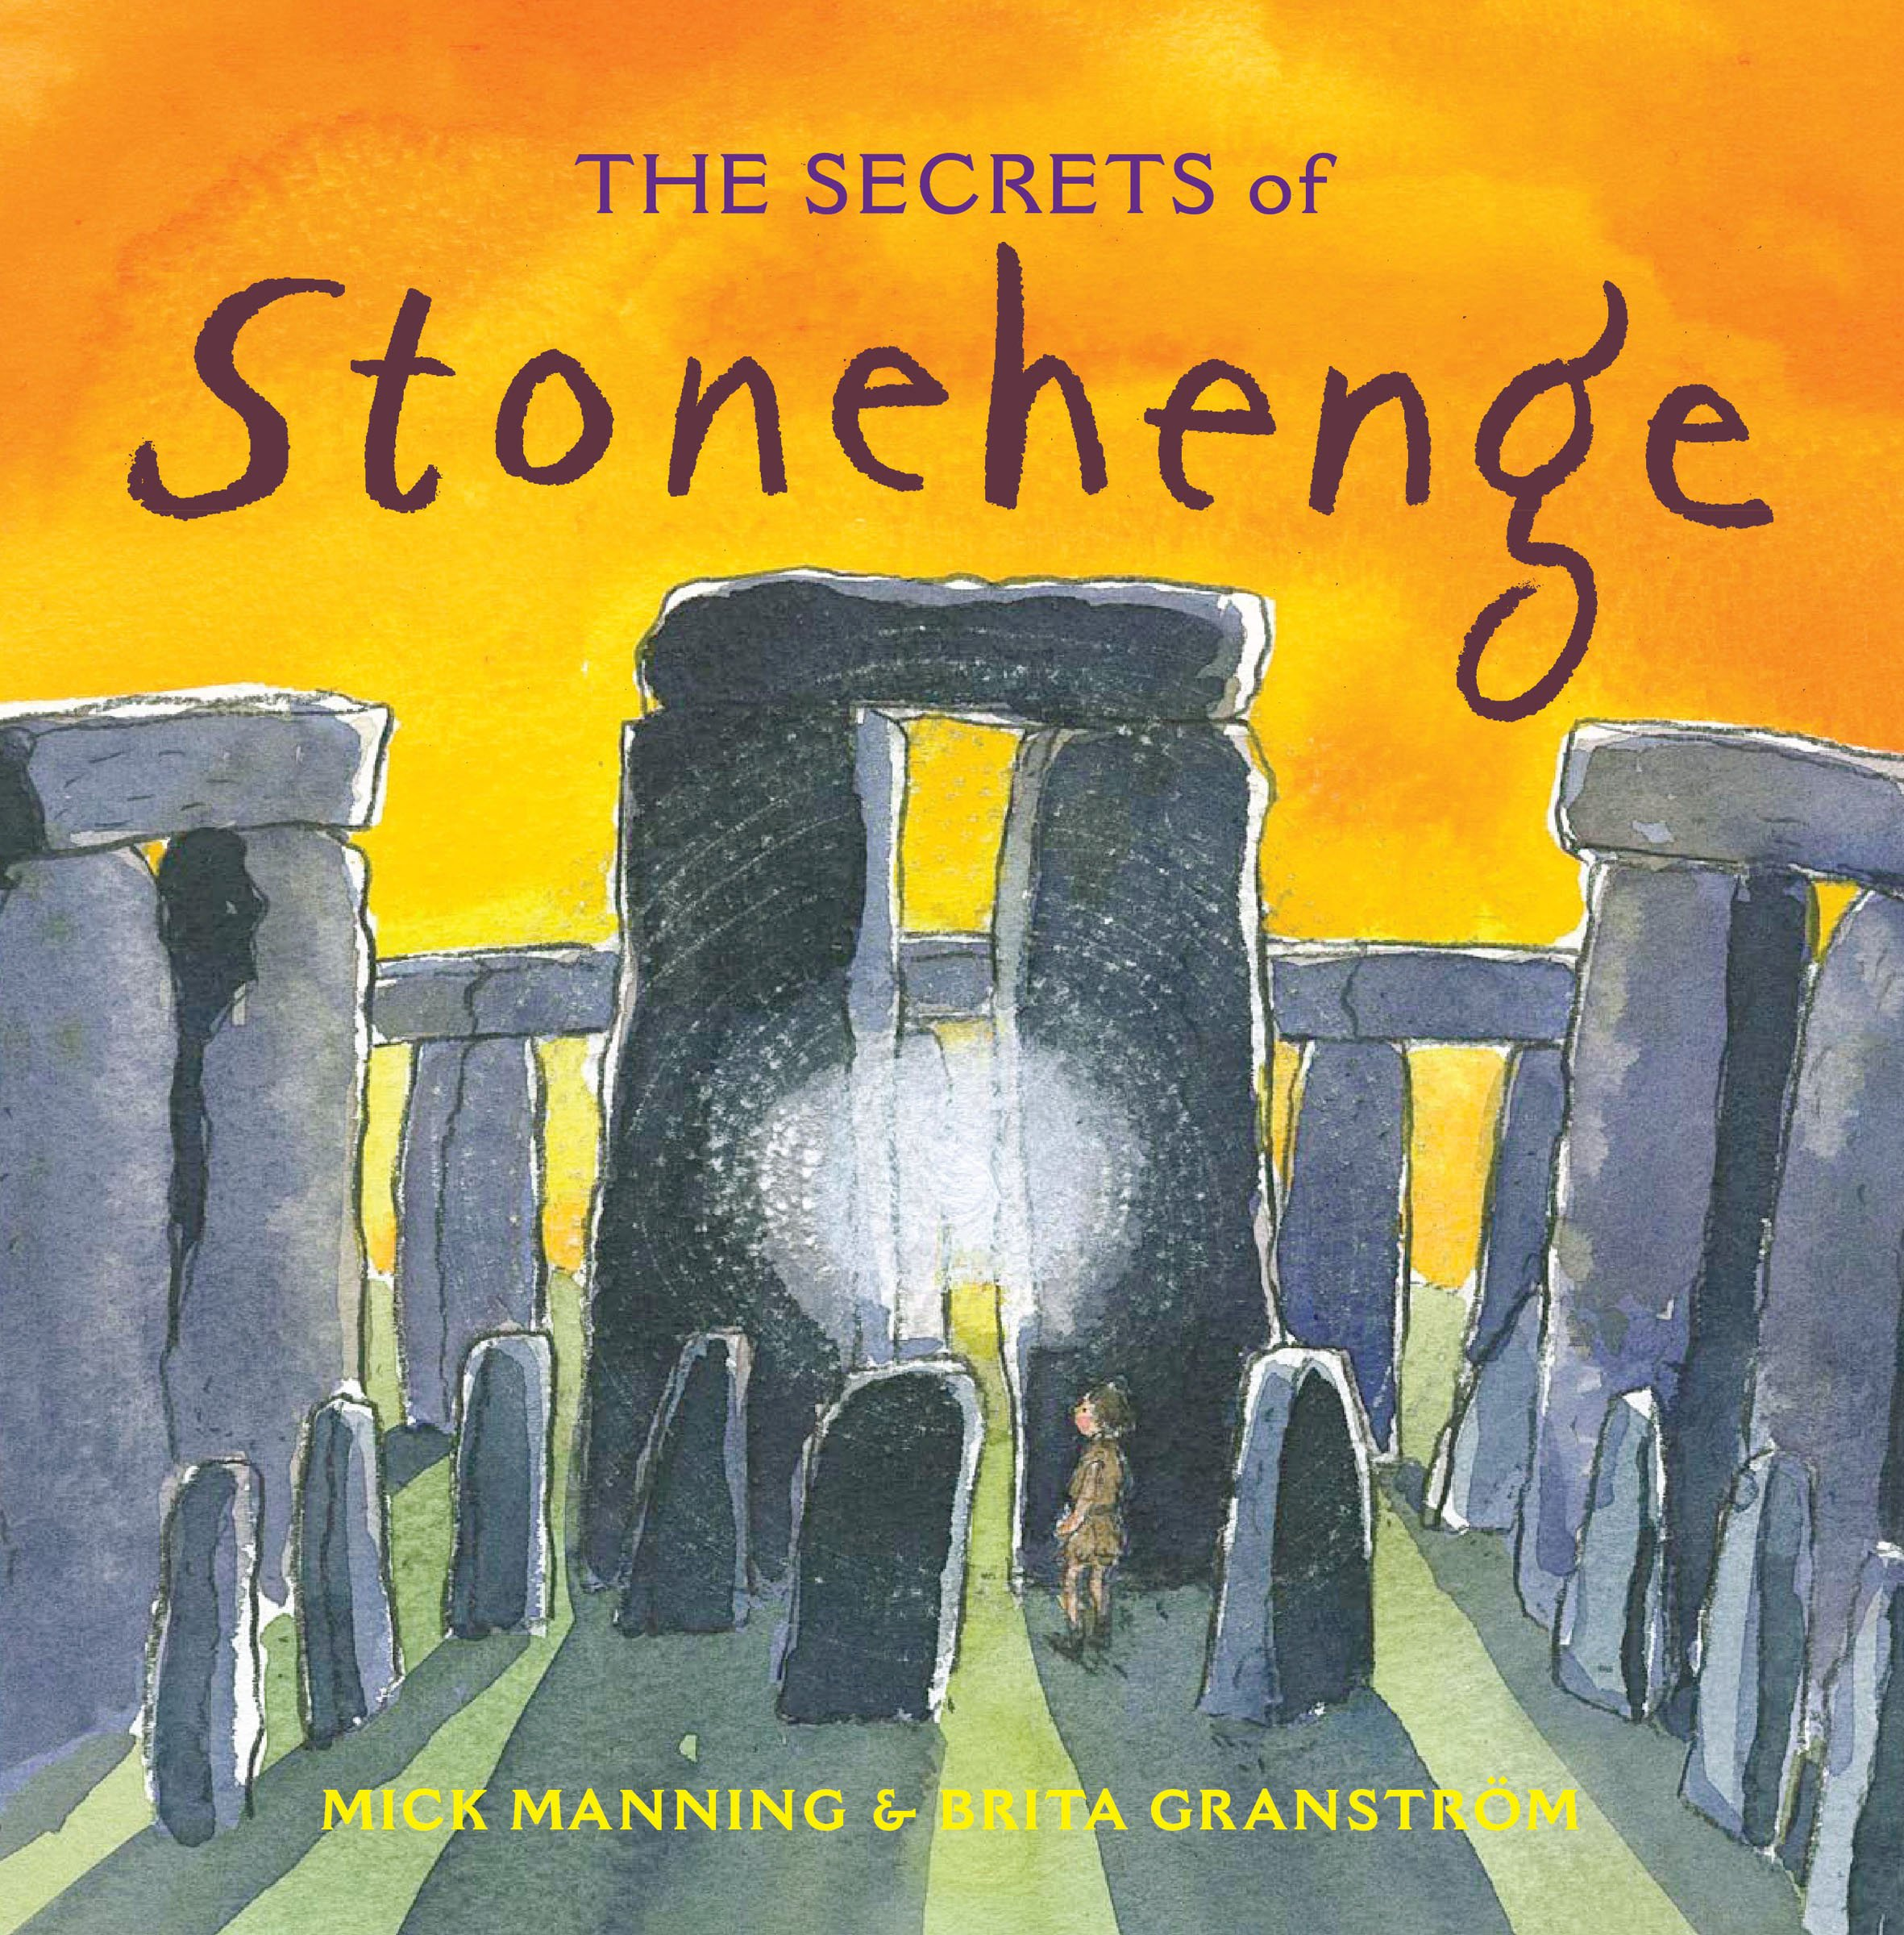 |  |  |  |  |  | As Scientists we will continue to be learning about rocks, fossils and soil. We will also be developing our investigation skills, learning how to conduct a fair test, make predictions and record findings in different ways.
Making Roots
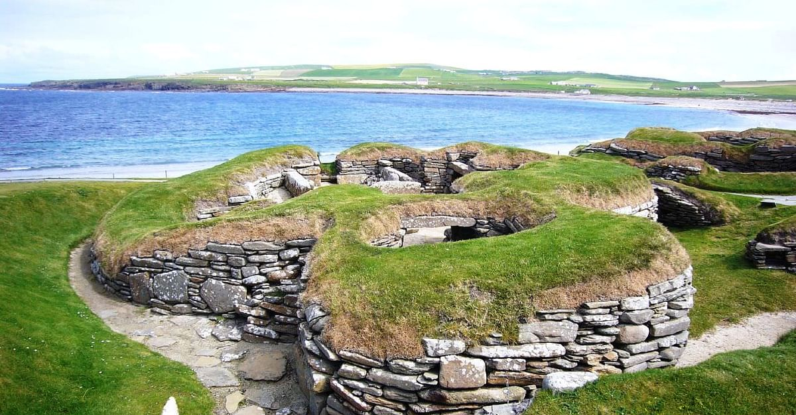
As Musicians we will develop an understanding of a wide range of music and create our own compositions using instruments in groups.

In Computing we will learn about online safety and how to use spreadsheets.
 | As Designers we will be focusing on mechanisms. Investigating links and levers before making our own 3D pop up cards. |  |  |  |  |  | In RE we will be focusing on Christianity and what people believe about the creation of our world. We will also be linking this to Stonehenge and its religious importance.  In PSHCE we will be thinking about our relationships with our friends and family. We will also be focussing on anti-bullying during the week of 15th November.  In PE we will be developing gymnastics routines in the hall and learning golf skills during our outdoor PE sessions.
As Historians we will be finding out about the houses and homes built during the Stone Age, Bronze Age and Iron Age. We will also focus on Skara Brae and Stonehenge and what these tell us about life in the past.

As Geographers we will be using maps and atlases to locate settlements and develop a good understanding of how maps work.

Supporting Learning at Home  - Maths: Key Instant Recall Facts (KIRFS) will be sent home to learn each half term.  - Mathletics: www.mathletics.co.uk  - Spelling: Children will be provided with a personalised spelling activity to complete at home. This will be sent on a Friday and should be returned the following Thursday.  - Bug Club: www.activelearnprimary.co.uk  - Reading  Ideally read daily with your child, ideally between 10-15 minutes. Please make a comment and sign the reading record. |  |  |  | Library Books  Our Library session, when library books can be changed, is Tuesday.  Contact  For any queries or enquiries, please contact the school office and your email will be forwarded on to your child’s class teacher.  office@pendragon.cambs.sch.uk |  |  |  | PE Lessons  Please ensure that your child comes in to school wearing their PE kit, ready for PE on the PE days below.  PE is on Wednesdays and Fridays.  If your child has long hair, please ensure they have a hair band, as long hair must be tied back for PE. It is expected that all children can remove watches/earrings for PE. If your child is unable to remove their own stud earrings these should be removed at home on PE days or micropore tape provided so they can cover them.  Thank you for your support with this.  The Haven and wellies  Each class will have a weekly time slot to use the Haven. Wellies should be brought into and kept in school so that this space can be used throughout the year. Pumas will be using the Haven on Fridays.

