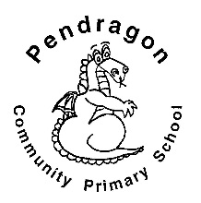 | Pendragon Community Primary School  Lynx Class- Miss Trotter | 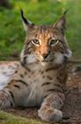

 | National Curriculum
 | As Mathematicians, we will be continuing subtraction, learning to solve problems, doubling and halving number to 20 and investigating odd and even numbers. |  | What makes our world wonderful? | As Writers we will be writing character descriptions, retelling traditional tales, creating our own characters and writing our own traditional tales. Based on our other learning we will plan and write texts of our own choice in Pendragon Writers Club.
 | In Design and Technology we will be designing and making our own gingerbread man puppets. We will also be focusing joining materials with cotton. |  |  | As Readers we will read, listen to and discuss a variety of traditional tales. We will think about characters thoughts and feelings and the use of story language.
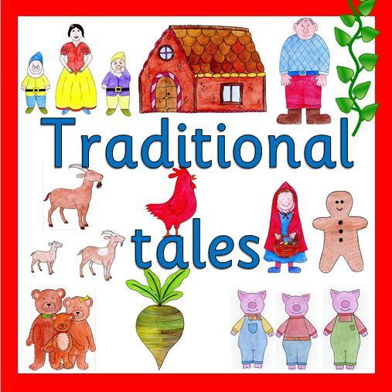
Year 1- Spring 1

What British Traditions make our lives wonderful?
 | In PSHCE we will be learning about ‘Me and My Emotions/Good to be Me’. We will also be learning how to support our well-being and ourselves. |  |  | 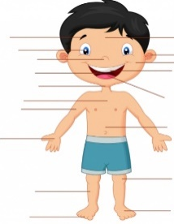  As Scientists we will be identifying, naming, drawing and labelling the basic parts of the human body. We will also learn which part of the body is associated with each sense.
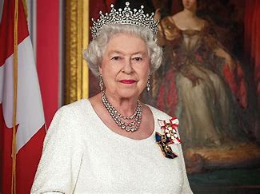
In History we will learn about past and present Kings and Queens. We will find out about The Prime Minister and how he is in charge of our government.
 | As Musicians we will be exploring instruments and symbols |  | In Computing we will be learning about animation and creating Story Books with the Purple Mash Program – 2Create A Story | In RE we will be comparing similarities and differences when Jesus was a boy and today’s children. We will also be discussing where Jesus lived and the type of house he lived in.
 |  |  |  | In PE we will be learning about ball skills and Traditional Folk Dancing.
Pendragon Community Primary School

Lynx Class- Miss Trotter

National Curriculum
 | Supporting Learning at Home  Mathletics:www.mathletics.co.uk  Maths: Key Instant Recall Facts (KIRFs) will be sent home to learn each half term.  Reading:  Children will choose a book on a Friday from our Year 1 sharing library – snuggle up and enjoy together over the weekend.  School reading scheme book – on a Monday your child will bring a book home to read with you. This book should be discussed and read at least three times throughout the week, it will be handed in every Friday. Ideally read daily for at least 10-15mins. Children should bring their reading record and book to school each day. Please make a comment and sign the reading record.  Once your child is reading Yellow Set 3 and above they will change their book on a Monday and a Wednesday. It is still important for your child to read their book more than once in order to build fluency.  BugClub: To be enjoyed all week long. www.activelearnprimary.co.uk  Word wallet – your child will bring home a wallet that contains common high frequency words, some of which will be ‘tricky’ words. All words in the wallet must be learnt by sight (not sounding out). | Contact  For any queries or enquiries, please contact your child’s teacher using the email below:  Miss Trotter  ktrotter@pendragon.cambs.sch.uk  Please note that teachers will check their email up to 8.30am every morning, if you have an urgent message; please contact the office instead via phone or email, so that they can pass the message on to the class teacher.  Entry and exit procedures.  When dropping off, please say goodbye to your child at the small gate. On collection, once the main gate has been unlocked, you will need to wait on the main playground infront of Year 1 class rooms. Please find a space so you are socially distanced from others and avoid queuing. You will then exit via the main gates on the playground. | PE Lessons  Please ensure that your child comes in to school in their named PE kit, ready for PE on the PE days below.  Monday afternoon (indoor) and Thursday afternoon (outdoor)  If your child has long hair, please ensure it is tied back with a hair band, as long hair must be tied back for PE. It is expected that all children can remove watches/earrings for PE. If your child is unable to remove their own stud earrings these should be removed at home on PE days or micropore tape provided so they can cover them.  Thank you for your support with this.  The Haven and wellies  Each class will have a weekly time slot to use the Haven. Wellies should be brought into and kept in school so that this space can be used throughout the year. Lynx class is Tuesday afternoon.  Personal belongings in school  Your child should only come into school each day with their packed lunch, water bottle and reading book. All other resources that the children require for their learning will be provided by school.

