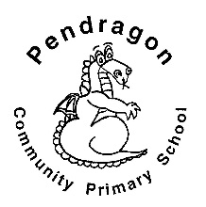 | Pendragon Community Primary School  Lynx Class – Miss Trotter

National Curriculum
As Readers we will read, listen to and discuss a variety of fiction and non-fiction texts about the UK. We will think about the differences between them and what we can learn from them. |  | As Writers we will be learning about different non-fiction formats and creating a visitor’s guide to the United Kingdom. Based on our other learning we will plan and write texts of our own choice in Pendragon Writers Club. | As Mathematicians we will be continuing learning number facts to 20 and doubling and halving. We will also be exploring the 2 operations; addition and subtraction, and looking at different ways of solving problems.
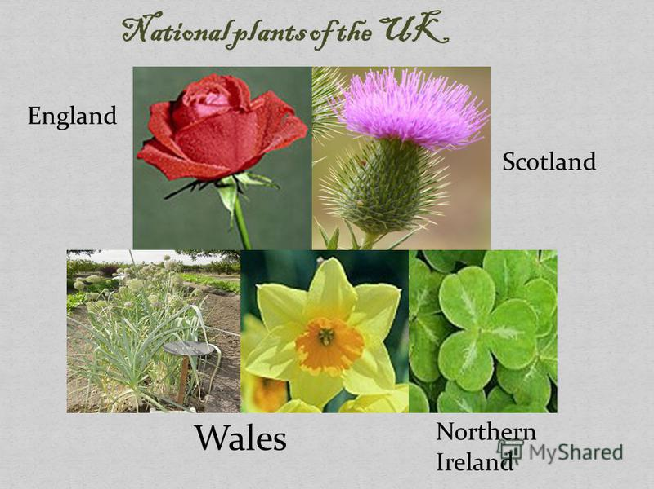 | In Art and Design we will be observing the UK’s national flowers and developing our collage, sketching, pastel and painting skills. | Year 1  We are the United Kingdom | As Scientists we will be learning about the four seasons and looking at the weather associated with each season. |  | 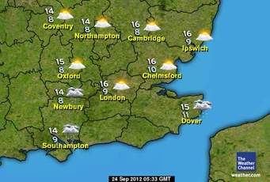
As Musicians we will be exploring timbre, tempo and dynamics. |  |  | In RE we will be learning about the 4 Patron Saints of the United Kingdom.
In PSHCE we will be learning about our emotions and what makes us special and unique as individuals.  In PE we will be learning about running, throwing and catching, and creating our own sequences in yoga. |  | In Computing we will learn how to use the program 2Count to design pictograms and develop coding skills.  In History we will learn about the Royal family and changes in living memory. | In Geography we will be learning about the four countries that make up the United Kingdom and each capital city. | 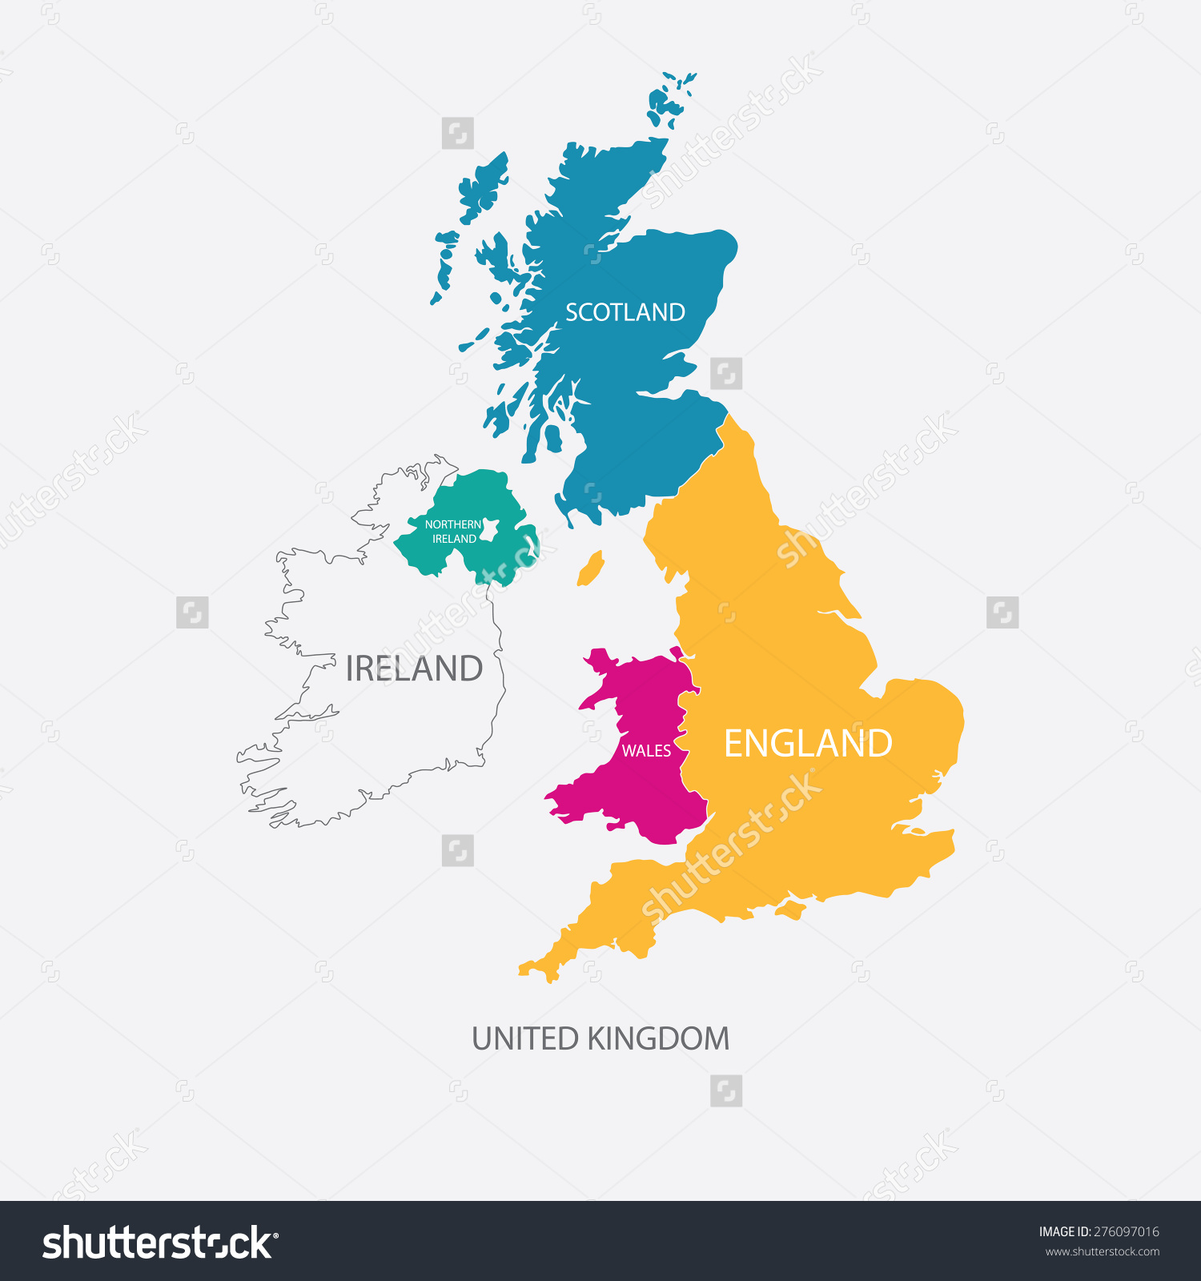

Supporting Learning at Home  - Mathletics:www.mathletics.co.uk  - Maths: Key Instant Recall Facts (KIRFs) will be sent home to learn each half term.  - Reading:  Choose a book once a week from our Year 1 sharing library – snuggle up and enjoy together over the weekend!  School reading scheme book – on a Monday your child will bring a book home to read with you. This book should be discussed and read more than once throughout the week, it will be handed in every Friday. This will begin Monday 13th September. Ideally read daily for at least 10-15mins. Children should bring their reading record book to school each day. Please make a comment and sign the reading record.  Once your child is reading Yellow Set 3 and above they will change their book on a Monday and a Wednesday. It is still important for your child to read their book more than once in order to build fluency.  Bug Club to be enjoyed all week long.  www.activelearnprimary.co.uk  Word wallet – your child will bring home a wallet that contains common high frequency words, some of which will be ‘tricky’ words. All words in the wallet must be learnt by sight (not sounding out). | Contact  For any queries or enquiries, please contact your child’s teacher using the email below:  Miss Trotter  ktrotter@pendragon.cambs.sch.uk  Please note that teachers will check their email up to 8.30am every morning, if you have an urgent message, please contact the office instead via phone or email, so that they can pass the message on to the class teacher.  Entry and exit procedures.  When dropping off, please say goodbye to your child at the small gate. On collection, once the main gate has been unlocked, you will need to wait on the main playground infront of Year 1 class rooms. Please find a space so you are socially distanced from others and avoid queuing. You will then exit via the main gates on the playground. | PE Lessons  Please ensure that your child comes in to school in their named PE kit, ready for PE on the PE days below.  Indoor PE Thursday afternoon and outdoor PE Friday afternoon  If your child has long hair, please ensure it is tied back with a hair band, as long hair must be tied back for PE. It is expected that all children can remove watches/earrings for PE. If your child is unable to remove their own stud earrings these should be removed at home on PE days or micropore tape provided so they can cover them.  Thank you for your support with this.  The Haven and wellies  Each class will have a weekly time slot to use the Haven. Wellies should be brought into and kept in school so that this space can be used throughout the year. Lynx Class will use the Haven on a Thursday.  Personal belongings in school  Your child should only come into school each day with their packed lunch, water bottle and reading book. All other resources that the children require for their learning will be provided by school.

