Pendragon Community Primary School

Leopards Class – Miss Crow
 | National Curriculum
 | As Readers we will be reading ‘Rosie Revere, Engineer’ and ‘Charlie and the Chocolate Factory’ focusing on characters, settings and how an interesting pace is created. We will read non-fiction texts linked to learning in other subjects and will ask and answer questions based on our reading. |  |  |  | As Mathematicians we will be able to understand the number system and place value including larger numbers and make connections between addition, subtraction, multiplication and division. We will use fluent written methods to solve increasingly difficult problems. |  | As Writers we will learn about limericks, write reports and explore fiction texts linked to our theme. Based on learning in other subjects, we will plan and write texts of our own choice in Pendragon Writers' Club.
 | 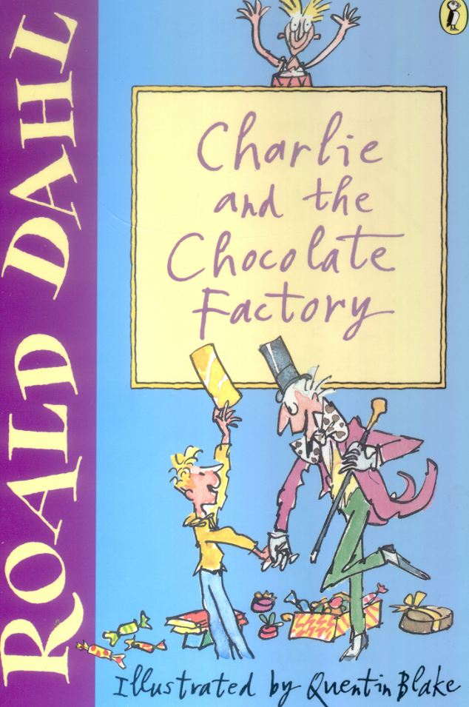 |  |  |  |  |  | As Scientists we will be finding out about inventors and inventions, focusing on light and forces.
Year 3
Eureka!

In DT we will invent our own sweets based on Charlie and the Chocolate factory. We will also be focusing on inventions using mechanical systems.

In Computing we will learn about e-safety (staying safe online), develop our understanding of technology and digital literacy using a range of programmes, including Starz.
 | As Artists we will be looking at Van Gogh’s Starry Night; explore light and shadow with tonal drawings; use colour and collage to create stained glass windows and lanterns; and continue to develop our basic art skills.  In French we will be learning about the location of France. As well as this we will be learning count to 10 and introduce ourselves to a friend. |  |  |  |  |  | In RE we will be investigating religion, beliefs and our backgrounds in our class.  In PSHCE we will think new beginnings, friendships and the school motto REAcH.  In PE we will develop our dance skills d uring a ‘Machines’ unit. We will also be focusing on ball handling skills and using these in team games.
 | As Musicians we will develop an understanding of a wide range of music and create our own compositions using instruments in groups.
 | Curriculum Drivers
 | Enquiry and Risk Taking |  | Emotional Awareness |  |  | Ambition |  |  | Community and Diversity
 | As people with enquiring minds we will: |  | As emotionally aware people we will: |  |  | As people with ambition we will: |  |  | As members of a diverse community we will:
 | - Know that we can succeed and begin to know what we need to do to achieve goals (next steps).  - Take responsibility for our own learning and work hard.  - Try new things, express our doubts and fears and learn from our mistakes.  - Find out how others have challenged themselves to achieve their ambitions. |  | - Consider the feelings of characters in different texts.  - Think about our own emotions and feelings as we begin a new school year.  - Discuss different ways we can stay safe, including when using the Internet. |  |  | - Know that we can succeed and know what we need to do to achieve goals (next steps).  - Take responsibility for our own learning and work hard.  - Try new things, express our doubts and fears and learn from our mistakes.  - Find out how others have challenged themselves to achieve their ambitions. |  |  | - Use questions as the starting point for our learning e.g. what is religion? How have inventions changed our lives?  - Find out about the similarities and differences between people within our community.
 | Use of our environment and the acquisition of knowledge of the world
Supporting Learning at Home  - Maths  Work will be provided to practise what has been learned in class as an activity on Mathletics:www.mathletics.co.uk  Key Instant Recall Facts (KIRFs) will be sent home to learn each half term.  - Spelling.  Children will be provided with a spelling activity to complete at home. This will be sent on Friday and should be returned on the following Thursday.  - Reading  Ideally read daily with your child. Please make a comment and sign the reading record. Children can also read a range of books on Bug club: www.activelearnprimary.co.uk |  |  |  | Library Books  Our Library session, when library books can be changed, is Friday. Please remember it is also open at lunch times.  Support in class  We are always happy to have helpers in class, if you are interested, please contact your child’s class teacher by email or after school. Or if you cannot commit on a regular basis, remember you can offer ‘one-off’ support too!  Contact  Please feel free to come and talk to me about any concerns you may have. You can catch me for quick question before and after school, or make an appointment by contacting the office or e-mailing directly.  Miss Crow  gcrowel@pendragon.sch.uk |  |  |  | PE Lessons  Please ensure that PE kits are in all week, as the days may change to accommodate the weather.  Indoor PE is on Friday and outdoor PE is on Tuesday. All uniform and kit must be named or it is difficult to reunite it with your child if it gets muddled up!  If your child has long hair, please ensure they have a hair band, as long hair must be tied back for PE. It is expected that all children can remove watches/earrings for PE. If your child is unable to remove their own stud earrings these should be removed at home on PE days or micropore tape provided so they can cover them.  Thank you for your support with this.

