 | 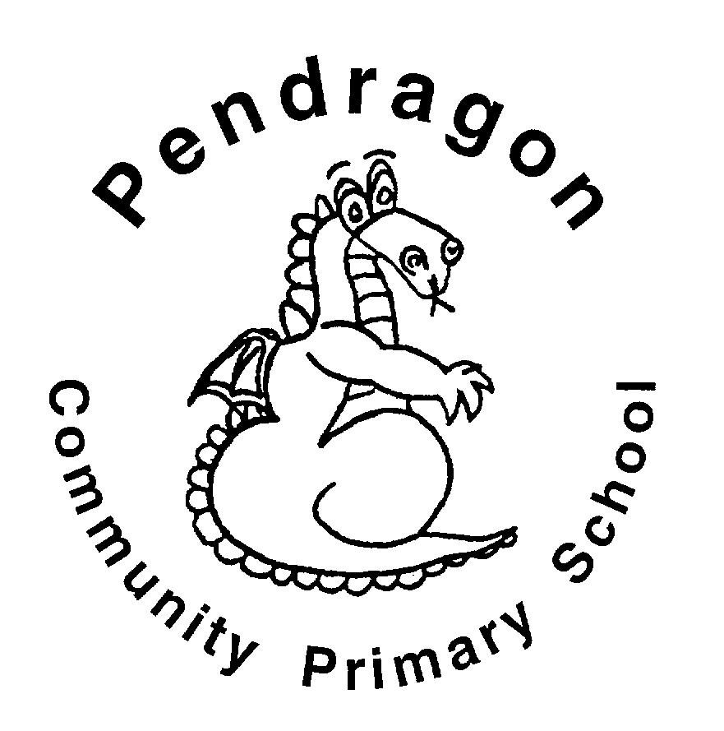 | Pendragon Community Primary School  Pumas Class – Miss Cracknell |  |  |  |  |  |  |  | 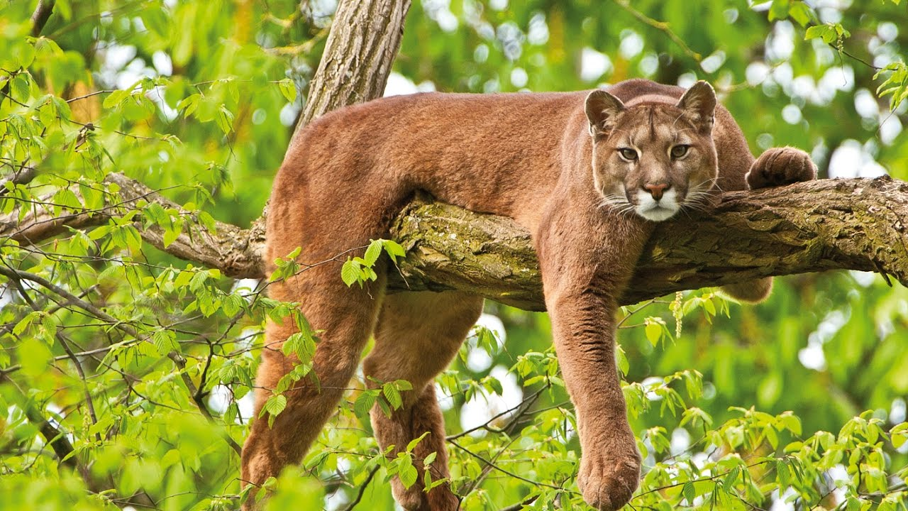
 | National Curriculum
 | As Readers we will be reading ‘Farm Boy’ and ‘Granny Marmalade and Uncle Tractor’. We will read non-fiction texts linked to learning in other subjects and will ask and answer questions based on our reading to develop our reading comprehension. |  |  |  | As Mathematicians we will be developing our multiplication and division knowledge learning with a focus on long multiplication and division. We will then be learning about time; telling the time and looking at durations of time.  We will also be learning and practising times tables to 12, with a particular focus on 3, 4 and 8.  What makes our planet so amazing? |  | As Writers we will focusing on performing and writing our own poems linked to food. Based on learning in other subjects, we will plan and write texts of our own choice in Pendragon Writers' Club.
 | 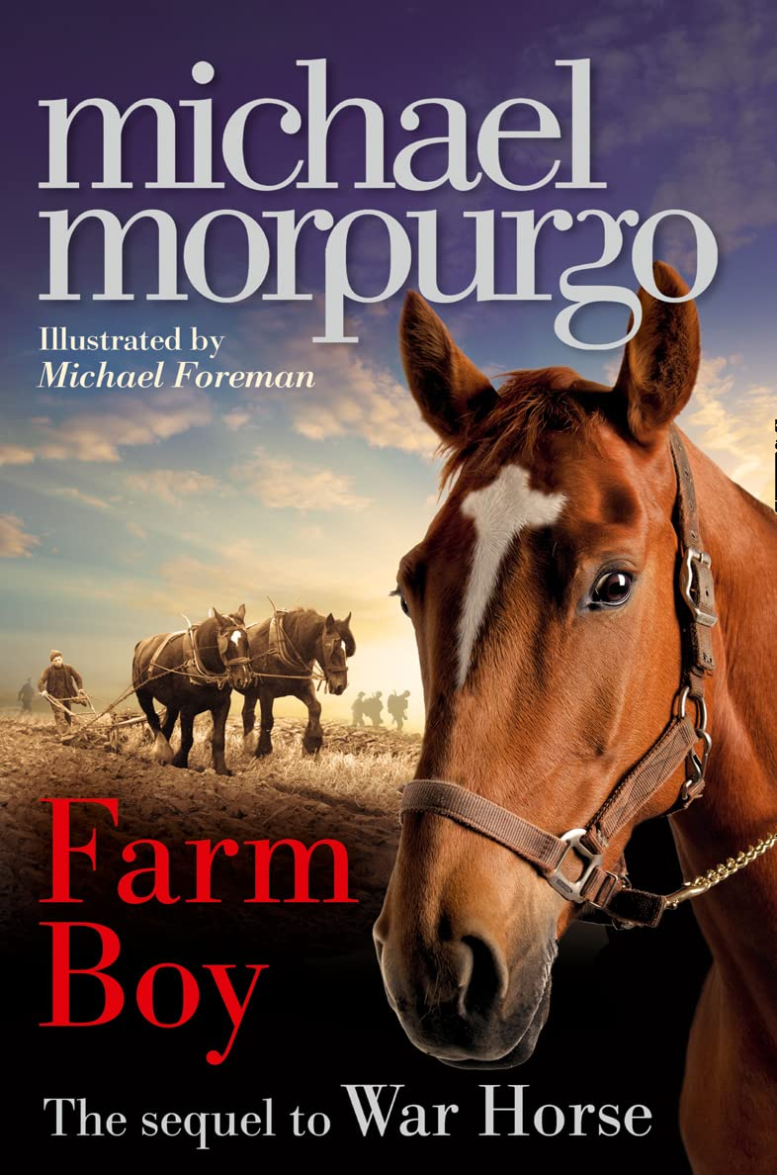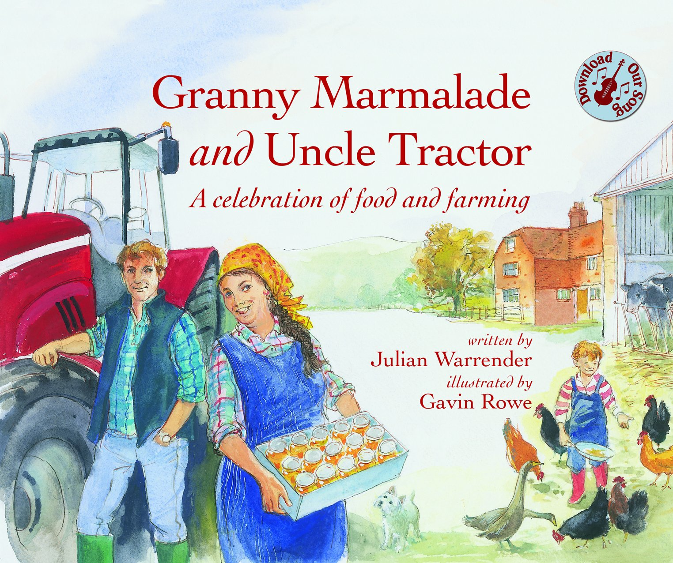 |  |  |  |  |  | As Scientists we will be learning all about plants. We will find out what they need to grow, be growing our own fruit and vegetables and carry out experiments to investigate how water moves through a plant and the best way to grow a healthy plant.
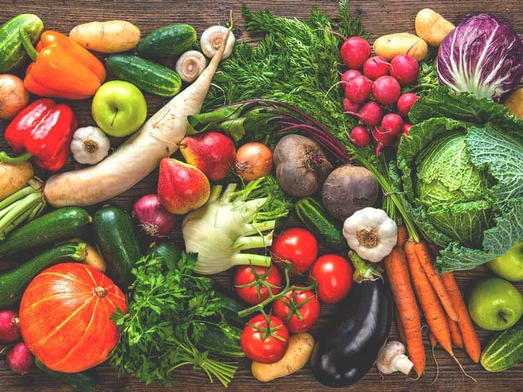
Grow It, Pick It Eat It

How does our food get from field to fork?

In French we will continue to practice our pronunciation and conversation skills. We will also learn the names of different fruit, vegetables and food.

In Computing we will learn about creating and exploring different simulations.
 | As Artists we will be practising and developing our drawing skills. With a focus on observational drawing we will be looking carefully at plants and flowers, exploring shading and colour mixing. |  |  |  |  |  | In RE we will be looking at the way in which different religions aim to make a difference to the world in which we live in.  In PSHCE we will be learning about risk, exploring what the word risk means, when it is safe to take risks and how we manage risk taking.  In PE we will be practising and applying skills we have learnt this year in Multi-skills activities. We will also be developing our team work and communication skills during orienteering.
In DT we will be exploring healthy foods with a focus on sandwiches and wraps. We will explore different fillings, learn and practice skills to prepare food before designing and making our own healthy wrap.

As Geographers we will be using maps to locate where different food comes from, we will be carrying out field work and developing our geographical knowledge.

Supporting Learning at Home  - Maths: Key Instant Recall Facts (KIRFS) will be sent home to learn each half term.  - Mathletics: www.mathletics.co.uk  - Spelling: Children will be provided with a personalised spelling activity to complete at home. This will be sent on a Friday and should be returned the following Thursday.  - Bug Club: www.activelearnprimary.co.uk  - Reading  Ideally read daily with your child, ideally between 10-15 minutes. Please make a comment and sign the reading record. |  |  |  | Library Books  Our Library session, when library books can be changed, is Tuesday.  Contact  For any queries or enquiries, please contact your child’s class teacher using the email below:  Miss Cracknell  ecracknell@pendragon.cambs.sch.uk |  |  |  | PE Lessons  Please ensure that your child comes in to school wearing their PE kit, ready for PE on the PE days below.  PE is on Wednesdays and Fridays.  If your child has long hair, please ensure they have a hair band, as long hair must be tied back for PE. It is expected that all children can remove watches/earrings for PE. If your child is unable to remove their own stud earrings these should be removed at home on PE days or micropore tape provided so they can cover them.  Thank you for your support with this.  The Haven and wellies  Each class will have a weekly time slot to use the Haven. Wellies should be brought into and kept in school so that this space can be used throughout the year. Pumas will be using the Haven on Fridays.

