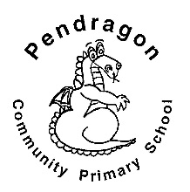 | Pendragon Community Primary School  Sand Cats Class – Mrs Smart

National Curriculum
As Mathematicians we will learn about 2D and 3D shapes and their properties. We will make patterns and sequences and use mathematical vocabulary to describe position, direction and movement. | What makes our planet so amazing? | As Writers we will write letters following patterns in those we have read and also write reports and recounts about learning in other subjects.  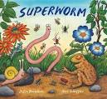  As Readers we will read, listen  to and discuss stories, poetry  and non-fiction books, giving  our thoughts and opinions.
As Artists we will explore nature in art and experiment and develop skills in sketching and printing through the work of artists and designers, such as William Morris.  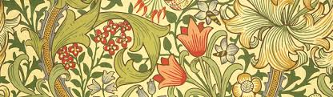 | In RE we will learn about Sihkism. | 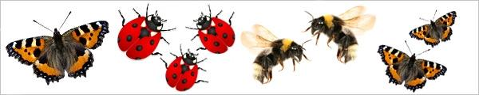
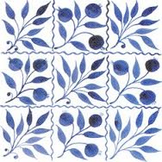

Year 2 – Summer 1

Wild and Wonderful
 |  | As Scientists we will develop our understanding of scientific enquiry by asking and answering our own questions. We will find out what seeds and bulbs need to grow and stay healthy by planting our own seeds and observing them grow. We will explore different local habitats and the living things that live there. We will visit Wicken Fen.
In PSHCE we will learn about managing different kinds of risk such as road safety, sun safety and safety in the home. | In Computing we will be learning a variety of presentation skills such as creating folders, printing files, adding images and formatting text and textboxes. | As Musicians we will we will listen to Yellow Bird and Beethoven Symphony No 5, explore tempo, style, pitch, dynamics, rests and rhythm. We will be introduced to making music digitally using 2Sequence (Purple Mash).
In PE we will be learning about points of contact in gymnastics. In games we will be learning to strike a ball with a bat, racket and golf club.

Pendragon Community Primary School

Sand Cats Class – Mrs Smart

Supporting Learning at Home  - Weekly phonics/spelling (usually given out on Mondays).  - Maths: www.mathletics.co.uk - Tasks set by teacher to be completed by deadline. Number facts (KIRFs) to be sent home each half-term.  - Reading book or Bug Club – ideally every day – it makes a real difference. Please make a comment and sign the reading record – and remind your child to change their book when they need to.  - Bug Club: School code – qkc7  www.activelearnprimary.co.uk  Read a book online and take the quiz – It really helps the development of comprehension skills.  - Library Books - our Library session, when library books can be changed, is Friday.  - Extended learning – if your child would like to extend their learning by carrying out their own research, writing, drawing or visiting a place of interest linked to their class topic, we welcome them to share their learning/work with the class. | Support in Class  Please feel free to contact me about any concerns you may have.  Mrs C Smart  csmart@pendragon.cambs.sch.uk | PE Lessons  These take place on Tuesdays and Wednesdays.  A reminder that for indoor P.E. your child needs :  - Shorts  - T-shirt  For outdoor PE they need  - jogging bottoms  - jumper/jacket  - trainers  If your child has long hair, please ensure they have a hair band, as long hair must be tied back for PE.  It is expected that all children can remove watches/earrings for PE. If your child is unable to remove their own stud earrings these should  be removed at home on PE days or micropore  tape provided from home so they can cover them.  Thank you for your support with this.

