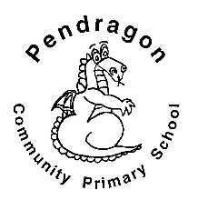 | Pendragon Community Primary School  Autumn Term  Panthers Class – Miss Safranek
National Curriculum
As Readers we will read a variety of texts linked to our topic Rainforest Rescue. We will focus on the picture book ‘The Great Kapok Tree’ by Lynne Cherry to understand issues surrounding deforestation. We will read and recognise features of persuasive letters and we will read poetry, identifying similes and metaphors. |  | As Mathematicians we will work on our multiplication and division facts, linking to counting in multiples and times tables. We will focus on measurement, including problem solving, conversion of units and comparing, estimating and calculating. | As Writers we will be looking at examples of different persuasive writing features before gathering information and creating our own ideas to use in a letter. They will be writing to try to persuade the logger to stop cutting down the rainforest.
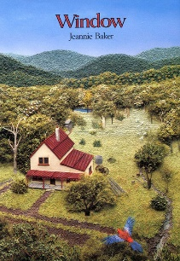  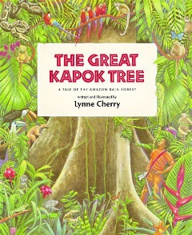 |  |  | As Scientists we will be learning about living things and their habitats. We will learn about the 7 characteristics of a living thing, classification keys and animals found in our local and wider environment.
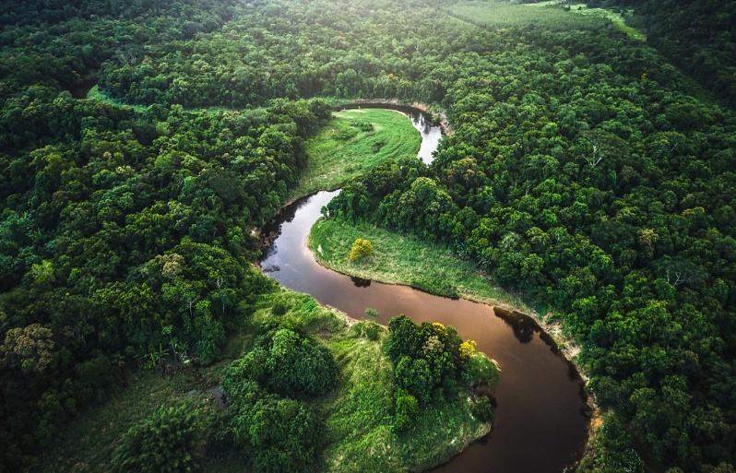

In Computing we will be using Purple Mash software to learn about online safety. It will include how children can be aware of phishing, scams and fake websites. This topic can allow children to feel safe and aware whilst browsing on the internet. We will also allow children to understand what a healthy amount of screen time should be.

As Artists we will study the artist Henri Rousseau’s paintings focusing on the rainforest theme. We will look at the colours used, light and shade, size of plants and flowers, foreground and background. Then the children will be able to design and create their own Rousseau pictures. |  |  | In RE we will be looking all year at what a saint is and we will look at the life stories of the patron saints of Great Britain, to try to understand why they have a special day.  As Musicians we will be learning through the online music scheme ‘Charanga’. We are focusing on a variety of different pieces, including ‘5 Gold Rings’ and some festive pieces towards the end of the term. Our songs will involve Makaton singing, listening, appraising, as well as performing.  In PE we will develop our balance skills in Gymnastics. Our outdoor PE will focus on competitive games, applying principles suitable for attacking and defending.  As Linguists we will be learning the French alphabet, numbers to 31, days and months of the year. We will also be learning vocabulary linked to the seasons, birthdays and Christmas.
In PSHCE we will be exploring the topics of friendship and bullying.
.

As Geographers the children will be exploring the Amazon Rainforest and the importance of this wonder to us as individuals. The children will be looking at layers of the rainforest, climate, deforestation and assessing what the Amazon Rainforest could do about the different challenges that it is facing.

Supporting Learning at Home  - Mathletics:www.mathletics.co.uk – set on Fridays and due the following Thursday.  - Maths: Key Instant Recall Facts (KIRFs) will be sent home to learn each half term.  - Times Tables A target for the end of Year 4 is for children to know their multiplication tables up to 12 × 12. It is important for children to practise their tables regularly. Early notice, all Year 4 children will complete a statutory multiplication times table check in early June 2021.  - Spelling Children will be provided with a spelling activity to complete at home. This will be sent home on Fridays and should be returned on the following Thursday.  - Reading book Ideally read daily for at least 10-15mins. Children should bring their reading record book to school each day.  - Bugclub: www.activelearnprimary.co.uk  School code: qkc7 | Contact  For any queries or enquiries, please contact your child’s teacher using the email below:  Miss Safranek  lsafranek@pendragon.cambs.sch.uk  Please note that teachers will check their email up to 8.30am every morning, if you have an urgent message, please contact the office instead via phone or email, so that they can pass the message on to the class teacher. | PE Lessons  Please ensure that your child comes in to school in their PE kit, ready for PE on the PE days below.  PE is on Tuesdays and Thursdays.  If your child has long hair, please ensure they have a hair band, as long hair must be tied back for PE. It is expected that all children can remove watches/earrings for PE. If your child is unable to remove their own stud earrings these should be removed at home on PE days or micropore tape provided so they can cover them.  Thank you for your support with this.  The Haven and wellies  Each class will have a weekly time slot to use the Haven. Wellies should be brought into and kept in school so that this space can be used throughout the year.  Personal belongings in school  Your child should only come into school each day with their packed lunch, water bottle and reading book. All other resources that the children require for their learning will be provided by school.

