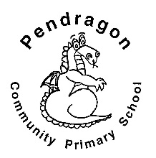 | Pendragon Community Primary School  Lynx Class- Miss Trotter | 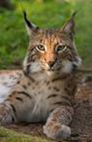

National Curriculum
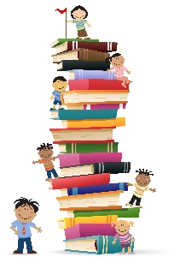  As Readers we will read non-fiction texts linked to learning in other subjects and will ask and answer questions based on our reading. We will read, listen to and discuss contemporary fiction linked to our topic. | As Writers we will be exploring and writing fact files about pets and their needs.  Based on our other learning we will plan and write texts of our own choice in Pendragon Writers Club. | As Mathematicians we will be learning about number, money and measures. We will also be exploring the 4 operations; addition, subtraction, multiplication and division.
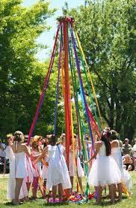  In outdoor PE we will be learning about multiskills games. In indoor PE we are learning how to May pole dance. | What makes our planet so amazing?  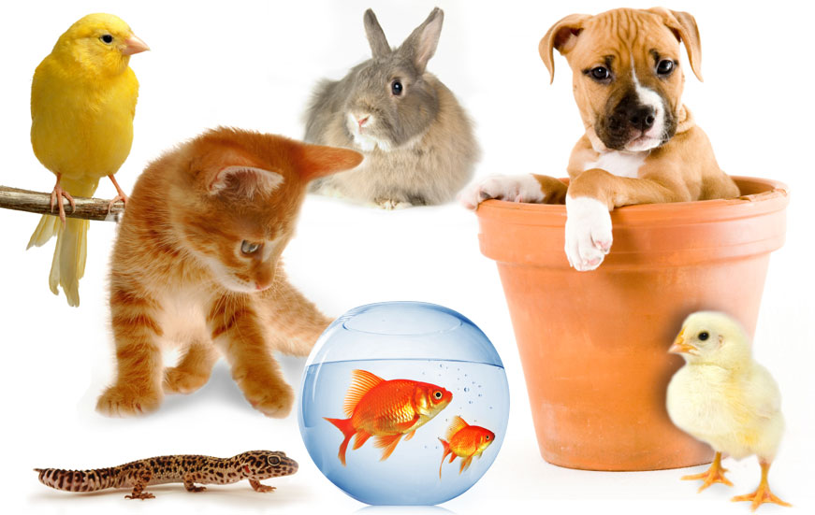  Pets at Home Which animals are a man’s best friend? | As Scientists we will be identifying and naming a variety of common animals, learning about what they need to be happy and healthy and comparing them to humans.
As Musicians we will be exploring sounds and duration, using the song ‘Round and round’. |  | In PSHCE we will be learning about managing risk and staying safe.
In RE we will be learning Parables: Stories Jesus told and what his stories taught. | In Computing we will learn how to interpret and create spreadsheets using a simple program called 2calculate.  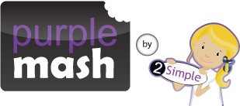 |  | As Artists we will be using modelling clay to sculpt different pets. We will also be creating natural art animals in the Haven and linking these to our topic work.

Supporting Learning at Home  Mathletics:www.mathletics.co.uk  Weekly homework will be set on Fridays and to be completed by the following Tuesday.  Maths: Key Instant Recall Facts (KIRFs) will be sent home to learn each half term.  Reading:  Children will choose a book on a Friday from our Year 1 sharing library – snuggle up and enjoy together over the weekend.  School reading scheme book – on a Monday your child will bring a book home to read with you. This book should be discussed and read at least three times throughout the week, it will be handed in every Friday. Ideally read daily for at least 10-15mins. Children should bring their reading record and book to school each day. Please make a comment and sign the reading record.  Once your child is reading Yellow Set 3 and above they will change their book on a Monday and a Wednesday. It is still important for your child to read their book more than once in order to build fluency.  BugClub: To be enjoyed all week long. www.activelearnprimary.co.uk  Word wallet – your child will bring home a wallet that contains common high frequency words, some of which will be ‘tricky’ words. All words in the wallet must be learnt by sight (not sounding out). | Contact  For any queries or enquiries, please contact your child’s teacher using the email below:  Miss Trotter  ktrotter@pendragon.cambs.sch.uk  Please note that teachers will check their email up to 8.30am every morning, if you have an urgent message; please contact the office instead via phone or email, so that they can pass the message on to the class teacher.  Entry and exit procedures.  When dropping off, please say goodbye to your child at the small gate. On collection, once the main gate has been unlocked, you will need to wait on the main playground infront of Year 1 class rooms. Please find a space so you are socially distanced from others and avoid queuing. You will then exit via the main gates on the playground. | PE Lessons  Please ensure that your child comes in to school in their named PE kit, ready for PE on the PE days below.  Monday afternoon (indoor) and Thursday afternoon (outdoor)  If your child has long hair, please ensure it is tied back with a hair band, as long hair must be tied back for PE. It is expected that all children can remove watches/earrings for PE. If your child is unable to remove their own stud earrings these should be removed at home on PE days or micropore tape provided so they can cover them.  Thank you for your support with this.  The Haven and wellies  Each class will have a weekly time slot to use the Haven. Wellies should be brought into and kept in school so that this space can be used throughout the year.  Personal belongings in school  Your child should only come into school each day with their packed lunch, water bottle and reading book. All other resources that the children require for their learning will be provided by school.

