 | Pendragon Community Primary School  Spring Term  Leopards and Panthers Class – Miss White and Miss Safranek |  |  | 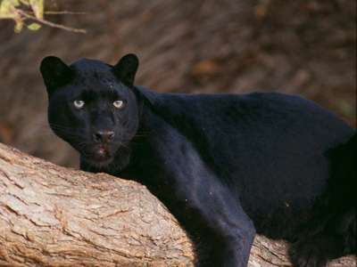
National Curriculum
As Mathematicians, we will work on properties of shapes, symmetry, decimals, money and problem solving involving decimals to two decimal places. We will also be looking at adding and subtracting fractions with the same denominator. Finding fractions of quantities and fractions in the context of measure.

As Readers, we will read a variety of explanation texts with a focus on the water cycle. We will read and recognise features of explanation texts to allow us to create an effective explanation text for someone detailing how the water cycle works. |  | What makes our lives wonderful?  Why are rivers an important part of  human life?  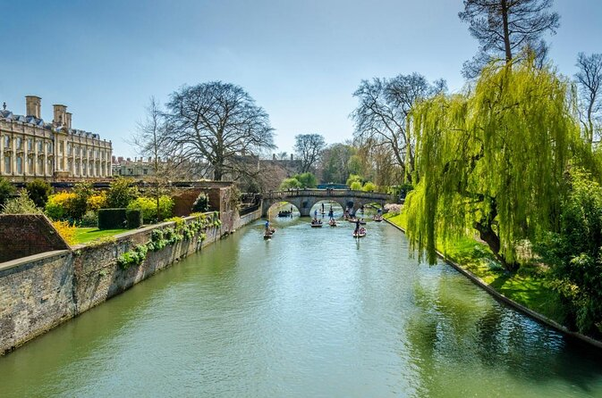 | As Writers, we will be looking at examples of different features of explanation texts and using these to support our writing. We will also be writing a recount of our trip to Burwell House. These recounts will give others a great insight into our experiences on the trip.  As Scientists, we will be learning about the Water cycle involving the scientific processes of evaporation and condensation to support our understanding for our explanation texts. We will also be finding out about hydro-electricity and its importance for producing electricity for our planet.
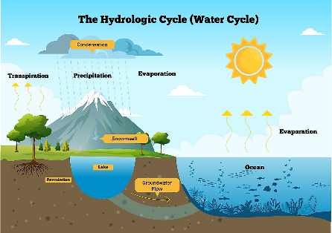  In RE we will be looking at the Church and learning about Easter. We will be finding out if Easter is a festival of new beginnings or sacrifice.  As Artists, we will design and create our own river scene in the style of Claude Monet after undertaking an artist study. |  |  | As Linguists, we will be learning the different shapes and prepositions. They will be using the prepositions to describe the positions of shapes and objects.
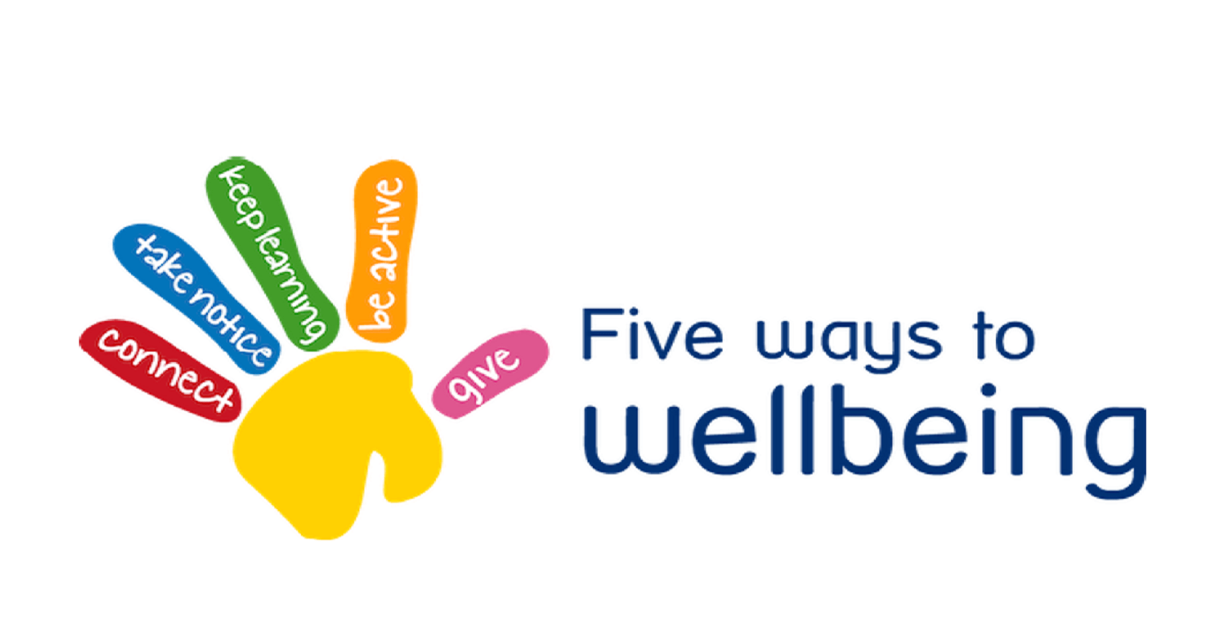  In PSHCE, we will focus on the NHS 5 ways to wellbeing, focusing on different strategies we can use to improve our wellbeing.  In Computing, we will be using Purple Mash software to learn about spreadsheets. It will include how to enter data into spreadsheets accurately. This topic will help us to understand how to use the number formatting tools within 2Calculate to appropriately format numbers.  As Geographers, we will locate different rivers globally and locally. We will explore the importance of rivers and the different uses of water and the importance of water conservation, linking to our previous topic on the Amazon Rainforest. |  |  | As Musicians, we will be learning through the online music scheme ‘Charanga’. All learning will focus around one song, ‘Stop!’ Which links to the theme of bullying. We build on our previous knowledge and learn about the interrelated dimensions of music through games, singing and composing.  In PE, we will be creating and performing our own version of a rugby ‘Haka’. Our outdoor PE will focus on OAA (outdoor adventurous activities), where we will take part in a range of activities. We will be problem solving, following instructions, taking part in team challenges and orienteering.
Supporting Learning at Home  - Mathletics:www.mathletics.co.uk – set on Fridays and due the following Thursday.  - Maths: Key Instant Recall Facts (KIRFs) will be sent home to learn each half term.  - Times Tables A target for the end of Year 4 is for children to know their multiplication tables up to 12 × 12. It is important for children to practise their tables regularly. Early notice, all Year 4 children will complete a statutory multiplication times table check in early June 2021.  - Spelling Children will be provided with a spelling activity to complete at home. This will be sent home on Fridays and should be returned on the following Thursday.  - Reading book Ideally read daily for at least 10-15mins. Children should bring their reading record book to school each day.  - Bugclub: www.activelearnprimary.co.uk  School code: qkc7 | Contact  For any queries or enquiries, please contact your child’s teacher using the email below:  Miss White  swhite@pendragon.cambs.sch.uk  Miss Safranek  lsafranek@pendragon.cambs.sch.uk  Please note that teachers will check their email up to 8.30am every morning, if you have an urgent message, please contact the office instead via phone or email, so that they can pass the message on to the class teacher.  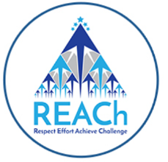 | PE Lessons  Please ensure that your child comes in to school in their PE kit, ready for PE on the PE days below.  PE in Leopards is on Thursdays and Fridays.  PE in Panthers is on Tuesdays and Thursdays.  If your child has long hair, please ensure they have a hair band, as long hair must be tied back for PE. It is expected that all children can remove watches/earrings for PE. If your child is unable to remove their own stud earrings these should be removed at home on PE days or micropore tape provided so they can cover them.  Thank you for your support with this.  The Haven and wellies  Each class will have a weekly time slot to use the Haven. Wellies should be brought into and kept in school so that this space can be used throughout the year.  Personal belongings in school  Your child should only come into school each day with their packed lunch, water bottle and reading book. All other resources that the children require for their learning will be provided by school.

