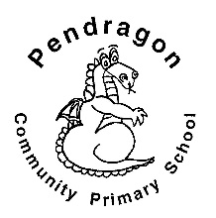 | Pendragon Community Primary School  Bobcats Class – Miss Westlake and Mrs Bardell

National Curriculum
As Mathematicians we will continue to consolidate all number skills and particularly focus on multiplication (including 2x, 5x and 10x tables), division and fractions. |  | 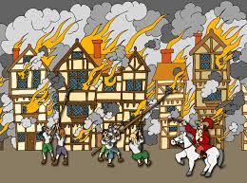  As Designers we will design, construct and evaluate houses based on those destroyed in The Great Fire of London. | As Writers we will explore vocabulary and try out new words. We will write poems following patterns in those we have read and write diaries linked to our learning in History. Based on our other learning we will plan and write texts of our own choice in Pendragon Writers Club.
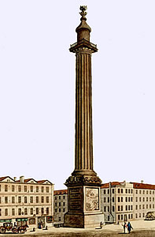 | As Artists we will explore a range of sketching, painting and collage techniques linked to the theme of fire.  As Historians we will find out about a key event from the past; The Great Fire of London of 1666. We will think about how it would have felt to be in danger, how the fire affected people’s lives and the impact it had on London. |  | As Readers we will read poems to develop our vocabulary; read, listen to and discuss stories and non-fiction books, giving our thoughts and opinions. | 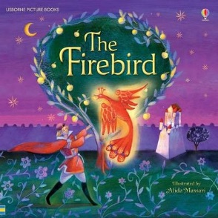

Year 2 – Spring 2

Fire & Ice
 |  |  | As Scientists we will investigate the suitability of different materials for particular uses. We will link this to our history topic by exploring how materials are changed by melting and burning.
As Musicians we will explore pitch by listening to music and through singing. |  | In Computing we will learn about what algorithms are; how they are implemented as programs on digital devices; and that programs execute by following precise and unambiguous instructions. | In RE we will learn about the Christian festival of Easter.
In PE we will develop our movement skills in dance, focussing on action words and in games will develop our skills of running, throwing, catching and dribbling. |  |  | In PSHCE we will learn about Personal Safety; possible dangers and how to keep ourselves safe.

 | Curriculum Drivers
 | Ambition | Community and Diversity | Emotional Awareness | Enquiry and Risk Taking
 | As people with ambition we will: | As members of a diverse community we will: | As emotionally aware people we will: | As people with enquiring minds we will:
 | - Take responsibility for our own learning and work hard.  - Think about whether we have a fixed or growth mind-set.  - Understand our strengths and know what our next steps are.  - Challenge ourselves to try new things, express our doubts and fears and learn from our mistakes. | - Find out more about different families with different religions, traditions and lifestyles.  - Find out more about how we live our lives and learn from each other’s experiences. | - Explore feelings of fear, nervousness and excitement.  - Consider how working together in pairs and groups makes us feel and how we can respond to this.  - Think and talk about the feelings of others and how it would have felt to lose your home and all of your possessions in the Great Fire of London. | - Use questions as the starting point for our learning.  - Ask and answer our own questions about the world e.g.  - What was it like in London in 1666?  - How would it feel to have been there when London was on fire?  - Why did people behave the way they did?
Use of our environment and the acquisition of knowledge of the world

Supporting Learning at Home  - Weekly phonics/spelling to be sent home at the beginning of each week and returned after the weekend.  - Maths: www.mathletics.co.uk - Tasks set by teacher to be completed by deadline. Number facts (KIRFs) to be sent home each half-term.  - Reading book or Bug Club – at least 3 times a week but ideally every day – it makes a real difference. Please make a comment and sign the reading record – and remind your child to change their book when they need to.  - Bug Club: School code – qkc7  www.activelearnprimary.co.uk  Read a book online and take the quiz – It really helps the development of comprehension skills.  - Library Books - our Library session, when library books can be changed, is Tuesday.  - Extended learning – if your child would like to extend their learning by carrying out their own research, writing, drawing or visiting a place of interest linked to their class topic, we welcome them to share their work/learning with the class. | Support in Class  We really need some more help to hear children read. If you can help, please let us know and we can arrange a convenient time.  If you cannot commit on a regular basis please do feel you can offer ‘one-off’ support too.  Please feel free to come and talk to me about any concerns you may have. You can catch me for quick questions before and after school, or make an appointment by contacting the office or e-mailing directly.  Miss H Westlake  Mrs A Bardell  hwestlake@pendragon.cambs.sch.uk  abardell@pendragon.cambs.sch.uk | PE Lessons  These take place on Tuesdays and Wednesdays.  A reminder that for indoor P.E. your child needs :  - Shorts  - T-shirt  For outdoor PE they need  - jogging bottoms  - jumper/jacket (not their school jumper)  - trainers (these MUST be different from the shoes they wear to school in case they get muddy during the PE lesson)  These need to be kept in school all week as we sometimes change days/times of sessions.  If your child has long hair, please ensure they have a hair band, as long hair must be tied back for PE.  It is expected that all children can remove watches/earrings for PE. If your child is unable to remove their own stud earrings these should be removed at home on PE days or micropore tape provided from home so they can cover them.  Thank you for your support with this.

