

**Pendragon Community Primary School Calculation Policy**

**Stages in counting**

All children go through these stages in counting. Generally, they should be secure with them by the end of Year FS.

1. Stable order (knowing numbers come in an order)
2. One to one correspondence (touching and counting)
3. Cardinal (knowing last number is the total)
4. Order irrelevance (doesn’t matter how you count, the total will be the same)
5. Abstraction (being able to count without seeing/touching items)

By the end of Year FS children should be able to:

ELG: Number Children at the expected level of development will:

- Have a deep understanding of number to 10, including the composition of each number;

- Subitise (recognise quantities without counting) up to 5;

- Automatically recall (without reference to rhymes, counting or other aids) number bonds up to 5 (including subtraction facts) and some number bonds to 10, including double facts.

ELG: Numerical Patterns Children at the expected level of development will:

- Verbally count beyond 20, recognising the pattern of the counting system;

- Compare quantities up to 10 in different contexts, recognising when one quantity is greater than, less than or the same as the other quantity;

- Explore and represent patterns within numbers up to 10, including evens and odds, double facts and how quantities can be distributed equally

**Key mental calculation strategies**

It is important to spend time developing mental calculation strategies so that children have a bank of them to use when calculating. Often a calculation can be answered more efficiently using these and yet most children in KS2 will use a written method. Spend a week or maybe two developing these before working on written methods.

**Some of these are started in EYFS and Year 1 and developed in subsequent years. They include:**

From Year FS:

* Doubles FS up to double 5 extended up to 10 for more able and near doubles only for more able from FS

e.g. 6 + 6 = 12, 25 + 26 = double 25 add 1

* Some number pairs to 10 majority should know up to 7,

e.g. 3 + 7 = 10

Keep practising and developing the above. Additional strategies from Year 1:

* Partition and recombine one number to 20, e.g. 14 = 10 + 4
* Counting on to subtract numbers close together,

e.g. 26 – 17: + 3 + 6 = 9

* Think 5, 10, 15, 20 see below for examples
* Adding near multiples of ten and adjusting

e.g. 145+199 =145+200-1

* Sequencing to 100

e.g. 256+153 = 256 + 100 + 50 + 3 = 409

* Using patterns of similar calculations,

e.g. 136 + 45 = 181, 146 + 45 = 191, 156 + 45 = 201

* Using known number facts,

e.g. 6 x 7 = 42, 6 x 70 = 420, 6 x 35 = 210

* Bridging though ten, hundred, tenth,

e.g. 26 + 15 = 30 + 11 = 41, 125 + 76 = 130 + 71 = 201

* Use relationships between operations,

e.g. 4 x 5 = 20, 5 x 4 = 20, 20 ÷ 5 = 4, 20 ÷ 4 = 5

Keep practising and developing the above. Additional strategies from Year 3:

* Regrouping for division,

e.g. 132 ÷ 3: 120 ÷ 3 = 40 and 12 ÷ 3 =4

* x4 by doubling and doubling again,

e.g. 36 x 4 = 72 x 2 = 144

* x5 by x10 and halving or vice versa,

e.g. 346 x 5 = 3460 ÷ 2 or 173 x 10 = 1730

* x20 by x10 and doubling,

e.g. 427 x 20 = 4270 x 2 = 8540

* x15 by x 10, halve and ad,

e.g. 135 x 15: 1350 + 675 = 2025

* ÷4 by halving and halving,

e.g. 120 ÷ 4 = 60 ÷ 2 = 30

* ÷5 by dividing by 10 and doubling,

e.g. 375 ÷ 5 = 37.5 x 2 = 75

* ÷20 by dividing by 10 and halving,

e.g. 246 ÷ 20 = 24.6 ÷ 2 = 12.3

**Models and images for mental calculation strategies that children *may* find helpful.**

Bead strings +7

0 5 10 12



+2

+5

Partitioning for sequencing

48 + 33

30 3 = 78 + 3 = 81 48 + 30 + 3 = 78 +3 = 81

Think 10

7 + 6= 13

10 + 3 = 13

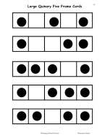Fives frames for numbers to 5

Tens frames for number pairs to 1, 10, 100, multiplication

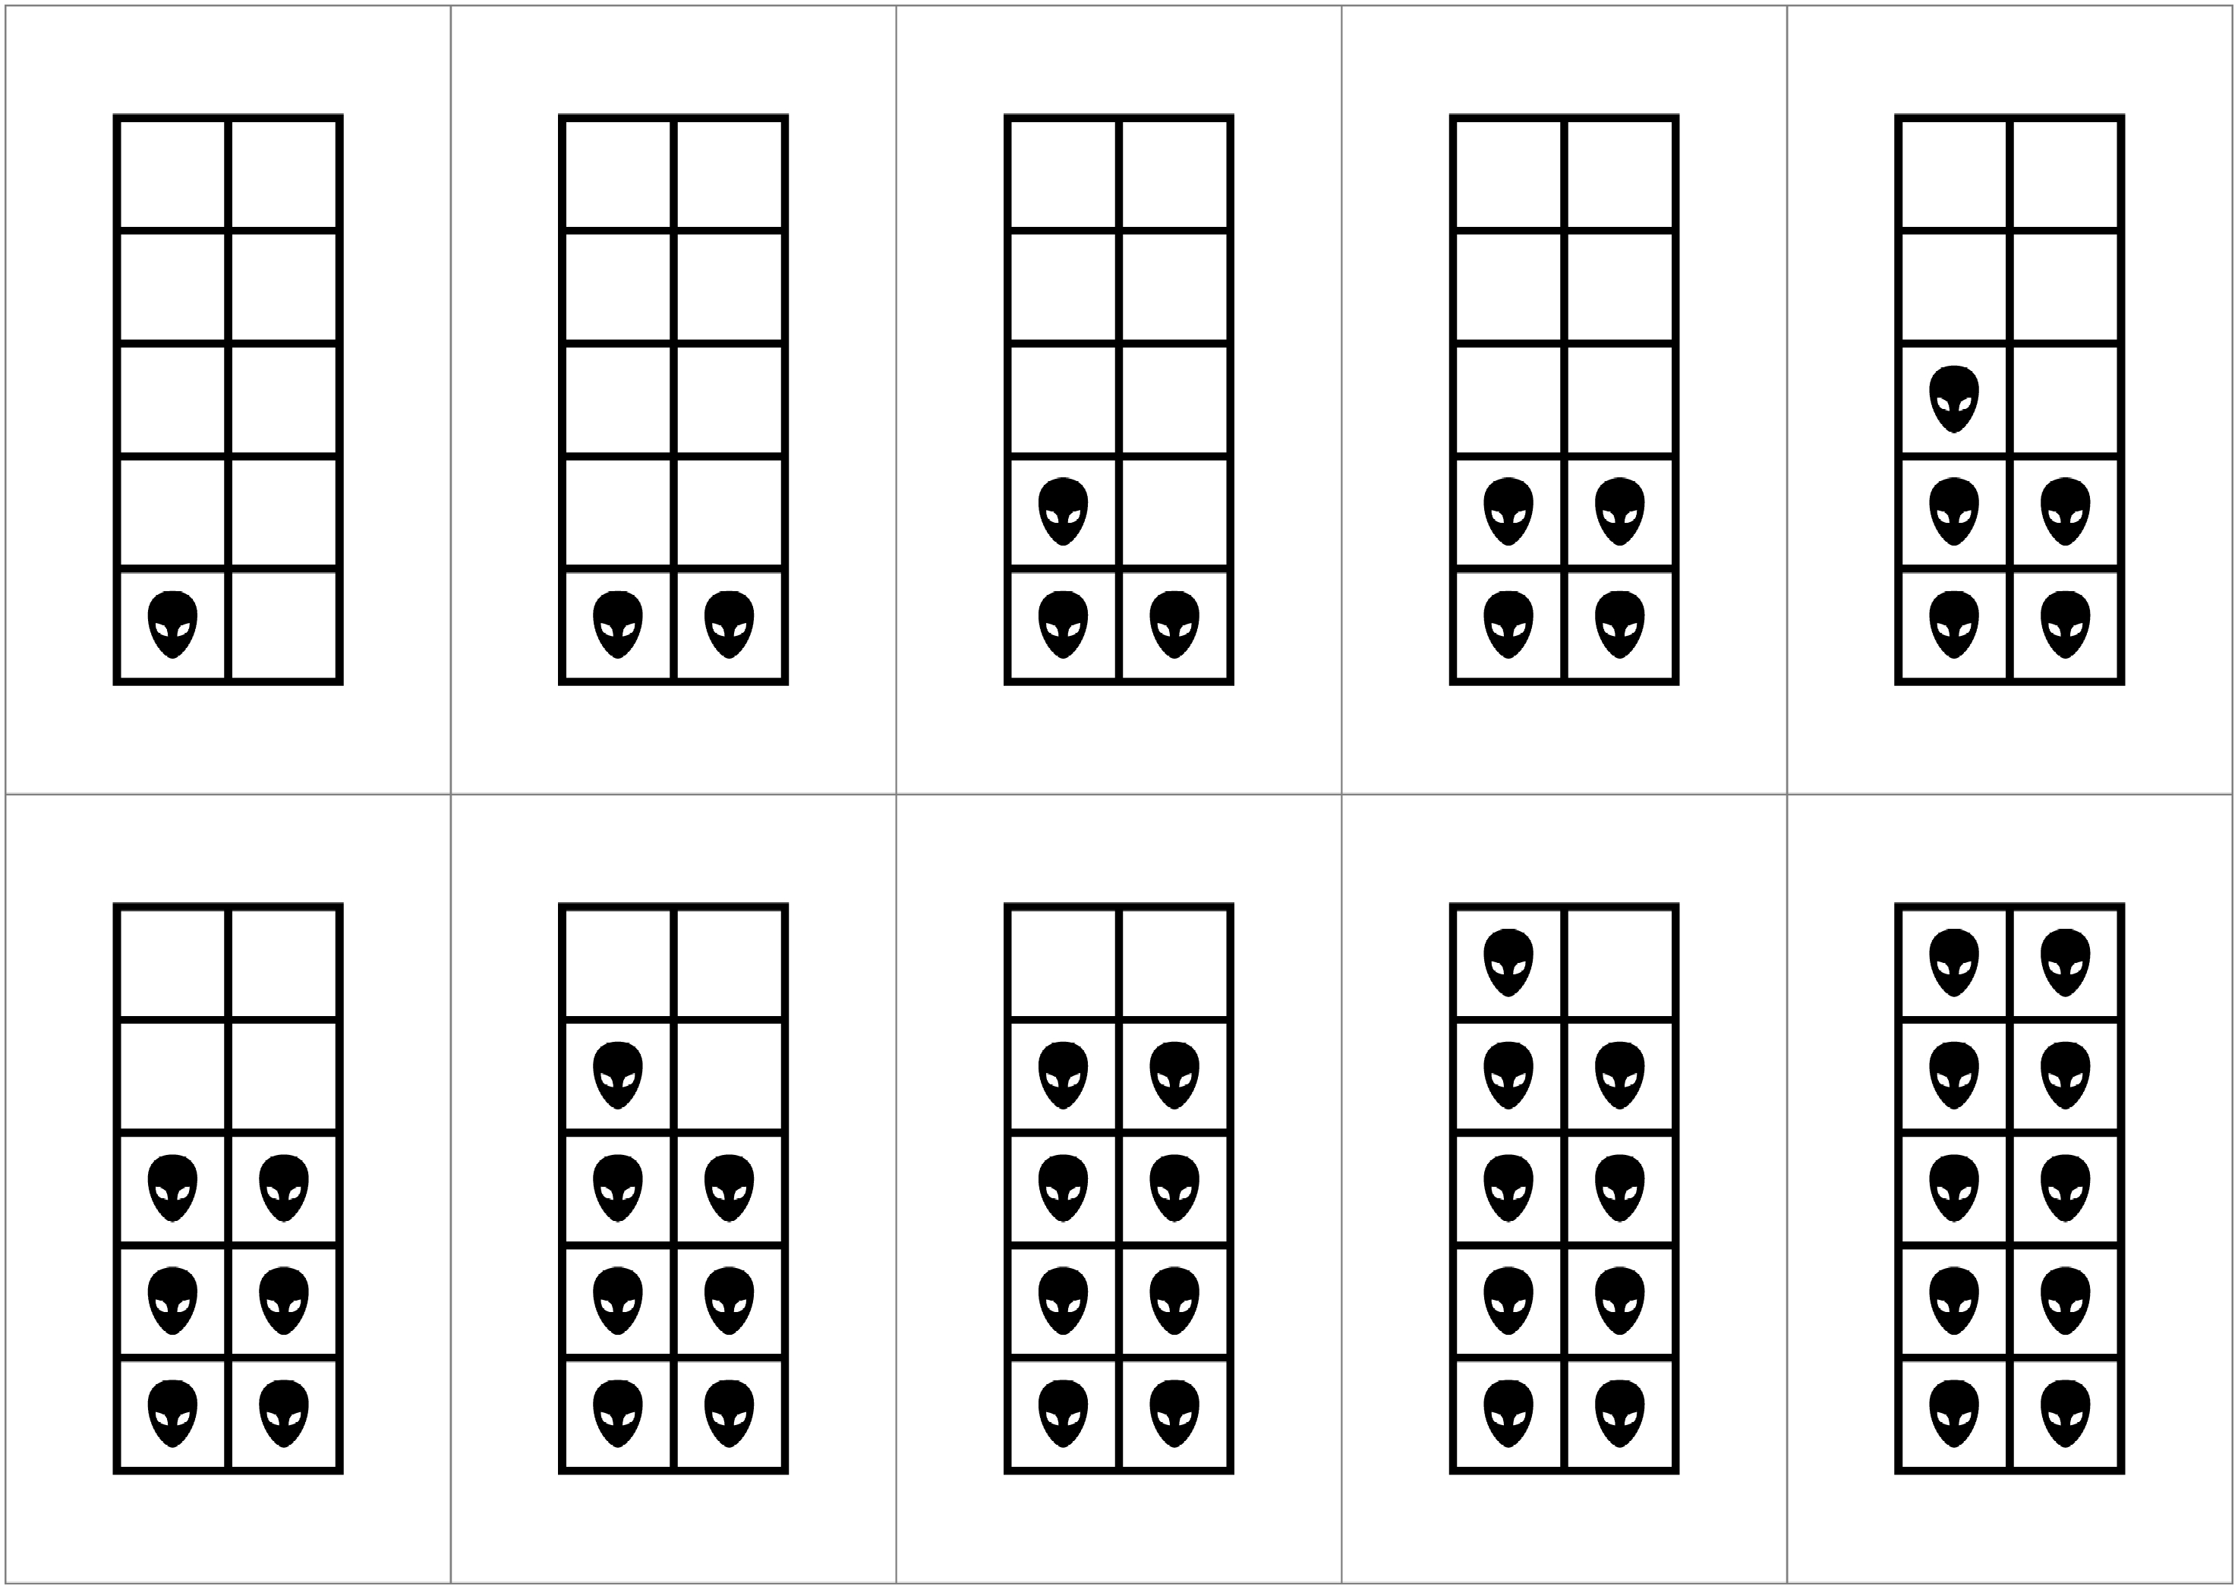



Ifrepresents 10, show me the frame that goes with to make 10. What calculations can we make? 7 + 3 = 10 and 3 + 7 = 10 because addition is commutative.

What if****represents 100?

What if ****represents 1? 0.1? This is a good activity for number facts.

If ****represents 40, show me 32. What calculations can we make? 8 x 4 = 32, 4 x 8 = 32 because multiplication is commutative.

If ****represents 90, show me 108 and so. This is a good way to rehearse multiplication facts.

Multiplication grids to highlight the commutative property of multiplication - we only need to learn half the facts, because in learning one we know two, e.g. if we know 9 x 4 = 36, we also know 4 x 9 = 36.

|  |  |  |  |  |  |  |  |  |  |  |  |  |
| --- | --- | --- | --- | --- | --- | --- | --- | --- | --- | --- | --- | --- |
|  | 1 | 2 | 3 | 4 | 5 | 6 | 7 | 8 | 9 | 10 | 11 | 12 |
| 1 | 1 | 2 | 3 | 4 | 5 | 6 | 7 | 8 | 9 | 10 | 11 | 12 |
| 2 |  | 4 | 6 | 8 | 10 | 12 | 14 | 16 | 18 | 20 | 22 | 24 |
| 3 |  |  | 9 | 12 | 15 | 18 | 21 | 24 | 27 | 30 | 33 | 36 |
| 4 |  |  |  | 16 | 20 | 24 | 28 | 32 | 36 | 40 | 44 | 48 |
| 5 |  |  |  |  | 25 | 30 | 35 | 40 | 45 | 50 | 55 | 60 |
| 6 |  |  |  |  |  | 36 | 42 | 48 | 54 | 60 | 66 | 72 |
| 7 |  |  |  |  |  |  | 49 | 56 | 63 | 70 | 77 | 84 |
| 8 |  |  |  |  |  |  |  | 64 | 72 | 80 | 88 | 96 |
| 9 |  |  |  |  |  |  |  |  | 81 | 90 | 99 | 108 |
| 10 |  |  |  |  |  |  |  |  |  | 100 | 110 | 120 |
| 11 |  |  |  |  |  |  |  |  |  |  | 121 | 132 |
| 12 |  |  |  |  |  |  |  |  |  |  |  | 144 |

Focus on square numbers, learn these facts and link in with areas of squares – practically. Teach 3s and 6s together, 4s and 8s together, 6s and 12s together because one is double the other.

**Place value**

* Positional: the quantities represented by the individual digits are determined by the positions that they hold in the whole numeral. The value given to a digit is according to the position in a number

7

4

7

4 0

* Year 1 Arrow cards
* Base 10: the value of the position increases in powers of 10
* Multiplicative: the value of an individual digit is found by multiplying the face value of the digit by the value assigned to its position
* Additive: the quantity represented by the whole numeral is the sum of the values represented by the individual digits

For example:

|  |  |  |  |
| --- | --- | --- | --- |
| 1000 | 100 | 10 | 1 |
| 6 | 8 | 3 | 7 |

**Positional:** 6 is in the 1000’s position, 8 in the hundreds, 3 in the tens and 7 in the ones

**Multipicative:** because 6 is in the 1000’s position it is multipled by 1000 to give its value, 8 is multiplied by 100, 3 by 10 and 7 by one to give their values.

**Additive:** add all the numbers together to give the total 6000 + 800 + 30 + 7 = 6837

**Base 10:** if 37 is multipled by 10, 3 tens becomes 3 hundreds, 7 ones become 7 tens and a place holder is placed in the ones position: 370

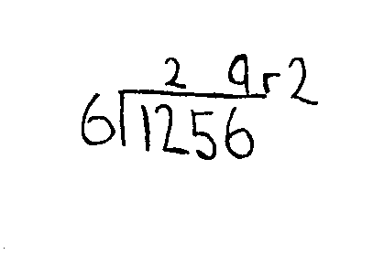

The children need to be able to partition numbers in different ways to help understanding and also to encourage mental calculation strategies:

* Partition all pairs of numbers for all numbers to 20, e.g. 1 + 4 = 5, 2 + 3 = 5, 3 + 2 = 5
* Partition 2-, 3- etc. digit numbers in different ways, e.g. 57: 50 + 7, 40 + 17, 30 + 27, 20 + 17, 10 + 7

**Equals sign**

The equals sign is not an indication of an answer. It is a sign of equivalence – the same as.

Year 1: 2 + 3 = 1 + 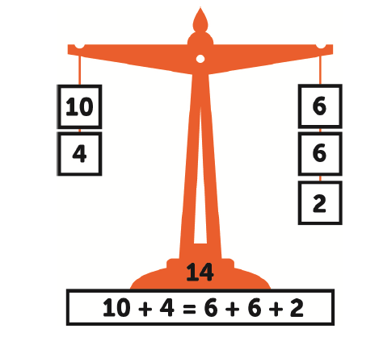

Year 5: 23 + y = 35. Take 23 away from 35, y = 12

Year 6: 2y + 36 = 40. Take 36 away from 40, 2y = 4. Divide by 2, y = 2

|  |  |
| --- | --- |
| 2y | 36 |
| 40 | |
| 4 | 36 |
| 4÷2  y = 2 |  |

**Greater than and less than**

Be mathematical when teaching this (no crocodiles)

Show these symbols plus equals like this (good to have on the wall):

2 < 4 4 > 2

How can we make these equal? 2 + 2 = 4 2 = 4 - 2

**Addition and subtraction**

**National Curriculum requirements**

**Year 1**

Add and subtract one-digit and two-digit numbers to 20, including zero using concrete objects, pictorial representations and mentally

Solve one-step problems that involve addition and subtraction, using concrete objects and pictorial representations, and missing number problems such as 7 =  - 9

**Year 2**

Add and subtract numbers using concrete objects, pictorial representations, and mentally, including:

* a two-digit number and ones

* a two-digit number and tens

* two, two-digit numbers

* adding three one-digit numbers

Solve problems with addition and subtraction:

* using concrete objects and pictorial representations, including those involving numbers, quantities and measures

* applying their increasing knowledge of mental and written methods

*Solve simple problems in a practical context involving addition and subtraction of money of the same unit, including giving change* (copied from Measurement)

**Year 3**

Add and subtract numbers mentally, including:

* a three-digit number and ones

* a three-digit number and tens

* a three-digit number and hundreds

Add and subtract numbers with up to three digits, using formal written methods of columnar addition and subtraction

Solve problems, including missing number problems, using number facts, place value, and more complex addition and subtraction

**Year 4**

Add and subtract numbers with up to 4 digits using the formal written methods of columnar addition and subtraction where appropriate

Solve addition and subtraction two-step problems in contexts, deciding which operations and methods to use and why

**Year 5**

Add and subtract numbers mentally with increasingly large numbers

Add and subtract whole numbers with more than 4 digits, including using formal written methods (columnar addition and subtraction)

Solve addition and subtraction multi-step problems in contexts, deciding which operations and methods to use and why

**Year 6**

Perform mental calculations, including with mixed operations and large numbers

Solve addition and subtraction multi-step problems in contexts, deciding which operations and methods to use and why

Solve problems involving addition, subtraction, multiplication and division using written methods

Recapping past learning: (with decimals)

* More complex subtraction e.g. 51-32.93
* Formal multiplication
* Formal division
* ÷ by 2 digit number

**Begin by teaching children the relationship between addition and subtraction – commutativity and inverse. When teaching addition use subtraction as a check. When teaching subtraction use addition as a check. Use calculators for checking!**

**Structures for addition**

**Counting all (aggregation) how many altogether?**

5 7

12

**Adding on to a set (augmentation) counting on**

7 8 9 10 11 12

**Think 10**

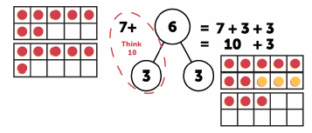

**Vocabulary: addition** augend commutative add addend equals sum, more, how many altogether? What is the total?

**Progression towards the written method**

Year FS: Use everyday objects, double sided counters and Numicon to encourage counting on from one number to find the sum of quantities to 10 and, if appropriate, to 20.

Year 1: Continue using Numicon, finding the two numbers putting them together and finding the sum without counting everything to 20 and, if appropriate, to 50. Subitise, commutative

Combine tens and ones using Dienes, Cuisinnaire, Numicon or bundles of straws and write number statements/draw pictures to show what they have done. Towards the end of Year 1 explore regrouping.

Year 2: Continue combining Dienes to make sums up to 100, including regrouping. Writing number statements/drawing pictures to show what they have done.

Towards end of the year introduce vertical partitioning to prepare children for Year 3. 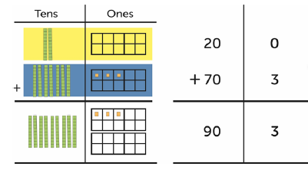

**With regrouping**

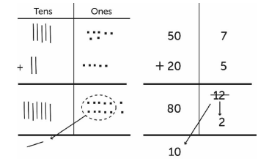

Year 3 and above: Use of manipulatives to lead to the written method. Important to explore why they need to begin with the least significant digit.

**Be careful to use 3-digit examples that cannot be answered using a mental method.**

2 4 8 leading to 2 4 8 with manipulatives

+ 1 3 9 + 1 3 9

3 0 0 3 8 7

7 0 1

1 7

3 8 7

**Example of regrouping**



**Written method: decimals (with manipulatives first)**

154.7 1.

+ 129.5

Add tenths, regroup 10 tenths for a one

284.2

1 1

2.

3.

Add ones, regroup 10 ones for a ten

Add tens and hundreds

**Every time new numbers are introduced, e.g. thousands, decimal places, use manipulatives first so children can see that the process is essentially the same.**

**Structures for subtraction**

**Subtraction (take-away)**

12 – 5 = 7

**Difference (comparison model)**

12

?

7

**Reduction (more abstract: temperature, speed)**

**Part-whole model**

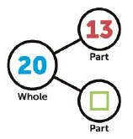

**Progression towards the written method**

**Vocabulary:** minuend subtract subtrahend equals difference minus less, how many left?

Year FS: Use everyday objects, double sided counters and Numicon to encourage counting on from one number to find the sum of quantities to 10 and, if appropriate, to 20.

Year 1: Continue using the manipulatives from Year R and Numicon, to find the difference between quantities to 20 and, if appropriate, to 50.

Make a number using Dienes, Cuisinaire, Numicon or bundles of straws and subtract a smaller number. Write number statements/draw pictures to show what they have done. Towards the end of Year 1 explore exchange.

Year 2: Continue using Dienes to find differences between quantities to 100, including exchange. Writing number statements/drawing pictures to show what they have done.

65 – 47 Take away 40

Regroup one 10 for 10 ones in order to take away 7

Written method

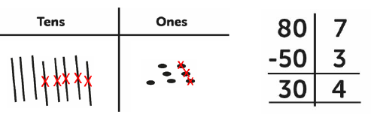

With regrouping

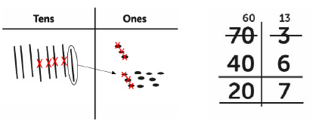

Year 3 and above: Use of manipulatives to lead to the written method by the end of Year 3, beginning of Year 4.

**Be careful to use 3-digit examples that cannot be answered using a mental method.**

Use of manipulatives to lead to compact method:

2 8914 1. 2. 3. 4. 5.

4. 5.

- 1 7 8

1 1 6

Subtract tens and then hundreds

Regroup one ten for ones and subtract 8

**Written method: decimals (with manipulatives first)**

1145123.12 1. 2. 3. 4.

- 9 7. 6

5 5. 6

Regroup one for 10 tenths and subtract 6 tenths

Regroup one ten for 10 ones

5. 6. 7.

Regroup one hundred for 10 tens and subtract 9 tens

Subtract 7

**Multiplication and division**

**National Curriculum requirements**

**Year 1** *Count in multiples of twos, fives and tens* (copied from Number and Place Value)

**Year 2**

Calculate mathematical statements for multiplication and division within the multiplication tables and write them using the multiplication (×), division (÷) and equals (=) signs. Multiplication facts expected to be known: 2x, 5x, 10x

**Year 3**

Write and calculate mathematical statements for multiplication and division using the multiplication tables that they know, including for two-digit numbers times one-digit numbers, using mental and progressing to formal written methods. Multiplication facts expected to be known: 3x, 4x, 8x

**Year 4**

Use place value, known and derived facts to multiply and divide mentally, including: multiplying by 0 and 1; dividing by 1; multiplying together three numbers. Multiply two-digit and three-digit numbers by a one-digit number using formal written layout. Multiplication facts expected to be known: 6x, 7x, 8x, 9x, 11x, 12x

**Year 5**

Multiply and divide numbers mentally drawing upon known facts

Multiply numbers up to 4 digits by a one- or two-digit number using a formal written method, including long multiplication for two-digit numbers

Divide numbers up to 4 digits by a one-digit number using the formal written method of short division and interpret remainders appropriately for the context

**Year 6**

Perform mental calculations, including with mixed operations and large numbers

Solve problems involving addition, subtraction, multiplication and division

Multiply multi-digit numbers up to 4 digits by a two-digit whole number using the formal written method of long multiplication

Divide numbers up to 4-digits by a two-digit whole number using the formal written method of short division where appropriate for the context divide numbers up to 4 digits by a two-digit whole number using the formal written method of long division with whole answers and interpret remainders as whole number remainders, fractions, or by rounding, as appropriate for the context

*Use written division methods in cases where the answer has up to two decimal places* (copied from Fractions (including decimals)

**Begin by teaching children the relationship between multiplication and division – commutativity and inverse. When teaching multiplication use division as a check. When teaching division use multiplication as a check. Use calculators for checking!**

**Link multiplication to repeated addition and division to repeated subtraction. Both are grouping. Link the sharing model for division to fractions.**

**Structures of multiplication**

**Grouping (repeated addition)**

**Scaling (2, 3, 4 etc. times as many)**

**Progression towards the written method**

**Vocabulary:** multiplicand multiplied by multiplier equals product, commutative

Year FS: Use counters, bead strings, any ‘stuff’ to groups of quantities to 10 and, if appropriate, to 20.

Year 1: Continue using the manipulatives from Year FS and also Numicon, to find groups of quantities, e.g. 2, 5 and 10 to 20 and, if appropriate 50. In addition, sharing into equal and equal and unequal groups.

4 groups of 3 = 3 four times = 3 x 4

Bead strings

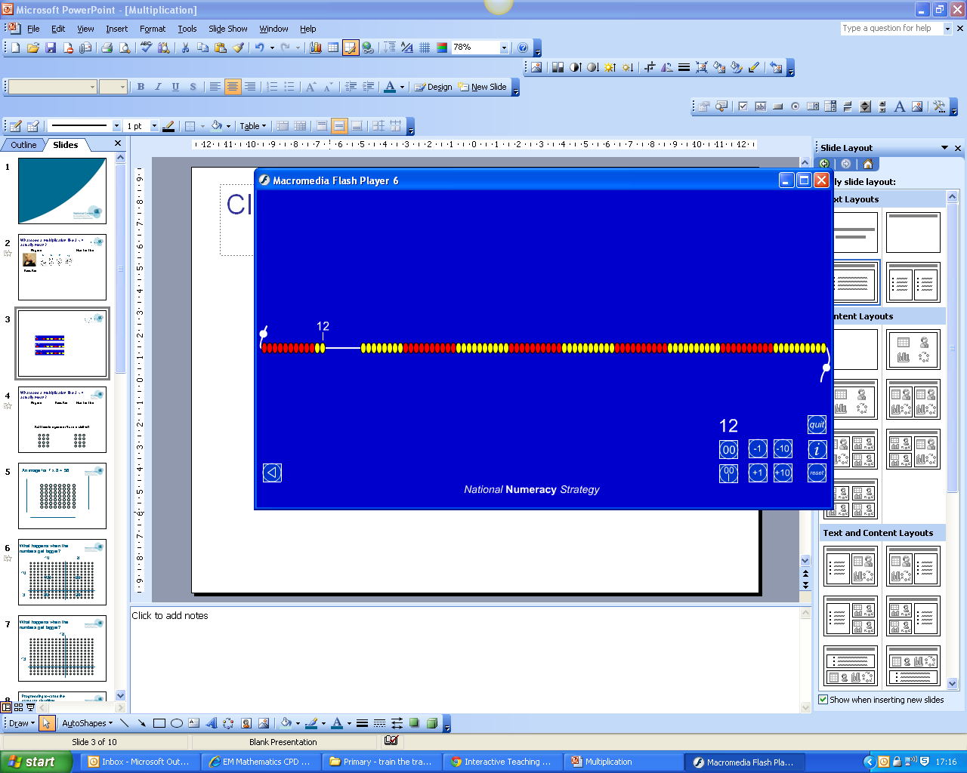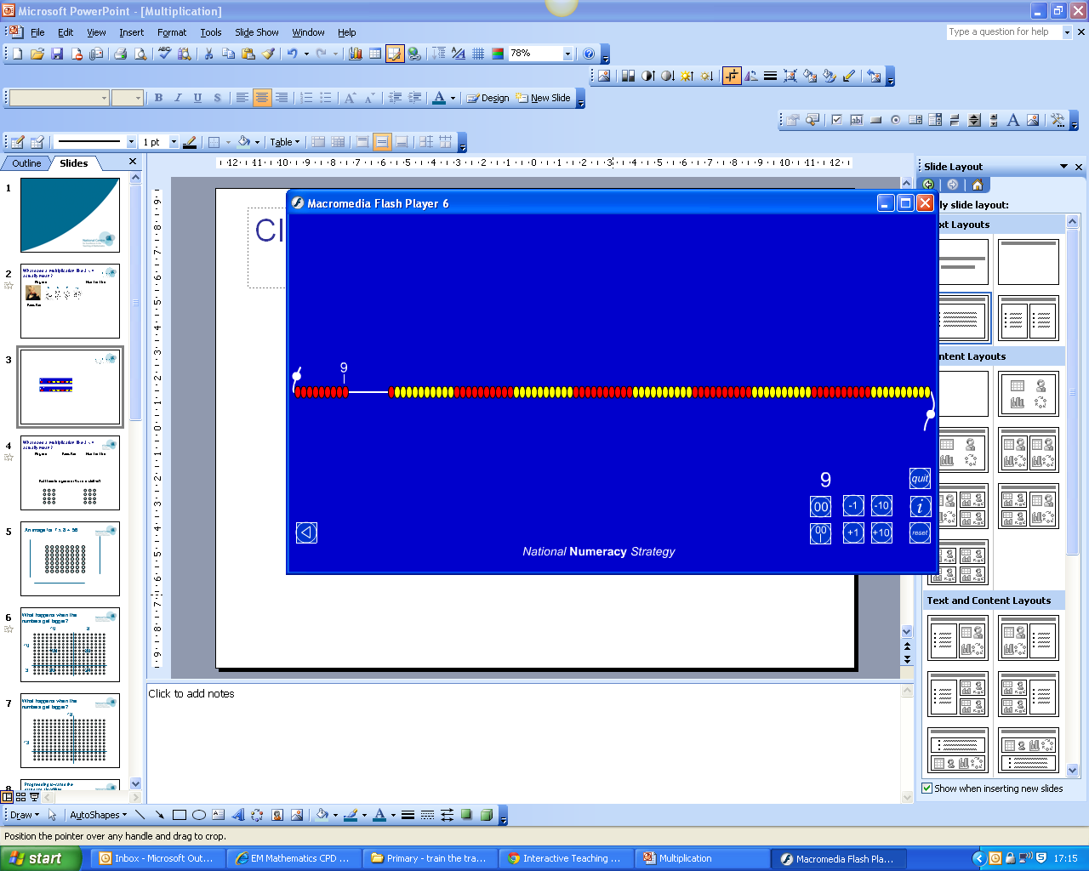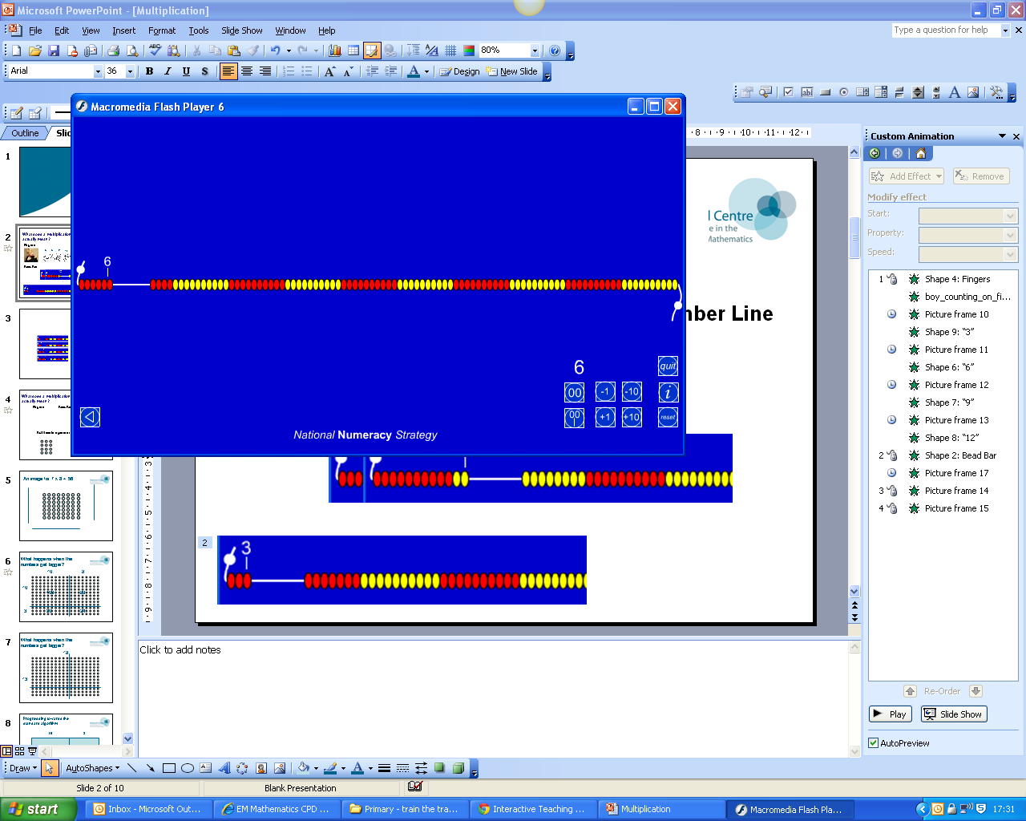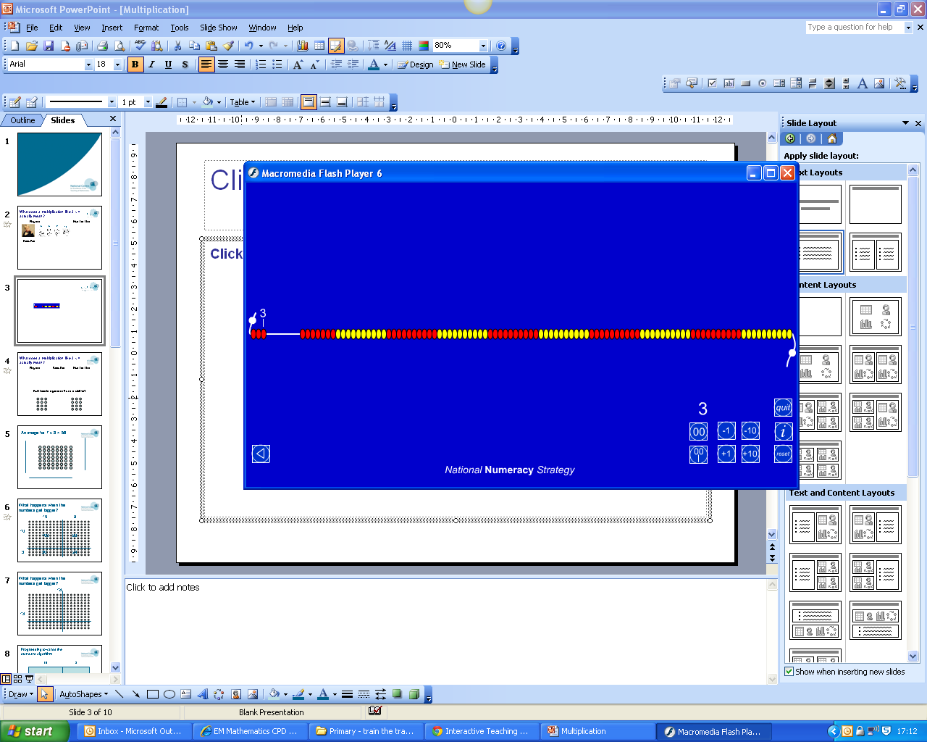

Set counters out as arrays and explore commutativity and early inverse by taking groups away.

Arrays

3 x 4 4 x 3

Year 2: Continue as in Year 1, focussing on arrays, include multiplying by 3 and writing the commutative number statements.

Fingers

**12**

**9**

**6**

**3**

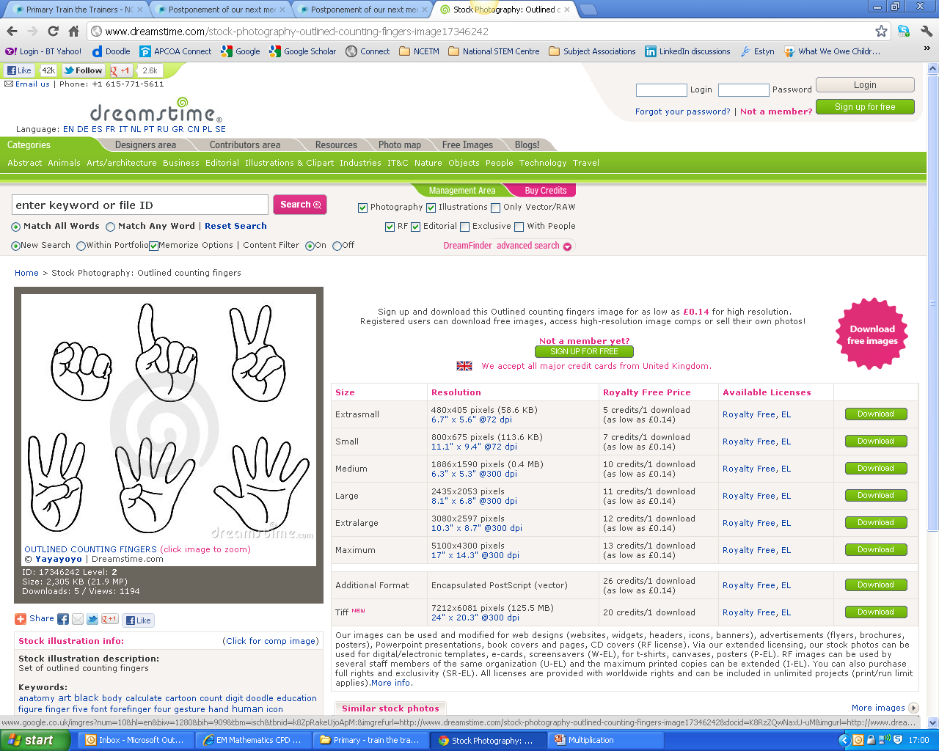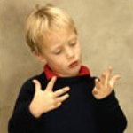



Year 3 and above: Use arrays and link to the grid methods, beginning with 2-digit multiplicands.

**Be sure to use multipliers that do not lend themselves to a mental method, e.g. 2, 4, 5, 10**.

These multipliers are suitable: 3, 6, 7, 8 and 9.

Arrays to support the grid method

10 8

3

10 8

3 30 24 18 x 3 = 54

200 50 2

6

200 50 2

6 1200 300 12 = 1512

Or… leading to written method

252 252

x 6 x 6

12 1512

300 3 1

1200

1512

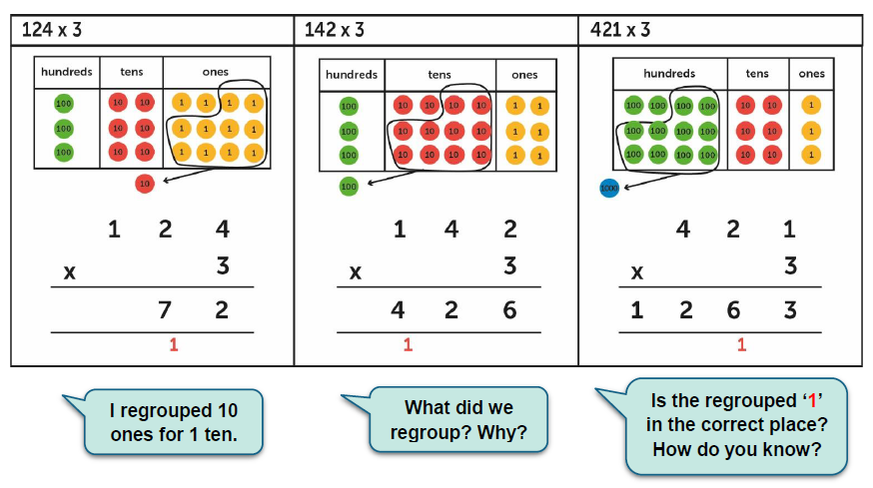

Long multiplication begins in Year 5:

10 8

10

3

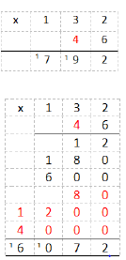

Also use Dienes and place value counters to demonstrate this

10 8

10 100 80 180

3 30 24 54

Total: 234

**Leading to written method:**

18

or…

18 18 180

x 10 x 3 + 54

180 54 203

x 13

54

180

234

**Written method: decimals**

Regroup as appropriate and group together to give 481.2

100 40 5 .3

4 400 160 20 .12

145.3

x 4­­_

581.2

1 1 1

**Structures for division**

**Grouping** (repeated subtraction)

**Scaling** (a third, quarter, fifth etc. of the size)

**Sharing** (best linked to fractions)

**Progression towards the written method**

**Vocabulary:** dividend, divisor, quotient, division bracket

Year FS: Use counters, bead strings, any ‘stuff’ to make quantities to 10, then 20 into groups of 2s, 5s and 10s.

Year 1: Continue using the manipulatives from Year FS and also Numicon, to find how many groups they can make out of quantities, to 20 and, if appropriate 50.

12 ÷ 3

How many groups of 3 in 12?

Bead strings



Set counters out as arrays and explore taking groups away.

Arrays

12 ÷ 3 = 4 12 ÷ 4 = 3

Year 2: Continue as in Year 1, focussing on arrays and working out division calculations by counting in step on fingers.

Fingers

**12**

**9**

**6**

**3**



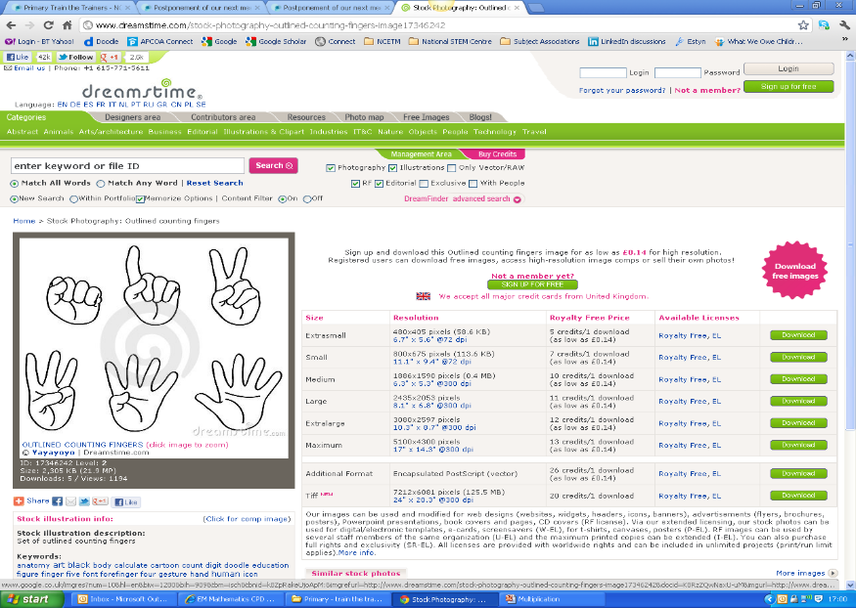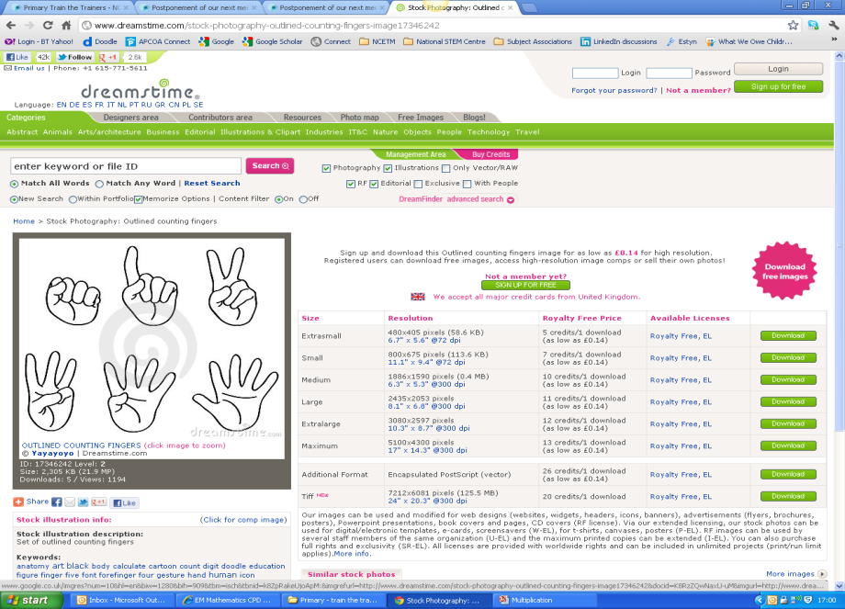

With remainders

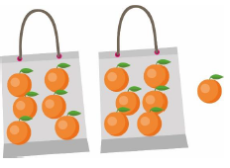

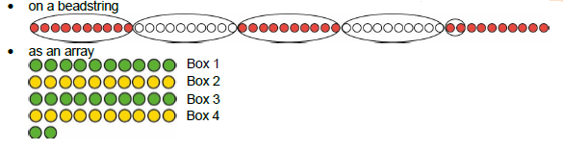

Year 3 and above: Use arrays and then move towards the written method using manipulatives.

**Arrays**

12 ÷ 3 = 4 12 ÷ 4 = 3

**8**

Introducing the conceptual variation of the written method with division bracket.

**56**

**7**

8

7 56

**7**

7

**56**

**8**

8 56

**16**

From this we know:

7 x 16 = 112

**112**

16 x 7 = 112

**7**

112 ÷ 16 = 7

112 ÷ 7 = 16

**Written method**

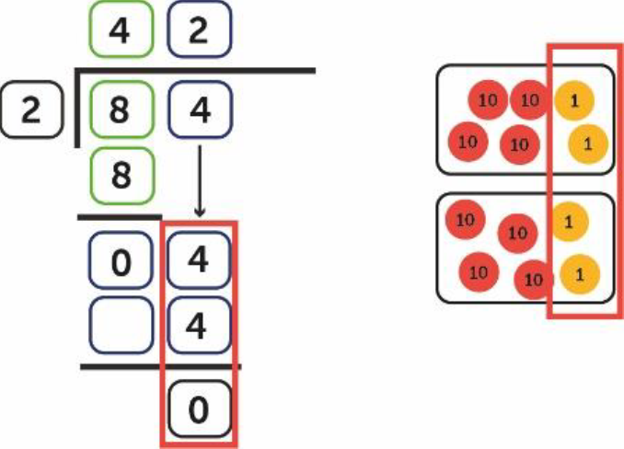

133 ÷ 6

Important to let the children use manipulatives such as place value counters to explore exchange:

You cannot take 6 groups of 100 away from the one 100

Exchange the 100 for 10 tens so you have 13 tens

6 1 13 3

You can now take two groups of 6 tens

2

6 1 13 3

One groups of ten will be left. This is exchanged for 10 ones. You now have 13 ones.

2

6 1 13 13

You can take another two groups of 6 ones from the 13 leaving a remainder of 1

2 2 1/6

6 1 13 13

**Written method: decimals (with manipulatives first)**

73.2 ÷ 6

Important to let the children use manipulatives such as place value counters to explore exchange:

You can take one group of six 10s away from the seven 10s. There will be one hundred left

Exchange the 10 for 10 ones so you have 13 ones

1

6 7 13. 2

You can now take two groups of 6 tens

1 2

6 7 13. 2

One will be left. This is exchanged for 10 tenths. You now have 12 tenths.

1 2. 2

6 713.12

You can take two groups of 6 tenths 1 2 2

1 2. 2

6 713.12

**Long division** These examples are taken from Y5, but simple examples long division begins in Year3-see above.

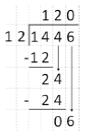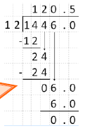

**The bar model**

This visual representation helps children make sense of problems. It needs to begin in FS (practically and visually) then developed throughout the school. Use manipulatives for this whenever the children want to. Develop the drawings from these. Cuisenaire and double sided counters are good for this.

FS:

The 5s and 10s frame is used to introduce bar model into FS

There are 3 footballs in the red basket and 2 footballs in the blue basket.

How many footballs are there altogether?

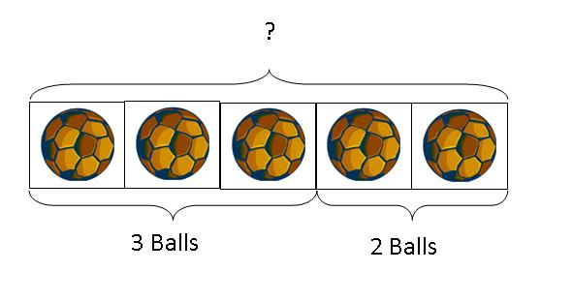

Peter has 3 marbles.

Harry gives Peter 1 more marble.

How many marbles does Peter have now?

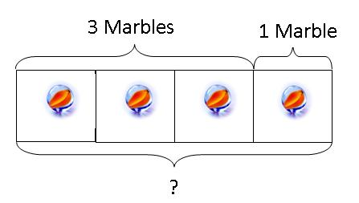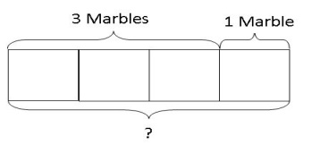

Visual to Abstract

Peter has 5 pencils and 3 erasers.

How many more pencils than erasers does he have?

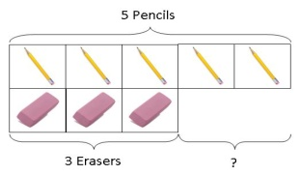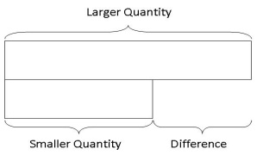

Visual to Abstract

Year 1 upwards:

10

4

6

This leads to an abstract model which helps with links between addition and subtraction

a = b + c a = c + b

b = a – c c = a - b

a

b

c

This can then help the children solve, for example, missing number problems:

45 + ? = 93, ? – 62 = 13, 146 - ? = 79, ? + 82 = 147

Peter has 4 books.

Harry has three times as many books as Peter. How many more books has Harry?

Peter’s books

Harry’s books

Sam had 5 times as many marbles as Tom. If Sam gives 26 marbles to Tom, the two friends will have exactly the same amount. How many marbles do they have altogether?

Tom’s marbles 26 so each circle is worth 13

Sam’s marbles

If the children had been proficient using this model, they would have found these more advanced SATs questions simple:

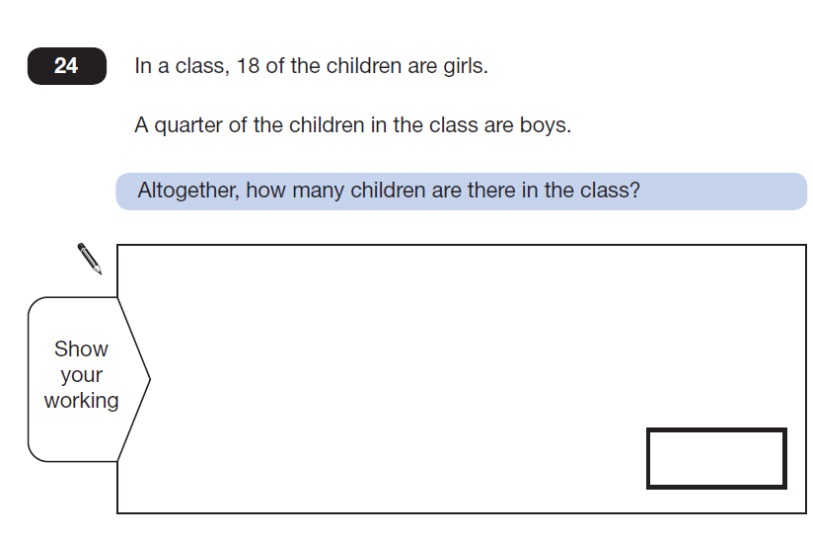 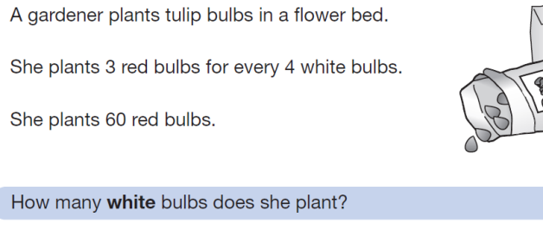

They would have been able to attempt this more advanced question

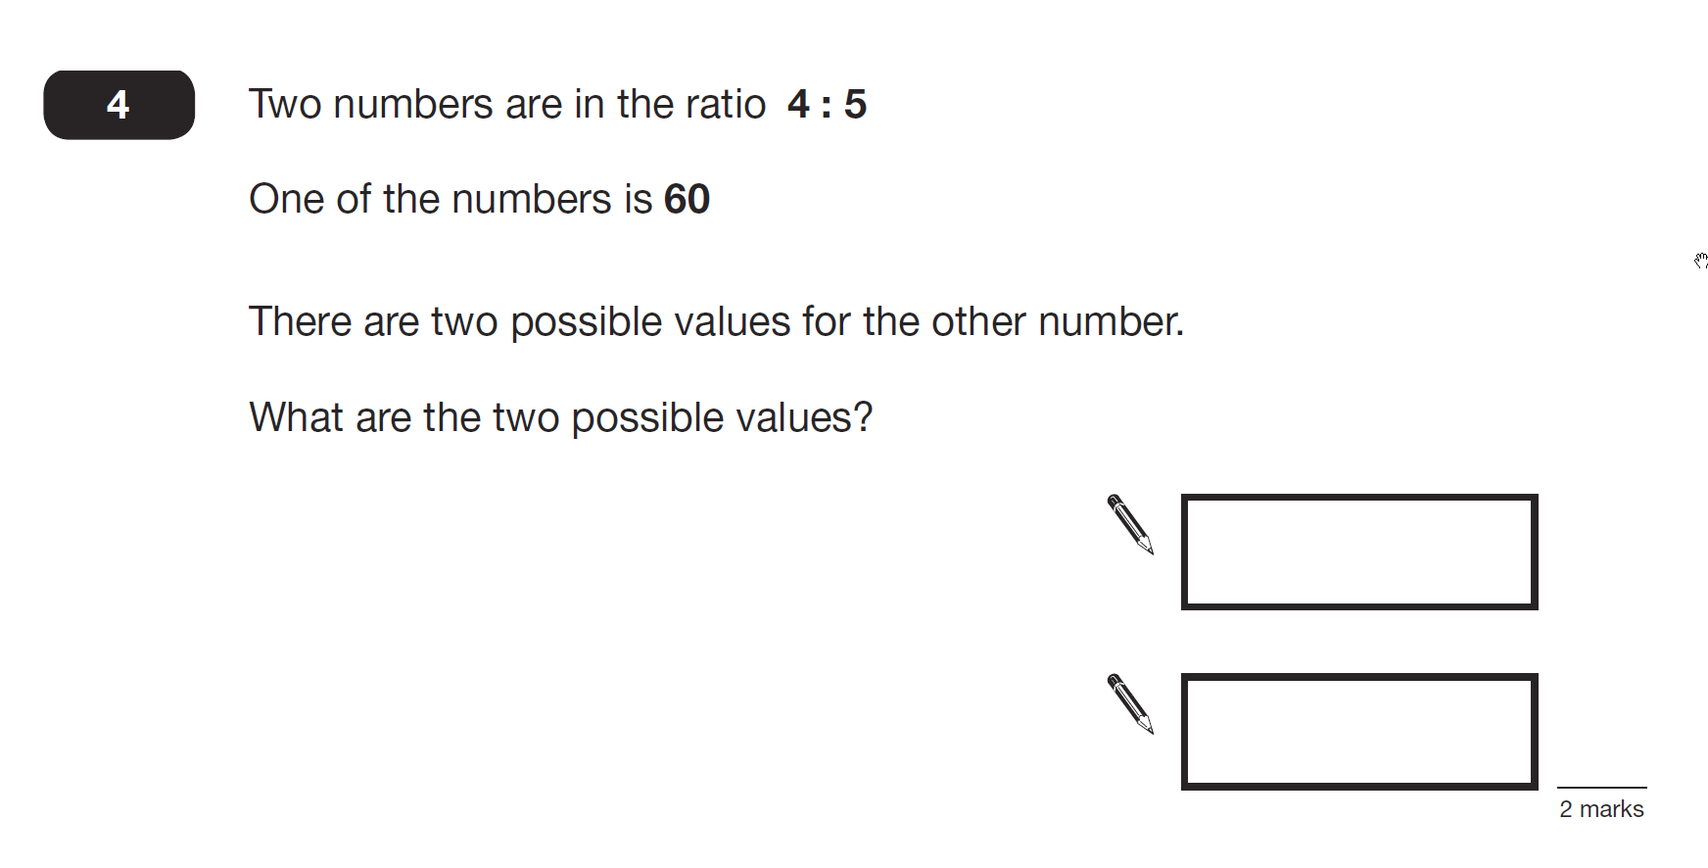

And questions like these:

A shop keeper sold 1/3 of his balloons in the afternoon and 2/5 of the remainder in the evening.

If he had 150 balloons left, find the number of balloons he had at first?

Iqbal and Sofia have £680 altogether. If Iqbal spends

$\frac{2}{5}$ of her money and Sofia spends £80, then they will have an equal amount of money left. How much money did Sofia have at first?

Mr Yap had a length of rope. He used 1/4 of it to tie some boxes together. He then used 5/9 of the remainder to make a skipping rope for his daughter. 120cm of rope were left. What was the length of rope used to tie the boxes together?

Michelle prepared a mixture of apple, carrot and celery juices. 1/3 of the mixture was apple juice and 2/5 of the remainder was celery juice. 315 ml of the mixture was celery juice. What volume of the mixture was carrot juice?

September

With thanks to Caroline Clissold. Adapted to the represent the learning sequences used in school. Vocabulary highlighted in yellow is not in common use yet but will be introduced gradually, until children are familiar and confident with it. Videos and images to illustrate the methods outlined above will be uploaded onto the school website over the coming year.