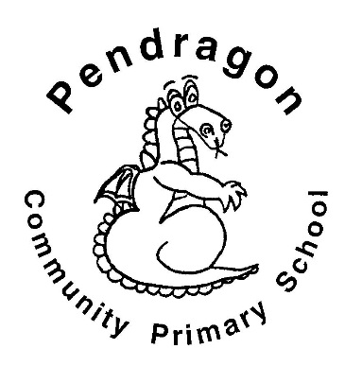 | Recommended Reading List | Year FS
The selection of books in this list are a guide for children aged 4-5 in Foundation Stage at school. The books are selected from a range of genres to cover all interests. If your child is a competent reader or has read many of these titles then try the books from the Year 1 list.
Burglar Bill | Allan Ahlberg
Elmer | David McKee
Zim Zam Zoom! | David Carter
Oi Frog! | Kes Gray & Jim Field
One Day on our Blue Planet … Savannah | Ella Bailey
Suddenly | Colin McNaughton
Wiggle and Roar | Julia Donaldson
Hooray for Fish | Lucy Cousins
Surprising Sharks | Nicola Davies
Bears Don’t Eat Egg Sandwiches | Julie Fulton
Yucky Worms | Vivienne French
All Aboard for the Bobo Road | Stephen Davies
Mog the Forgetful Cat | Judith Kerr
Tad | Benji Davies
The Runaway Wok | Ying Chang Compestine
The Fish Who Could Wish | John Bush
Out and About | Shirley Hughes
Blue Monster Wants it All | Jeanne Willis
All Join In | Quentin Blake
Aliens Love Underpants | Claire Freedman
Six Dinner Sid | Inga Moore
You Choose | Nick Sharratt
The Gruffalo | Julia Donaldson
I Am a Tiger | Karl Newson
Puffin Peter | Peter Horacek
Chickens Aren’t the Only Ones | Ruth Heller
Harry and the Bucketful of Dinosaurs | Ian Whybrow
Aaargh Spider! | Lydia Monks
Farmer Duck | Martin Waddell
The Teddy Robber | Ian Beck
Nighttime | Anna Milbourne
Naughty Bus | Jan Oke
Let’s Build a House | Mick Manning

