Lesson Elements - This clearly states what the teacher and pupils should be doing during the activity. Questions and tasks break up the lesson, meaning pupils get regular opportunities to practise new learning. Emphasis on deeper learning not task completion.

‘Dual coding’ – pictures and text. This improves the absorption of new knowledge without increasing extraneous cognitive load. Visuals should be high quality e.g. photos of artefacts from museum collections

Tasks should focus on thinking not completion of tasks as evidence. Don’t ask ‘Have you finished?’ Ask ‘What have you learned?’. Avoid worksheets – these can widen gaps

Low stakes multiple choice quizzes are efficient, effective and motivating for pupils, whilst providing teachers with vital information about what pupils have misunderstood, and/or what they are struggling to remember. These questions can be easily recycled, utilising the spacing effect and ensuring content is retained in the long term, and not forgotten soon after the lesson or unit has ended.

Question as title of lesson

Teach key vocabulary for lesson

Share information with class in form of teacher talk supported by a driving text, powerpoint, video, etc. Use dual-coding.

Tasks should focus on talking, listening, reading and thinking

At the end of the information sharing there is a recap quiz (retrieval practise) to assess what the children have learned/ retained from the session.

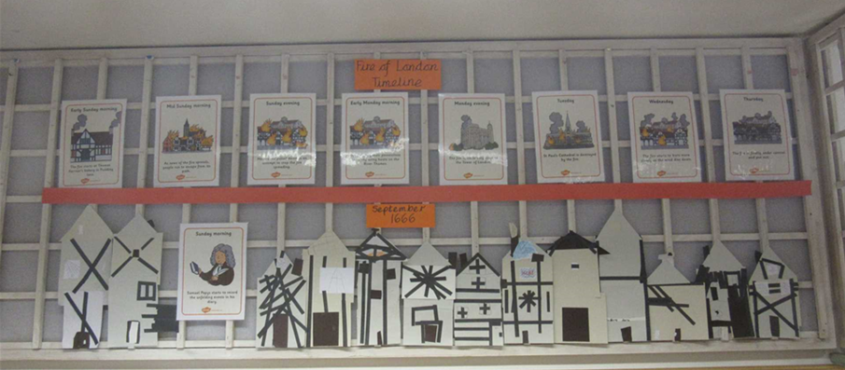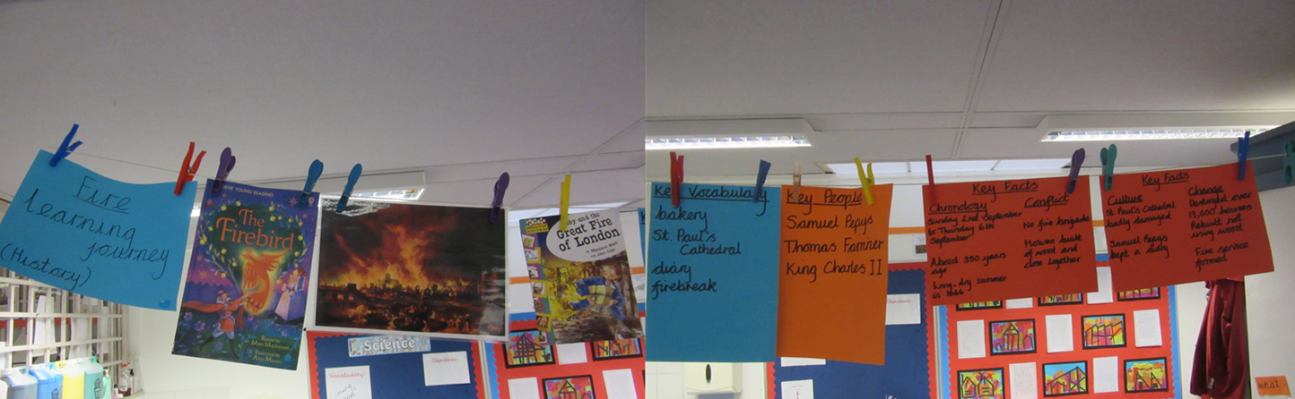

The Learning Journey should show children how much they have learned over the course of the half-term

Key knowledge, vocabulary, influential people, timeline, map, etc. displayed on ‘Learning Journey’ display