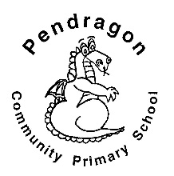 | Pendragon Community Primary School  Lynx Class- Miss Trotter

National Curriculum
As Readers we will read and enjoy, listen to and discuss a variety of stories and share our thoughts and opinions on them.  In PE we will be learning how to control a ball with our hands and feet and developing our gross motor skills. | As Writers we will write thought bubbles for book characters, lists, notes and a post cards. Based on our other learning we will plan and write texts of our own choice in Pendragon Writers Club.  Up, up and away | As Scientists we will develop our understanding of scientific enquiry by asking and answering our own questions. We will investigate and discuss a wide range of everyday materials and encourage the children to distinguish between an object and the material it is made from. |  |  | 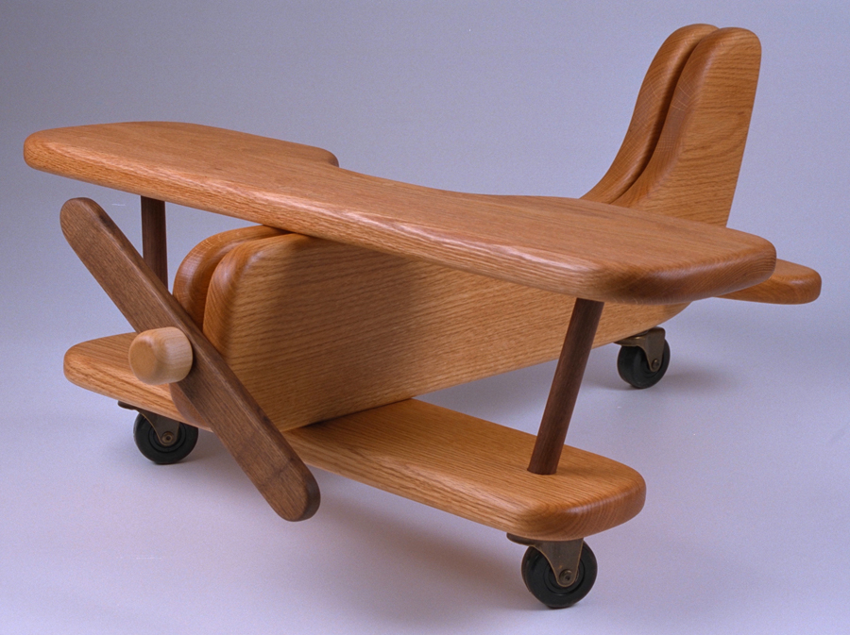
As Mathematicians we will be learning positional language, number and exploring addition and subtraction. We will also be looking at number fluency and different ways of solving problems. |  | 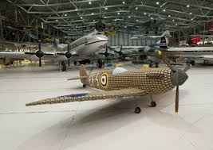 | As Design Technologists we will be designing and making our own aeroplane using a range of materials and experimenting with different joins.
 | In PSHCE we will think about ourselves, our relationships and new beginnings.
 |  | As Historians we will be learning about the changes in air travel and ‘The Wright Brothers’ first flight.
As Musicians we will be learning through the online music scheme ‘Charanga’ which will involve singing, listening, appraising, exploring pitch and pulse, as well as performing. | - In Computing we will learn more about e-safety (staying safe online), develop our understanding of technology, digital literacy and simple programming using a range of Purple Mash programmes. | In RE we will be thinking about what it means to belong and looking at a variety of religious artefacts to engage our thinking and learning.

Supporting Learning at Home  - Mathletics:www.mathletics.co.uk  - Maths: Key Instant Recall Facts (KIRFs) will be sent home to learn each half term.  - Reading:  Choose a book once a week from our Year 1 sharing library – snuggle up and enjoy together over the weekend!  School reading scheme book – on a Monday your child will bring a book home to read with you. This book should be discussed and read more than once throughout the week, it will be handed in every Friday. This will begin Monday 13th September. Ideally read daily for at least 10-15mins. Children should bring their reading record book to school each day. Please make a comment and sign the reading record.  Once your child is reading Yellow Set 3 and above they will change their book on a Monday and a Wednesday. It is still important for your child to read their book more than once in order to build fluency.  Bug Club to be enjoyed all week long.  www.activelearnprimary.co.uk  Word wallet – your child will bring home a wallet that contains common high frequency words, some of which will be ‘tricky’ words. All words in the wallet must be learnt by sight (not sounding out). | Contact  For any queries or enquiries, please contact your child’s teacher using the email below:  Miss Trotter  ktrotter@pendragon.cambs.sch.uk  Please note that teachers will check their email up to 8.30am every morning, if you have an urgent message, please contact the office instead via phone or email, so that they can pass the message on to the class teacher.  Entry and exit procedures.  When dropping off, please say goodbye to your child at the small gate. On collection, once the main gate has been unlocked, you will need to wait on the main playground infront of Year 1 class rooms. Please find a space so you are socially distanced from others and avoid queuing. You will then exit via the main gates on the playground. | PE Lessons  Please ensure that your child comes in to school in their named PE kit, ready for PE on the PE days below.  Indoor PE Tuesday Morning and outdoor PE Friday afternoon  If your child has long hair, please ensure it is tied back with a hair band, as long hair must be tied back for PE. It is expected that all children can remove watches/earrings for PE. If your child is unable to remove their own stud earrings these should be removed at home on PE days or micropore tape provided so they can cover them.  Thank you for your support with this.  The Haven and wellies  Each class will have a weekly time slot to use the Haven. Wellies should be brought into and kept in school so that this space can be used throughout the year. Lynx Class will use the Haven on a Thursday.  Personal belongings in school  Your child should only come into school each day with their packed lunch, water bottle and reading book. All other resources that the children require for their learning will be provided by school.

