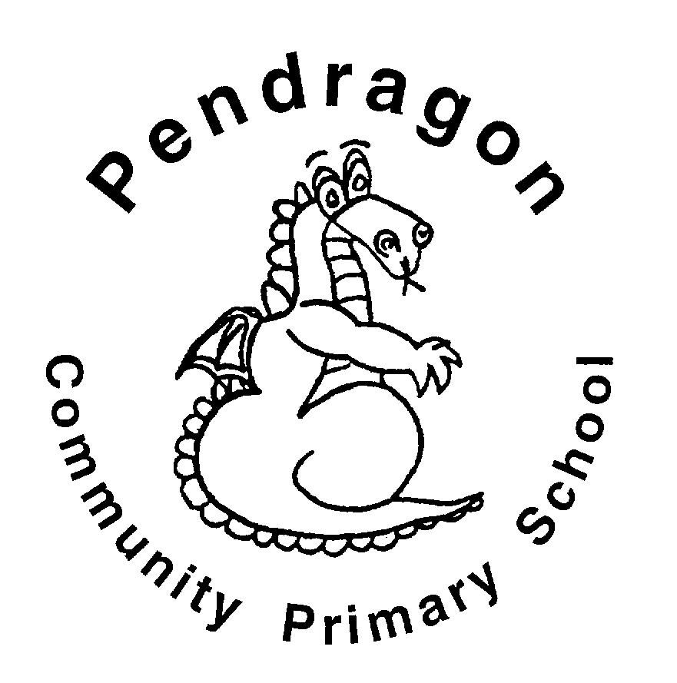 | Pendragon Community Primary School  Lions Class – Miss Hart
National Curriculum
As Readers we will be reading a variety of Roman myths and comparing them to those of the Ancient Greeks. We will read extracts from a variety of texts in our daily guided reading lessons. |  | As Mathematicians we will be able to understand the number system and place value including larger numbers and make connections between addition, subtraction, multiplication and division. We will use fluent written methods to solve increasingly difficult problems.  Year 5  Autumn 1  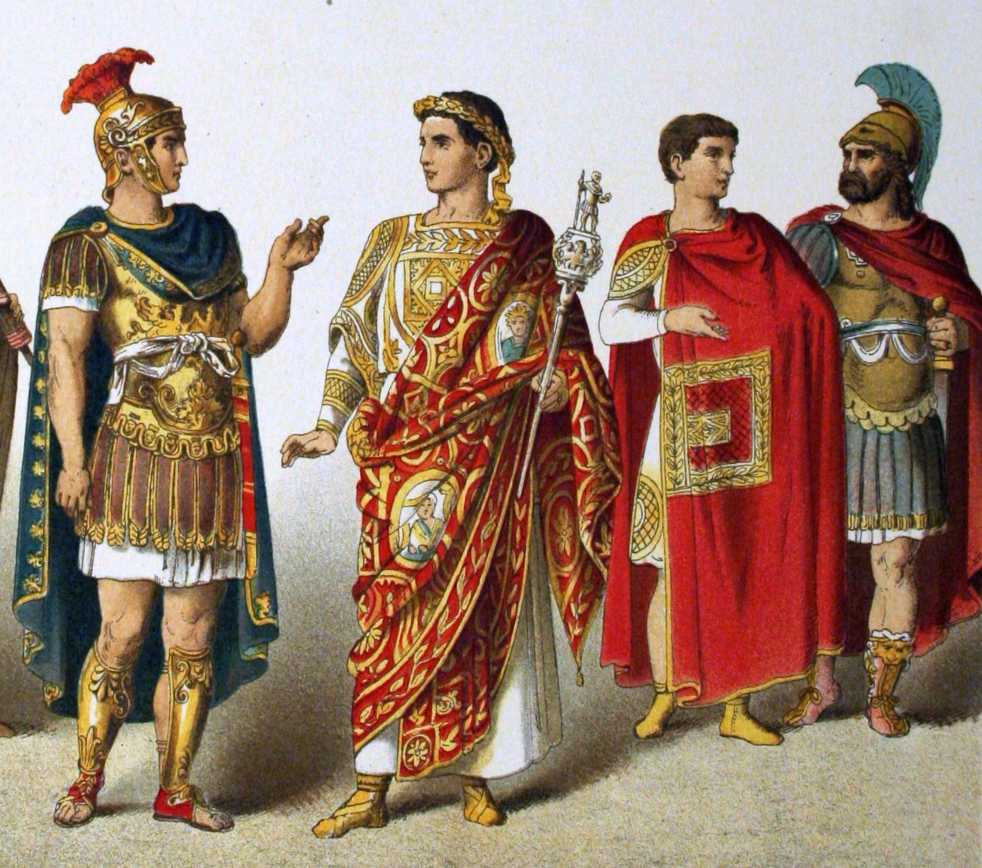 | As Writers we will be writing our own free verse poems and Roman myths. We will also plan and write texts of our own choice in Pendragon Writers' Club.
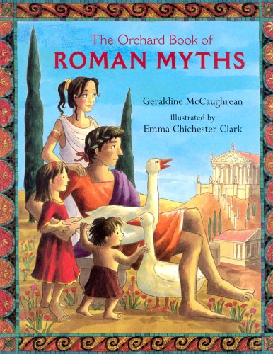 |  |  | 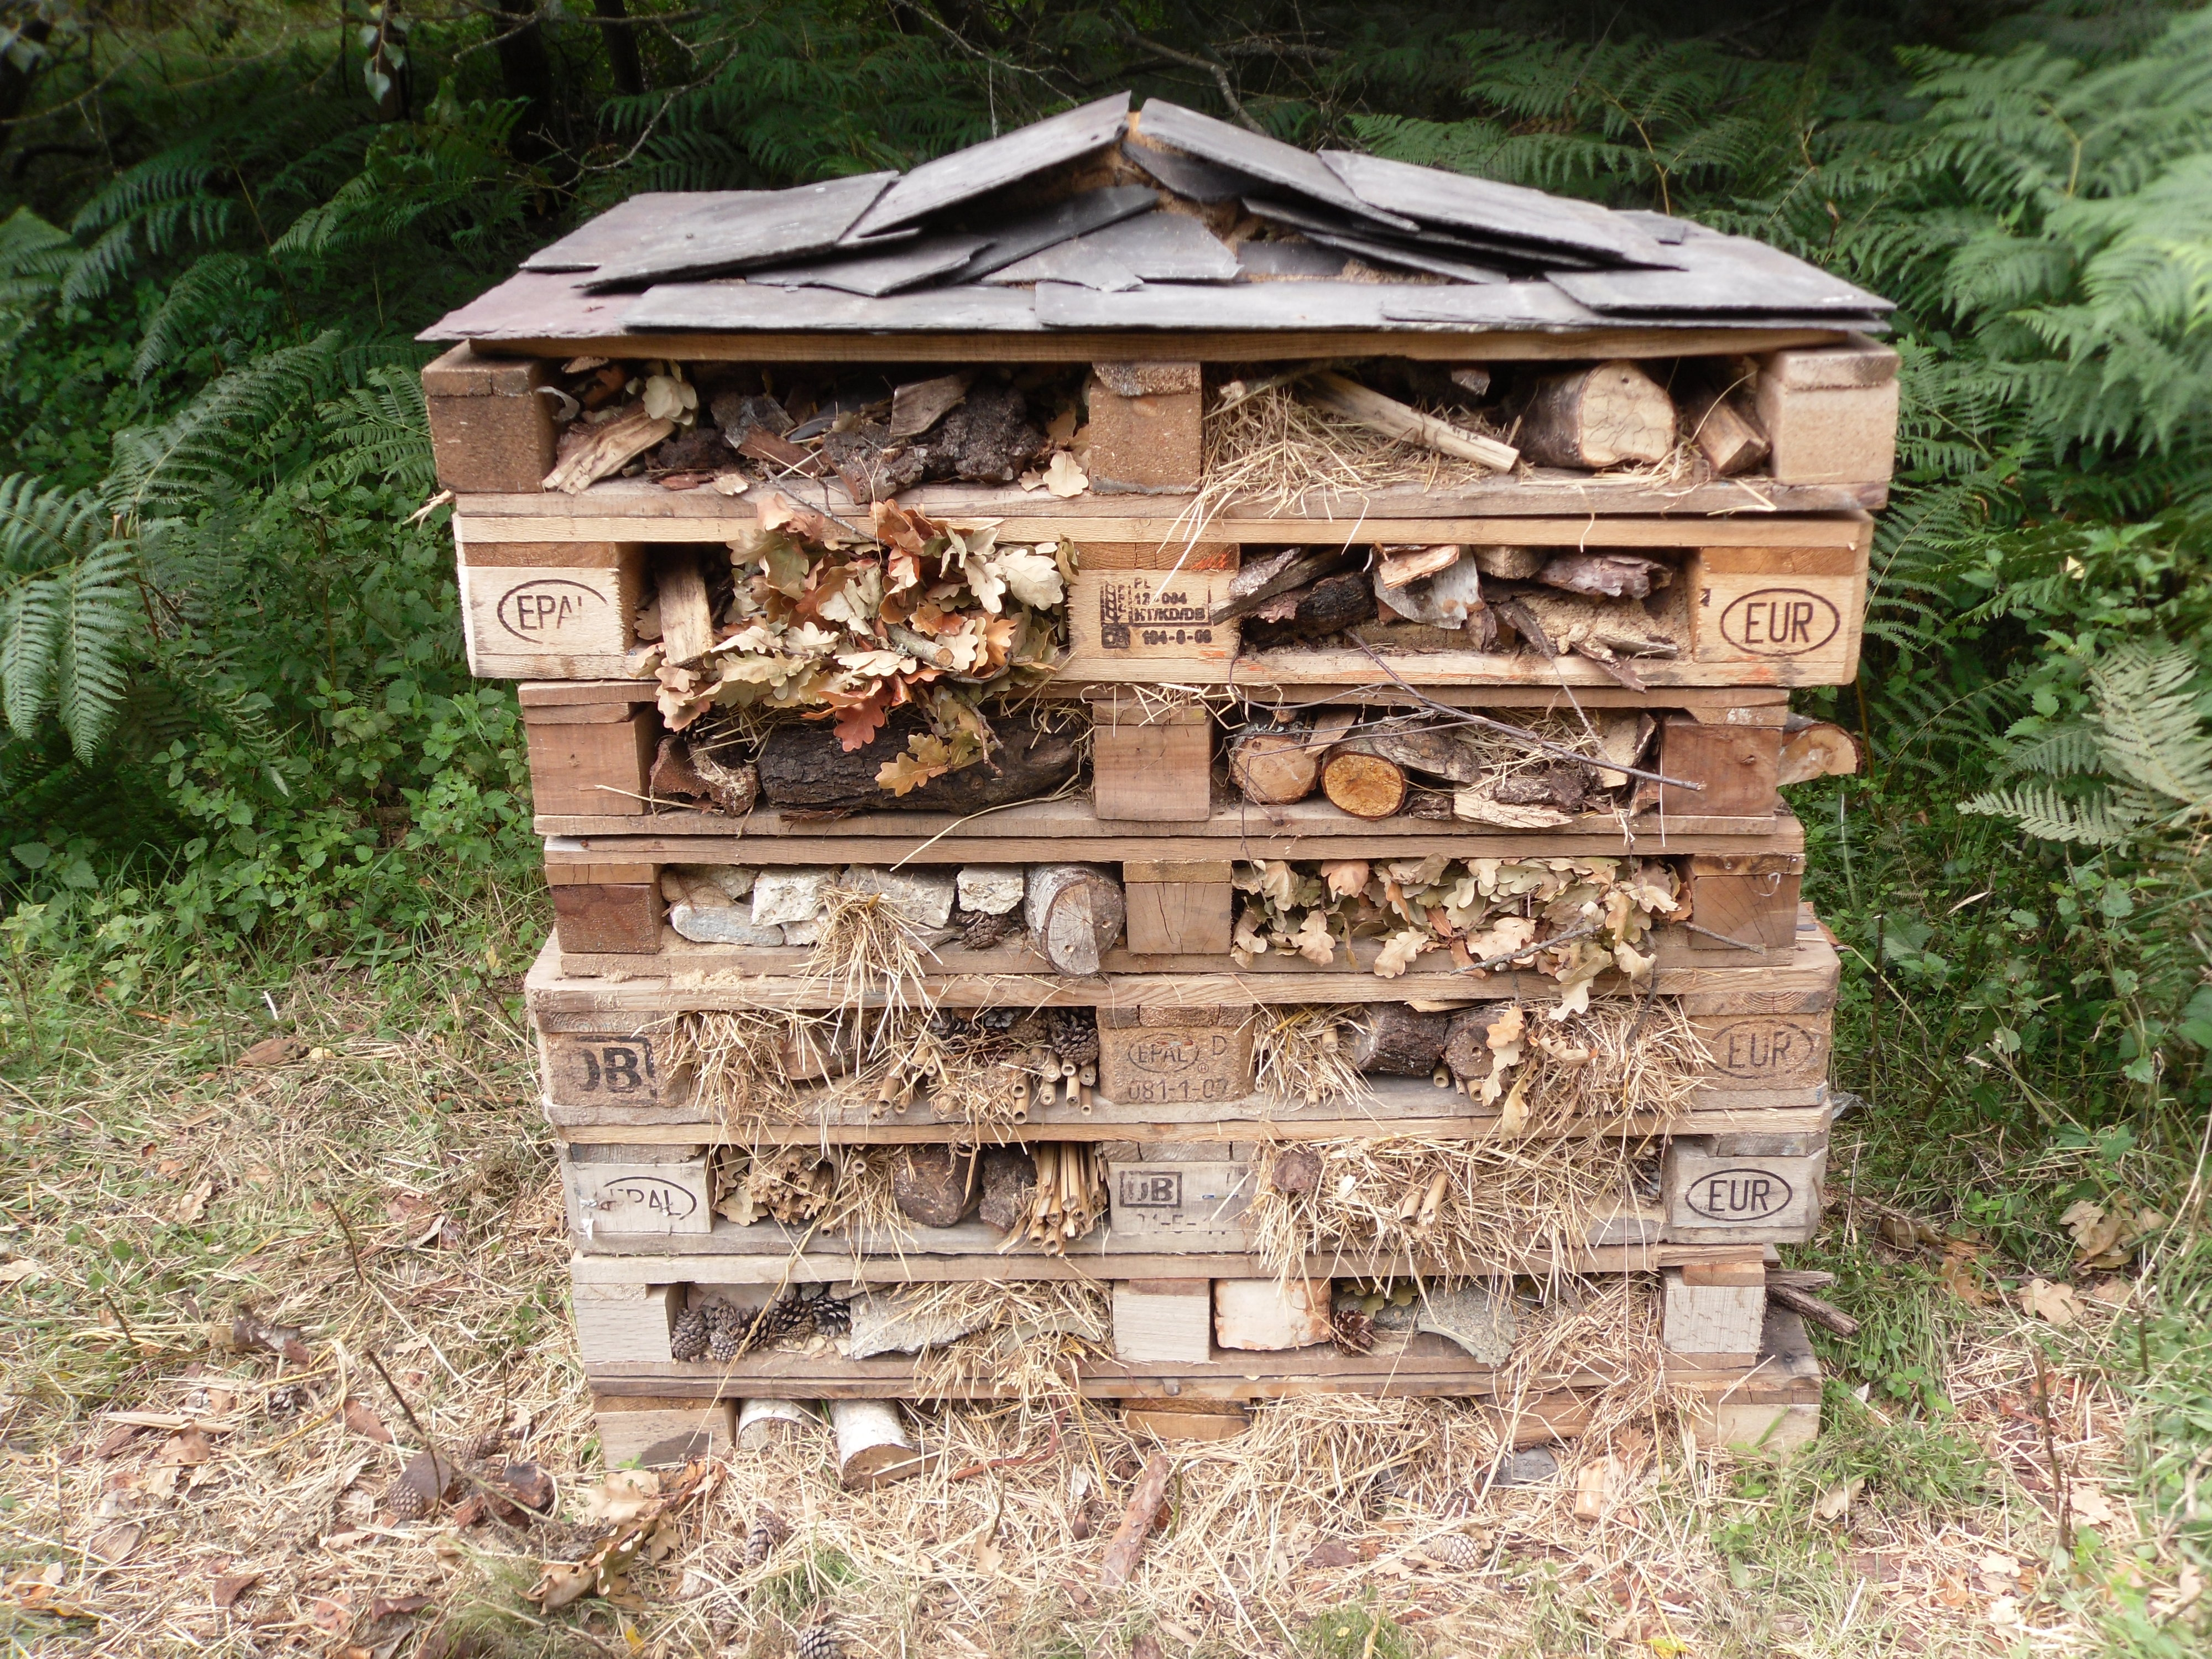  As Scientists we will find out about living things and their habitats. We will learn to describe the differences in the life cycles of a mammal, an amphibian, an insect and a bird. We will also describe the life process of reproduction in some plants and animals.
In DT we will be using CAD to design textiles.

In PE we will learn to play netball and develop our skills for net-based games and sports.

As Musicians we will be learning through the music scheme ‘Charanga’ using the song ‘Living on a prayer’ to focus on listening and appraising, singing, composing and performing.
As Historians we will study the Romans and their impact on Britain. We will learn about Julius Caesar’s attempted invasion, the Roman Empire and the power of its army. We will also learn about the impact of technology, culture and beliefs, including early Christianity |  |  | In RE we will look at how religion spreads around the world.  As French speakers we will be learning phrases linked to classroom language. We will revise how to say the letters in the French alphabet and to ask questions using a variety of question words.  In PSHCE we will be focusing on Myself and My Relationships: Beginning and Belonging.
In Computing we will learn about e-safety and using Purple Mash to develop our coding skills.

As Artists we will take our inspiration from the Roman crafts and technology and to make our own clay busts.

Supporting Learning at Home  - Mathletics:www.mathletics.co.uk – set on Fridays and due the following Thursday.  - Maths: Key Instant Recall Facts (KIRFs) will be sent home to learn each half term.  - Times Tables Please continue to practise multiplication tables up to 12 × 12 as this was a target for the end of Year 4.  - Spelling Children will be provided with a spelling activity to complete at home. This will be sent home on Fridays and should be returned on the following Thursday.  - Reading book Ideally read daily for at least 10-15mins. Children should fill in their reading rainbow bookmark which will be checked in school weekly. To receive their bronze reading award, they need to read three chapter books from the Year 5 book list plus two of their own choice.  - Bugclub: www.activelearnprimary.co.uk  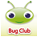  School code: qkc7 | Contact  For any queries or enquiries, please contact your child’s teacher using the email below:  nhart@pendragon.cambs.sch.uk  Please note that teachers will check their email up to 8.30am every morning, if you have an urgent message, please contact the office instead via phone or email, so that they can pass the message on to the class teacher. | PE Lessons  Please ensure that your child comes in to school wearing their PE kit, ready for PE on the PE days below:  PE is on Wednesdays and Thursdays.  If your child has long hair, please ensure they have a hair band, as long hair must be tied back for PE. It is expected that all children can remove watches/earrings for PE. If your child is unable to remove their own stud earrings these should be removed at home on PE days or micro-pore tape provided so they can cover them.  Thank you for your support with this.  The Haven and wellies  Each class will have a weekly time slot to use the Haven. Wellies should be brought into and kept in school so that this space can be used throughout the year. Lions Class will be using the Haven on Tuesdays.  Personal belongings in school  Your child should only come into school each day with their packed lunch, water bottle and reading book. All other resources that the children require for their learning will be provided by school.

