 | 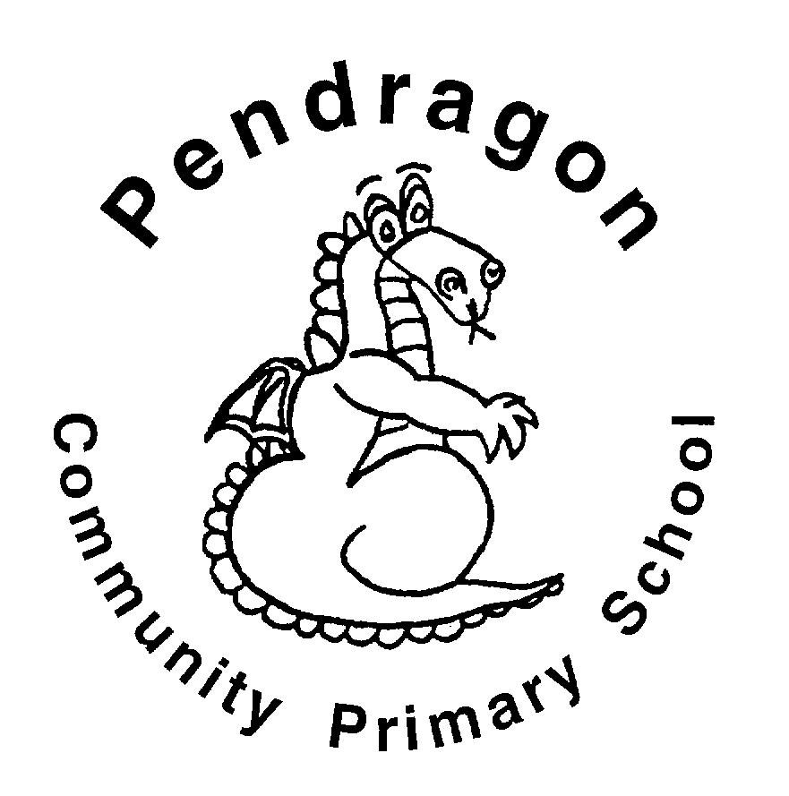 | Pendragon Community Primary School  Tiger Class – Mrs Millard
 | National Curriculum
 | As Readers we will read Viking sagas. We will investigate what makes speeches powerful and effective. We will explore playscripts. We will read non-fiction texts linked to learning in other subjects and will ask and answer questions based on our reading. |  |  |  | As Mathematicians we will be able to understand the number system and place value including larger numbers and make connections between addition, subtraction, multiplication and division. We will use fluent written methods to solve increasingly difficult problems. |  | As Writers we will write fact files, Viking sagas, speeches, playscripts and radio adverts. Based on learning in other subjects, we will plan and write texts of our own choice in Pendragon Writers' Club.
 | 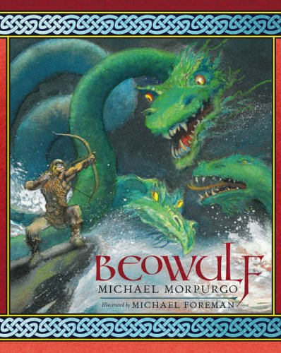 |  |  |  |  |  | 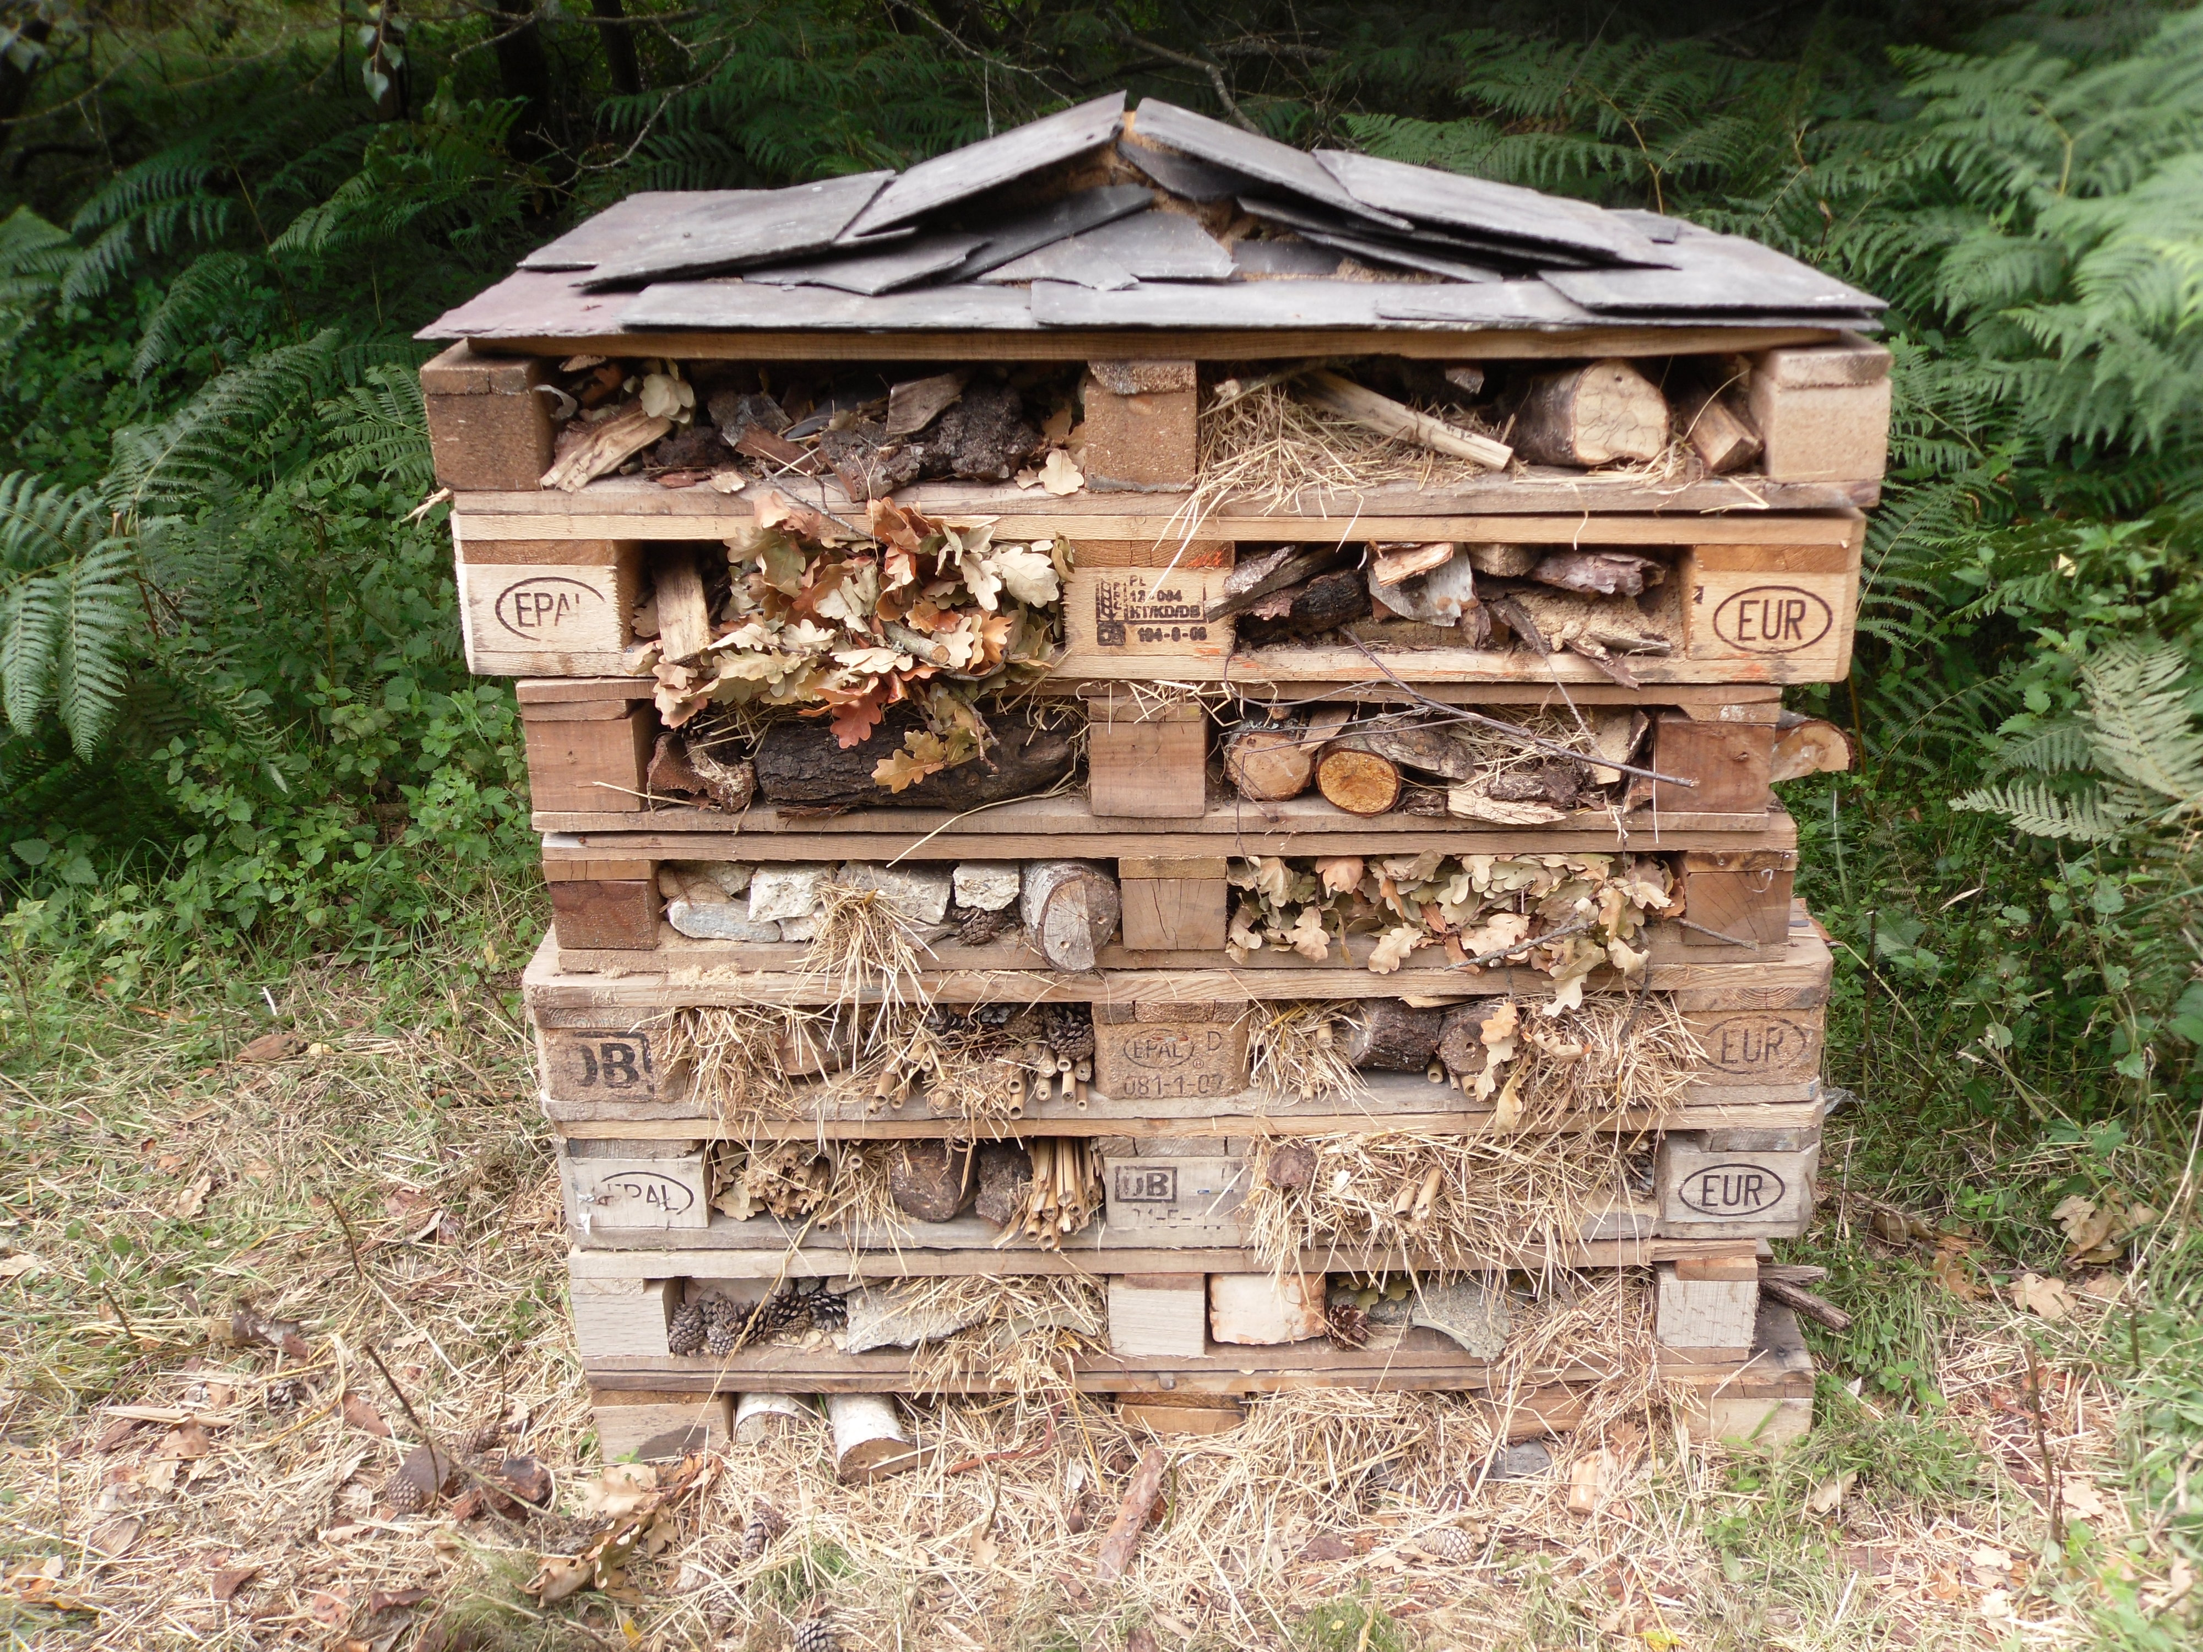  As Scientists we will find out about living things and their habitats. We will also be investigating forces.
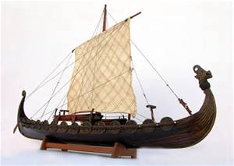
Year 5
Autumn Term

In DT we will study the design and structure of boats and make our own long ship.

In Computing we will learn about e-safety (staying safe online), develop our understanding of technology and digital literacy using a range of programmes, including Starz. We will further develop our coding skills through Kodu and Scratch and make our own Viking saga animations.
 | As Artists we will take our inspiration from the Anglo Saxon and Viking crafts and technology and to sketch and paint our own figure heads. |  |  |  |  |  | In RE we will look at how religion spreads around the world.  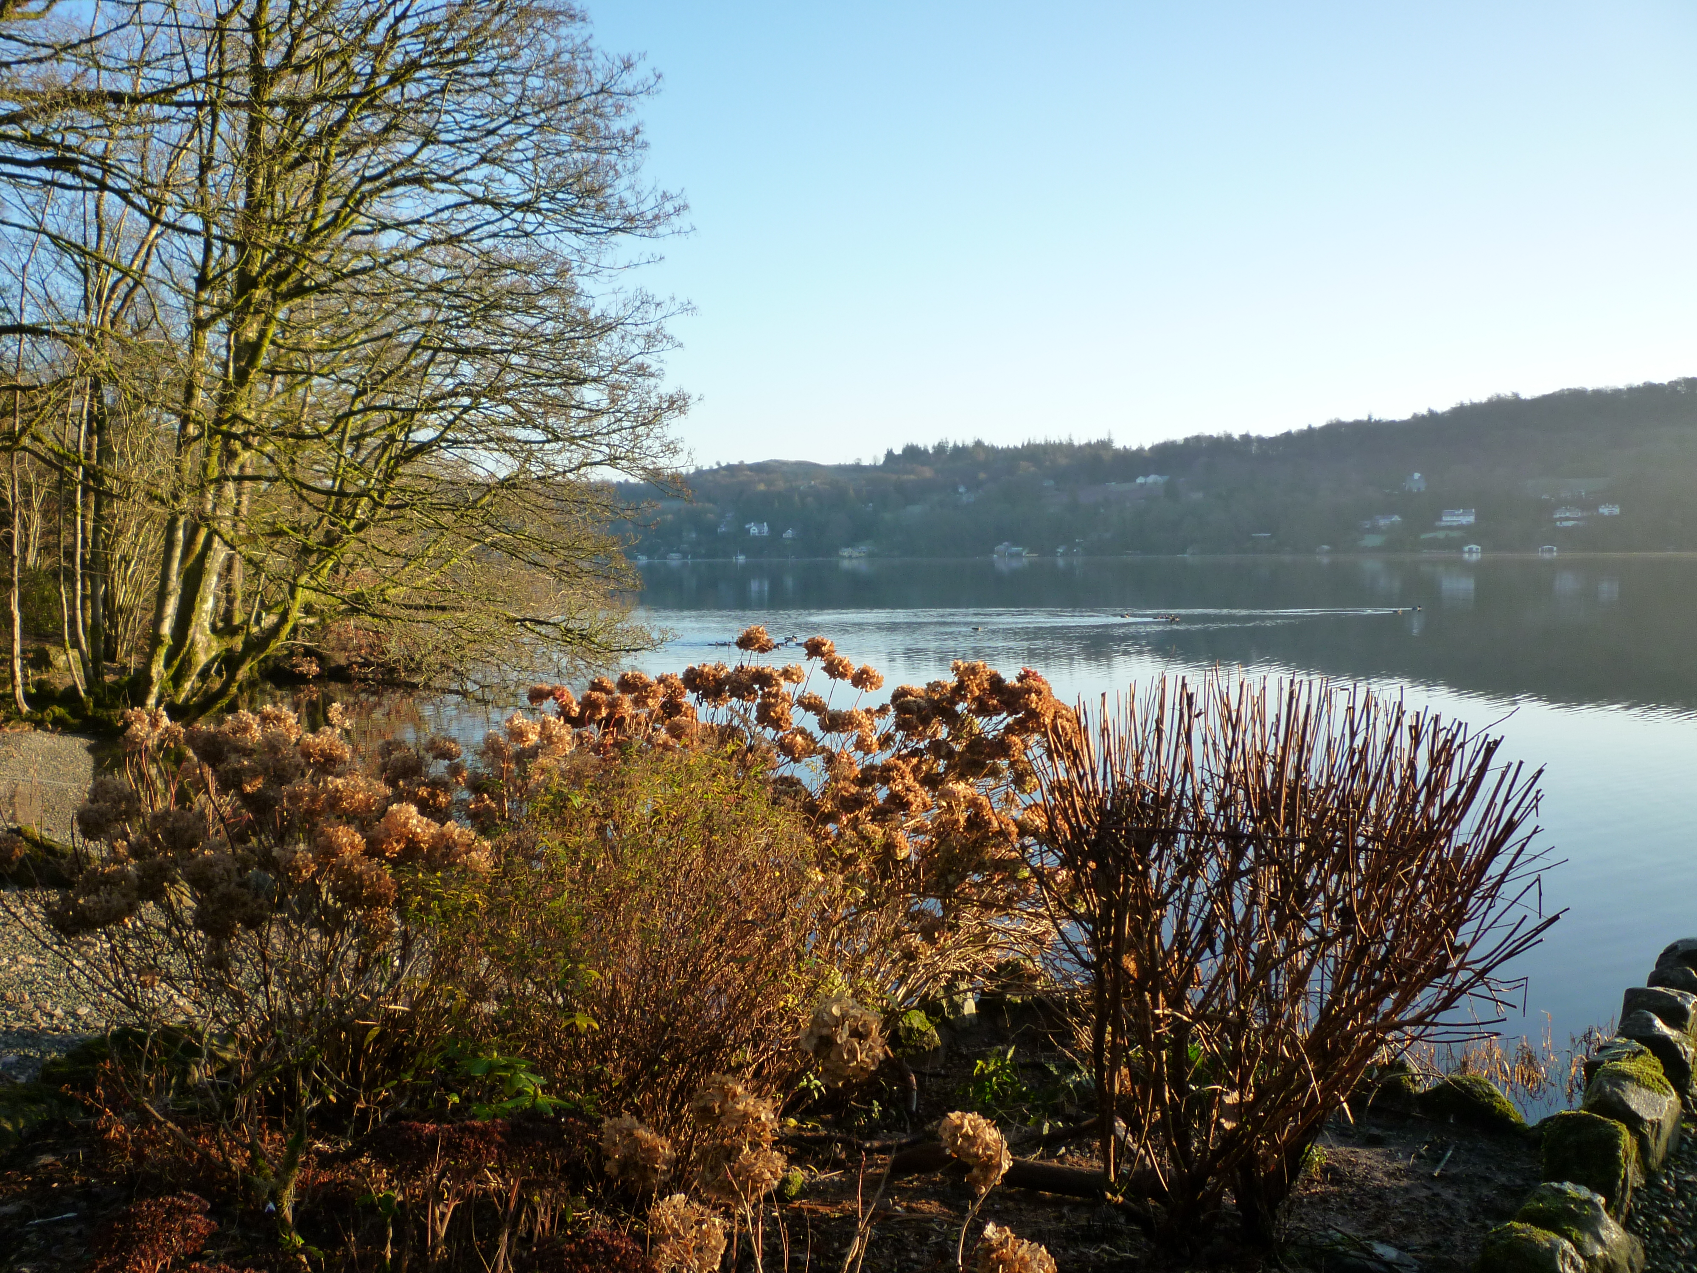I  In PSHCE we will think new beginnings, friendships and take part in anti-bullying week.  In PE we will develop our gymnastics skills, orienteering and invasion skills. We will also be playing games competitively and thinking of ways to improve and develop our skills.
As Musicians we will be using Charanga to listen and perform Christmas songs and Don’t stop believing. We will be considering the meaning of these songs and showing our understanding of these messages in our performance.

As Geographers and Historians we will study why the Angles, Saxons and Vikings chose to settle in Britain and how far they travelled around the world.

 | Curriculum Drivers
 | Enquiry and Risk Taking |  | Emotional Awareness |  |  | Ambition |  |  | Community and Diversity
 | As people with enquiring minds we will: |  | As emotionally aware people we will: |  |  | As people with ambition we will: |  |  | As members of a diverse community we will:
 | - Know that we can succeed and begin to know what we need to do to achieve goals (next steps).  - Take responsibility for our own learning and work hard.  - Try new things, express our doubts and fears and learn from our mistakes.  - Find out how others have challenged themselves to achieve their ambitions. |  | - When people settle in a new country how groups learn from each other.  - Examine the difficulties of settling in a new country.  - Consider how culture, technology and belief are influenced by the forming of new communities. |  |  | - Explore feelings of fear, nervousness and excitement.  - Think about how it feels to perform to an audience.  - Think about how it feels to be in danger.  - Explore the effects of anger and conflict and how to resolve this |  |  | - Use questions as the starting point for our learning e.g. what would we like to find out about the Vikings and Anglo Saxons?  - Ask and answer our own questions about the world e.g. Where would we settle if we were a Viking?  - Explore, experiment and work things out for ourselves in Design and Technology.
 | Use of our environment and the acquisition of knowledge of the world
Supporting Learning at Home  - Maths  Work will be provided to practise what has been learned in class as an activity on Mathletics:www.mathletics.co.uk  - Spelling.  Children will be provided with a spelling activity to complete at home. This will be sent on Friday and should be returned on the following Thursday.  - Reading  Ideally read daily with your child. Please make a comment and sign the reading record. Children can also read a range of books on Bug club: www.activelearnprimary.co.uk  - Multiplication Tables  Maths: Key Instant Recall Facts (KIRFs) will be sent home to learn each half term.  Children are expected to know all their multiplication tables up to 12 x 12 by the end of Year 4. If you know your child does not know them or struggles, please make sure they are learning and rehearsing these at home. |  |  |  | Year 6 Hilltop  There will be a meeting for any parents and children interested in the year 6 trip this term, Details will follow in a letter. If you have any queries in the meantime, please email Mr Pritchard at: spritchard@pendragon.cambs.sch.uk  Library Books  Our Library session, when library books can be changed, is Friday. Please remember it is also open at lunch times.  West Stow  We will be planning a trip to West Stow- details to follow in a letter.  Contact  Please feel free to come and talk to me about any concerns you may have. You can catch me for quick questions before and after school, or make an appointment by contacting the office or e-mailing directly.  Mrs Millard: cmillard@pendragon.sch.uk |  |  |  | PE Lessons  Please ensure that PE kit is in all week, as the days may change to accommodate the weather.  Indoor PE is on Monday and outdoor PE is on Wednesday. All uniform and kit must be named or it is difficult to reunite it with your child if it gets muddled up!  If your child has long hair, please ensure they have a hair band, as long hair must be tied back for PE. It is expected that all children can remove watches/earrings for PE. If your child is unable to remove their own stud earrings these should be removed at home on PE days or micropore tape provided so they can cover them.  Thank you for your support with this.

