 | 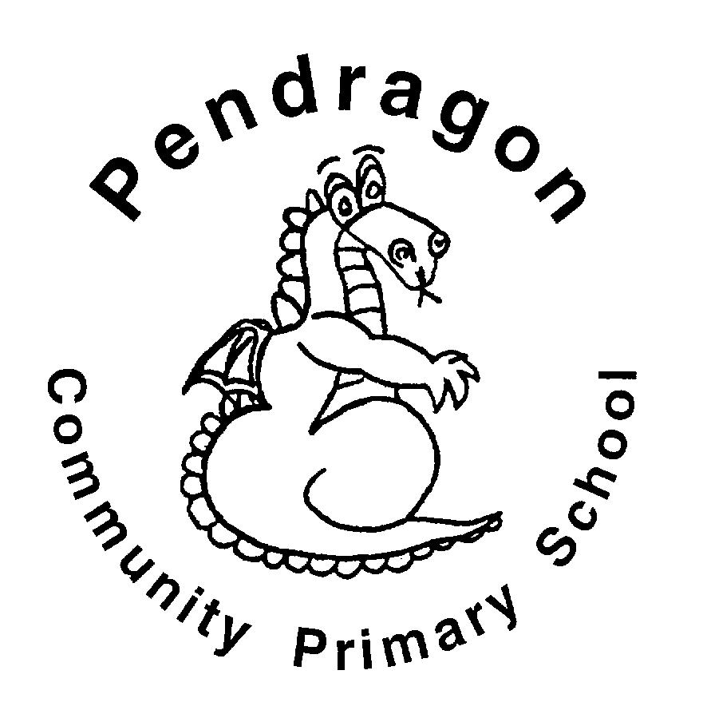 | Pendragon Community Primary School  Summer Term  Tiger Class – Mr Pritchard |  |  |  |  |  |  |  | 
 | National Curriculum
 | As Readers we will read myths and legends from Ancient Greece, and look at a variety of explanation texts. Later in the term we will be reading The Highwayman and be exploring arguments.   |  |  |  | As Mathematicians we will be learning about fractions (equivalence, ordering and comparing, and calculating). We will also be converting measures including area, perimeter and volume. In addition we will be learning about percentages, 2D and 3D shape, comparing, measuring and drawing angles, interpreting timetables and statistics. We will apply our skills to problem solving. |  | As Writers we will write a Greek myth inspired by the range of examples we have read. To link with our Science, we will be writing an explanation based on a concept to do with Earth and Space. In addition we will be writing a sequel to The Highwayman. Based on learning in other subjects, we will plan and write texts of our own choice in Pendragon Writer’s Club.
 |  |  |  |  |  |  | As Scientists we will be learning about the Earth and Space. Later in the term we will be exploring animals and humans linking with our SRE.
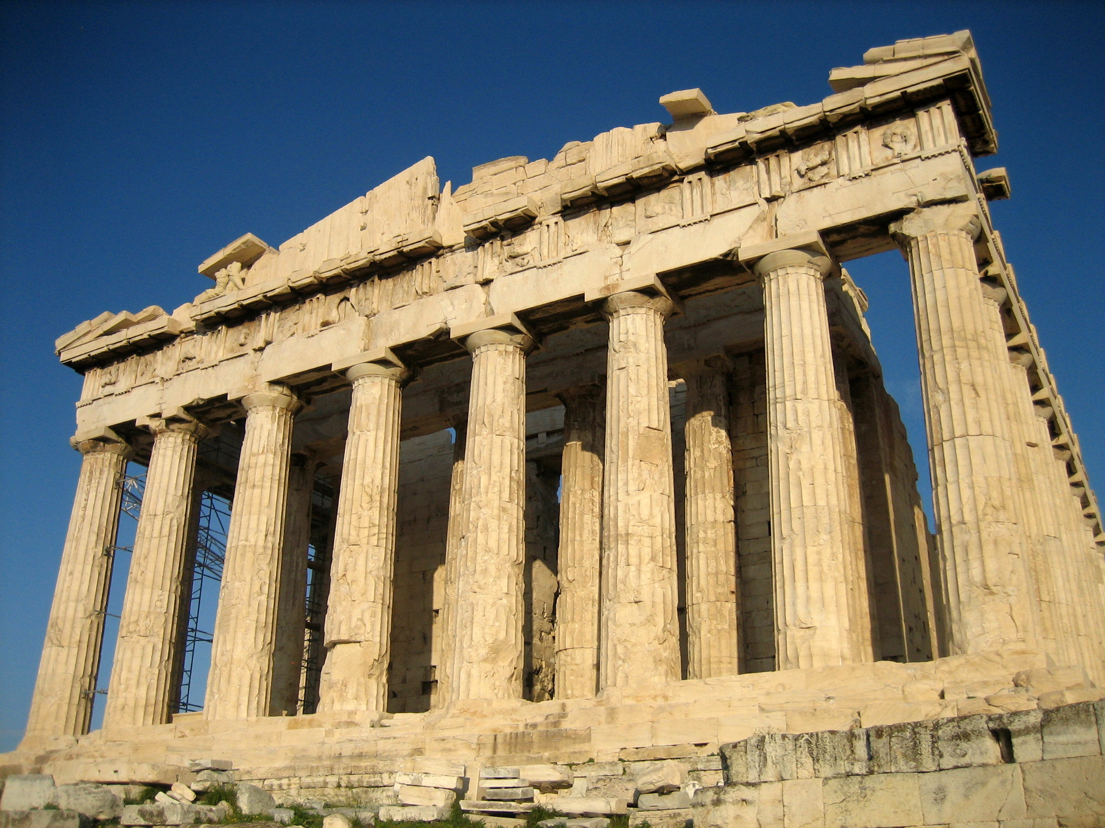

In Computing we will continue learning about e-safety and work towards our Gold certificates. We will link this to developing our understanding and safe usage of the online learning platform Starz. We will further develop our skills of coding by making labyrinth games using Scratch.
 | As Artists we will mimic the way Greeks made and decorated pots. In DT we will be creating a labyrinth to fit in with our Greek theme. We will need shoe boxes for our constructions so please get collecting! |  |  |  |  |  | In RE we will be thinking about the way Jesus is/was interpreted and followed. We will also be exploring the impact and inspiration that Jesus has had on people all over the world.  ?  As Musicians we will listen to the music of others; compose our own music and perform using a variety of instruments.  In PE we will develop athletic skills and complete Play Leader Training with the option to then lead lunch time activities.
In PSHE we will be considering and discussing diversity and communities both locally, nationally and globally. This includes developing children sense of personal identity and self-worth, as well as considering and respecting the views of others. Later in the term we will be doing SRE (Sex and Relationships Education).

As Historians we will be learning about Ancient Greece including: Greek democracy, the Trojan war, Gods and Hero’s, and Athens and Sparta.

 |  |  |  |  |  |  | .
 | Curriculum Drivers
 | Enquiry and Risk Taking |  | Emotional Awareness |  |  | Ambition |  |  | Community and Diversity
 | As people with enquiring minds we will: |  | As emotionally aware people we will: |  |  | As people with ambition we will: |  |  | As members of a diverse community we will:
 | - Use questions as the starting point for our learning e.g. what would I like to know about Ancient Greece?  - Ask and answer our own questions about the world e.g. what was life like as an Ancient Greek?  - Consider the diversity and communities locally and globally.  - Comparing our life with that of the Greeks. |  | - Think about our identities and consider our own self-worth.  - Consider what it must feel live in Ancient Greece.  - Explore the effects of changes in ourselves and the people around us.  - We will be using Moments of Mindfulness to reflect on our emotions. |  |  | - Know that we can succeed and begin to know what we need to do to achieve goals (next steps).  - Take responsibility for our own learning and work hard.  - Try new things, express our doubts and fears and learn from our mistakes.  - Find out how others have challenged themselves to achieve their ambitions. |  |  | - Consider how communities in different locations are built up.  - Study how communities are made up of a diverse range of groups.  - Consider the democracy of the Ancient Greek community.
 | ← ← ← ← Use of our environment and the acquisition of knowledge of the world → → → →
Supporting Learning at Home  - Maths  Work will be provided to practice what has been learned in class as an activity on Mathletics:www.mathletics.co.uk  - Spelling.  Children will be provided with spellings to complete at home. This will be sent on Friday and should be returned on Thursday  - Reading book h  Ideally read daily for at least 10-15mins using a variety of materials including Bug Club.  - Bug club: www.activelearnprimary.co.uk  - Library Books  Our Library session, when library books can be changed, is Friday. |  |  |  | SRE Meeting  We will be hosting an SRE meeting for parents so you are aware of the upcoming curriculum and also to answer any questions you may have. Dates to follow.  Greek day  We will be hosting an Ancient Greek day in Year 5. Dates to follow.  Mike Muller visit  We are very excited that Mike will be joining Year 5 and facilitating Growth Mind-set workshops linked to his BMX skills.  Contact  Please feel free to come and talk to me about any concerns you may have. You can catch me for quick question before and after school, or make an appointment by contacting the office or e-mailing directly.  Mr Pritchard  spritchard@pendragon.cambs.sch.uk |  |  |  | PE Lessons  Please ensure that PE kit is in all week. With the weather improving, it is likely we will go outside more often. PE is on Tuesday and Thursday. All uniform and kit must be named or it is impossible to reunite it with your child if it gets muddled up! If your child has long hair, please ensure they have a hair band, as long hair must be tied back for PE. It is expected that all children can remove watches/earrings for PE. If your child is unable to remove their own stud earrings these should be removed at home on PE days or micropore tape provided so they can cover them.  Thank you for your support with this.

