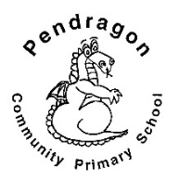 | Pendragon Community Primary School  Leopards and Panthers Class – Miss White and Miss Safranek |  |  | 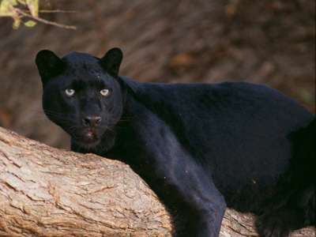
National Curriculum
How is life different to that of our ancestors?
As Readers we will read a variety of texts linked to our written tasks. We will read and recognise features of newspaper reports and read plays and poems by William Shakespeare, with focus on ‘The Twelfth Night’. |  | 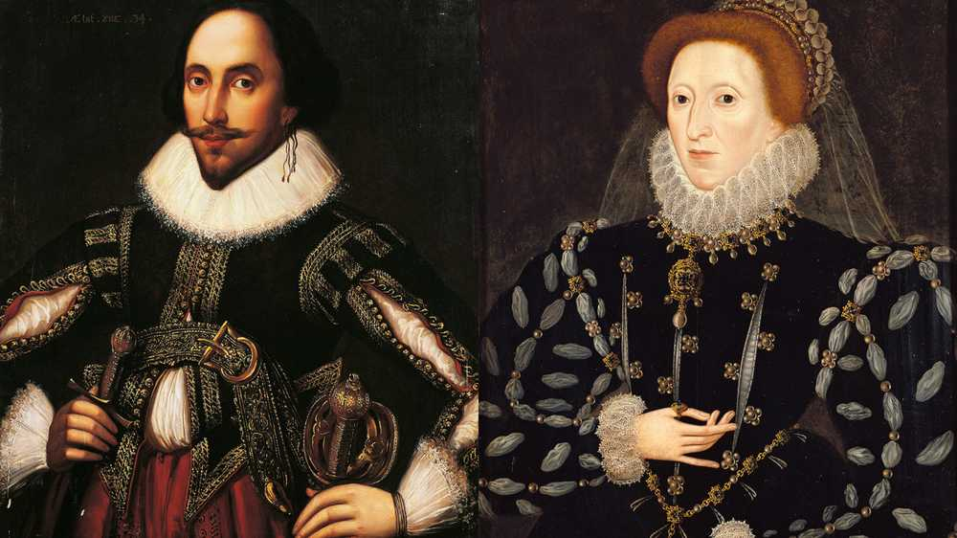  Year – 4  Spring 2 | As Writers, we will be using talk for writing to learn a finding tale, ‘The adventure at sandy cove.’ We will be writing our own finding tales, focusing on a detailed character description.
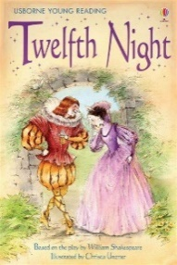  sta  In DT we will design and create our own theatre stage inspired by a Shakespearian play. With our knowledge of electrical circuits, we will add lighting to our theatres. |  |  | As Linguists we will be expanding our French vocabulary by learning the names for different parts of the face and body.  As Scientists we will be looking at the water cycle in more detail and the different scientific processes. We then will think about how hydroelectricity, linking back to our electricity unit.
 |  | How has Shakespeare changed the language we use today?
As Historians we will be learning about the writer William Shakespeare and how he has changed the language we use today. This unit will build on our knowledge about the Shakespeare’s plays studied throughout the school. We will learn about the playwright William Shakespeare and the period of history when he lived.  In PSHCE we will focus on healthy living and making healthy choices for our wellbeing.  In Computing we will be using Purple Mash software to explore how font size and style can affect the impact of text. We will a simulated scenario to produce news reports and write a community campaign.  As Musicians we will be learning through the online music scheme ‘Charanga’. Our Units this term are ’10 pieces’ and ‘Glockenspeil’ |  |  | In PE we will be creating and performing our own conditioning phrases in gymnastics. We will focus on rotation, and how we can transition between movements. We will also be learning multi skills applicable to other sports for our outdoor PE.  As Mathematicians we will be exploring problems involving measures, including conversions and money. We will look at properties of shape and symmetry. We will be learning to calculate with decimal numbers and to add and subtract fractions with the same denominator. We will learn about finding fractions of quantities, equivalent fractions, and ordering and comparing fractions.
Supporting Learning at Home  - Mathletics:www.mathletics.co.uk – set on Fridays and due the following Friday.  - Maths: Key Instant Recall Facts (KIRFs) will be sent home to learn each half term.  - Times Tables A target for the end of Year 4 is for children to know their multiplication tables up to 12 × 12. It is important for children to practise their tables regularly. Early notice, all Year 4 children will complete a statutory multiplication times table check in early June 2021.  - Spelling Children will be provided with a spelling activity to complete at home. This will be sent home on Fridays and should be returned on the following Thursday.  - Reading book Ideally read daily for at least 10-15mins. Children should bring their reading record book to school each day.  - Bugclub: www.activelearnprimary.co.uk  School code: qkc7 | Contact  For any queries or enquiries, please contact the office using the email below:  office@pendragon.cambs.sch.uk  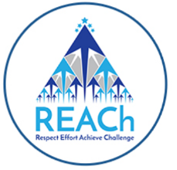 | PE Lessons  Please ensure that your child comes in to school in their PE kit, ready for PE on the PE days below.  PE in Leopards is on Thursdays and Fridays.  PE in Panthers is on Mondays and Thursdays.  If your child has long hair, please ensure they have a hair band, as long hair must be tied back for PE. It is expected that all children can remove watches/earrings for PE. If your child is unable to remove their own stud earrings these should be removed at home on PE days or micropore tape provided so they can cover them.  Thank you for your support with this.  The Haven and wellies  Each class will have a weekly time slot to use the Haven. Wellies should be brought into and kept in school so that this space can be used throughout the year.  Personal belongings in school  Your child should only come into school each day with their packed lunch, water bottle and reading book. All other resources that the children require for their learning will be provided by school.

