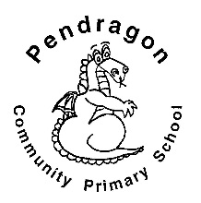 | Pendragon Community Primary School  Sand Cats – Mrs Smart

National Curriculum
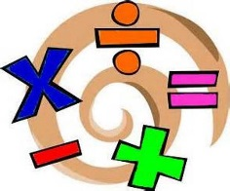  As Mathematicians we will develop our understanding of number and place value, by counting, grouping objects and exploring patterns. |  |  |  | As Writers we will write a range of texts linked to different areas of learning, including character descriptions, recounts and mini-adventures. Based on our other learning we will plan and write texts in Pendragon Writers Club.  As Readers we will read, listen to and discuss texts about superheroes and heroes. We will read non-fiction texts linked to our History and Science learning and will ask and answer questions based on our reading.  Year 2 - Autumn 1  Heroes  Why were Florence Nightingale and Mary Seacole heroes?  In RE we will learn about Harvest celebrations in different countries around the world.  As Musicians we will learn to sing and perform some Harvest songs |  | As Scientists we will learn about humans and animals. We will learn about the main parts of the human body and investigate the basic needs of humans for survival and the importance of exercise, hygiene and a balanced diet. |  |  | 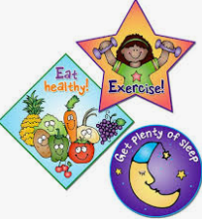
As Historians we will be finding out about the life of a significant person from history – Florence Nightingale. We will start by looking at what a hero is and then consider the impact that Florence Nightingale (& Mary Seacole) had. |  | 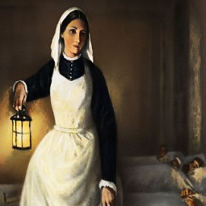 |  |  |  |  |  | As Design Technologists we will use our knowledge of healthy balanced diets to design, cook and evaluate simple dishes. We will develop our basic skills in preparing ingredients by hygienically cutting / peeling / grating and weighing/ measuring amounts.
As Geographers we will use world maps, atlases and globes to find important places that link to our learning in other subjects.  In Computing we will learn about online safety and coding  In PSHCE we will be exploring the topics of rights and responsibilities. |  |  |  |  |  | As Artists we will learn a variety of drawing techniques and use a range of media to create fruit cross-sections and self-portraits.
 |  |  |  |  |  | In PE we will refine the skills of running and changing directions on the move. We will develop throwing, catching, striking and dribbling skills. We will also learn the skills and knowledge needed to ride our scooters safely in Scootability lessons.
Pendragon Community Primary School

Sand Cats Class – Mrs Smart

Supporting Learning at Home  - Weekly phonics/spelling (usually given out and returned on Mondays).  - Maths: www.mathletics.co.uk - Tasks set by teacher to be completed by deadline. Number facts (KIRFs) to be sent home each half-term with weekly activities to help the children practise.  - Reading book Ideally read daily for at least 10-15mins. Children should bring their reading record book to school each day.  - Bug Club: School code – qkc7  www.activelearnprimary.co.uk  Read a book online and take the quiz – It really helps the development of comprehension skills.  - Extended learning – if your child would like to extend their learning by carrying out their own research, writing, drawing or visiting a place of interest linked to their class topic, we welcome them to share their learning/work with the class. | Contact  For any queries or enquiries, please contact the office using the email below:  office@pendragon.cambs.sch.uk  The office will forward your message on to the class teacher. If you have an urgent message, please continue to call the office. | PE Lessons  Please ensure that your child comes in to school in their PE kit, ready for PE on the days below.  PE is on Mondays (Scootability) and Tuesdays (Outdoor)  If your child has long hair, please ensure they have a hair band, as long hair must be tied back for PE. It is expected that all children can remove watches/earrings for PE. If your child is unable to remove their own stud earrings these should be removed at home on PE days or micropore tape provided so they can cover them.  Thank you for your support with this.  The Haven and wellies  Each class will have a weekly time slot to use the Haven. Wellies should be brought into and kept in school so that this space can be used throughout the year.  Personal belongings in school  Your child should come into school each day with their packed lunch, water bottle and reading book only. All other resources that the children require for their learning will be provided by school.

