Pendragon Community Primary School

Sand Cats Class – Mrs Smart

National Curriculum
As Mathematicians we will develop our understanding of methods of multiplication and division. We will learn to how to make amounts of money and find change. |  | 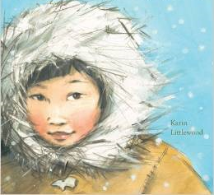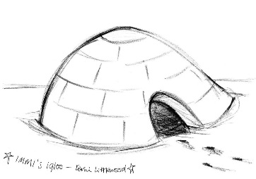 |  | As Writers we will explore vocabulary in poem and stories and try out new words. We will write stories following patterns in those we have read and write reports linked to our learning in Science and Geography. Based on our other learning we will plan and write texts of our own choice in Pendragon Writers Club.
As Artists we will explore a range of sketching, painting and collage techniques linked to the theme of ice and winter landscapes. |  |  |  | As Readers we will read poems to develop our vocabulary; read, listen to and discuss stories and non-fiction books, giving our thoughts and opinions.
Year 2 – Spring 1

Fire & Ice
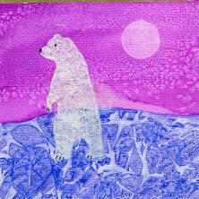 |  |  |  | As Scientists we will investigate the suitability of different materials for particular uses. We will learn about how materials can be changed by squashing, bending, twisting and stretching. We will learn more about polar habitats and the living things found there.
As Geographers we will revisit the world’s continents and oceans and use maps, atlases, globes and information texts to explore weather and climate in the UK and around the world.
As Musicians we will explore timbre, tempo and dynamics. We will learn new songs for our production. |  | In Computing we will learn about what algorithms are; how they are implemented as programs on digital devices; and that programs execute by following precise and unambiguous instructions. |  | In RE we will read and listen to stories from Hinduism.
In PE we will develop our movement skills in gym and in games will develop skills in throwing, catching, aiming and striking. |  |  |  | In PSHCE we will continue to explore citizenship themes of friendship, working together and going for goals!
Curriculum Drivers
Ambition | Community and Diversity |  | Emotional Awareness |  | Enquiry and Risk Taking
As people with ambition we will: | As members of a diverse community we will: |  | As emotionally aware people we will: |  | As people with enquiring minds we will:
- Know that we can succeed and begin to know what we need to do to achieve goals (next steps).  - Take responsibility for our own learning and work hard.  - Try new things, express our doubts and fears and learn from our mistakes.  - Find out how others have challenged themselves to achieve their ambitions. | - Find out more about the global journeys our families have made and why. |  | - Explore feelings of fear, nervousness and excitement.  - Consider how working together in pairs and groups makes us feel and how we can respond to this. |  | - Use questions as the starting point for our learning e.g. Who is…? Where do they live…? Why do they…? What is the best material for…?  - Ask and answer our own questions about the world e.g. What is it like in the Arctic / Antarctic?  - Explore, experiment and work things out for ourselves.
← ← ← ← Use of our environment and the acquisition of knowledge of the world → → → →

Supporting Learning at Home  - Weekly phonics/spelling to be sent home at the beginning of each week and returned after the weekend.  - Maths: www.mathletics.co.uk - Tasks set by teacher to be completed by deadline. Number facts (KIRFs) to be sent home each half-term.  - Reading book or Bug Club – ideally every day – it makes a real difference. Please make a comment and sign the reading record – and remind your child to change their book when they need to.  - Bug Club: School code – qkc7  www.activelearnprimary.co.uk  Read a book online and take the quiz – It really helps the development of comprehension skills.  - Library Books - our Library session, when library books can be changed, is Thursday. | Support in Class  We really need some more help to hear children read. If you can help, please let us know and we can arrange a convenient time.  If you cannot commit on a regular basis please do feel you can offer ‘one-off’ support too.  Please feel free to come and talk to me about any concerns you may have. You can catch me for quick questions before and after school, or make an appointment by contacting the office or e-mailing directly.  Mrs C Smart  csmart@pendragon.cambs.sch.uk | PE Lessons  These take place on Tuesday and Thursday afternoons.  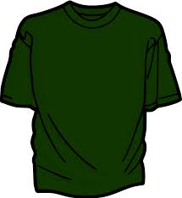  Named kit to be kept in school:  - Indoor: shorts and a t-shirt.  - Outdoors: jogging bottoms or shorts, t-shirt and trainers.  - A hairband for tying back long hair.  It is expected that all children can remove watches and earrings for PE. If your child is unable to remove their own stud earrings these should be removed at home on PE days or micropore tape provided from home so they can cover them. If your child wears trainers to school, please ensure that they have a change of trainers for PE to prevent water and mud being brought inside.  Thank you for your support with this.

