 | 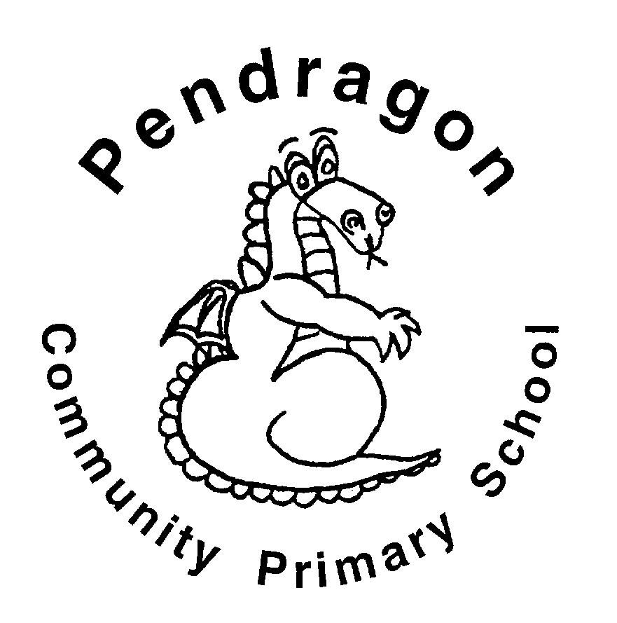 | Pendragon Community Primary School  Cubs Class – Mrs Marshall
 | Early Years Foundation Stage
 | Communication and Language  - Listening to stories, poems and non-fiction, responding to the different genres  - Talking about the books we read and answering questions to check comprehension  - Listening to others – adults and friends  - Asking and answering questions  - Talking to each other about what we do, learn and the things we make  - Learning new vocabulary linked to the theme  - Following instructions  - Retelling familiar stories using a range of sequencing words including first, next, then, after, after that, luckily, unluckily and finally  Personal, social and emotional development  - Continuing to reflect on the ‘5 ways to wellbeing’ within everything we do  - Developing independence as we complete work  - Following our school motto REACh  - Sharing and taking turns with others  - Exploring how our behaviour can affect others  - Talking about ways we can keep ourselves safe and healthy including the food choices we make, exercise, sleep and ways to stay clean  Physical Development  - Travelling in different ways and combining various movements including walking, skipping, running, jogging, hopping, marching and crawling  - Further our ball and racket skills when balancing a ball, patting it up in the air and striking it  - Developing our aiming skills when throwing a beanbag at a target  - Using a variety of tools and media such as pens, pencils, chalk, pastels and paintbrushes to create detailed pictures  - Continuing to form cursive graphemes for writing |  |  | Let it grow  What makes our planet amazing?  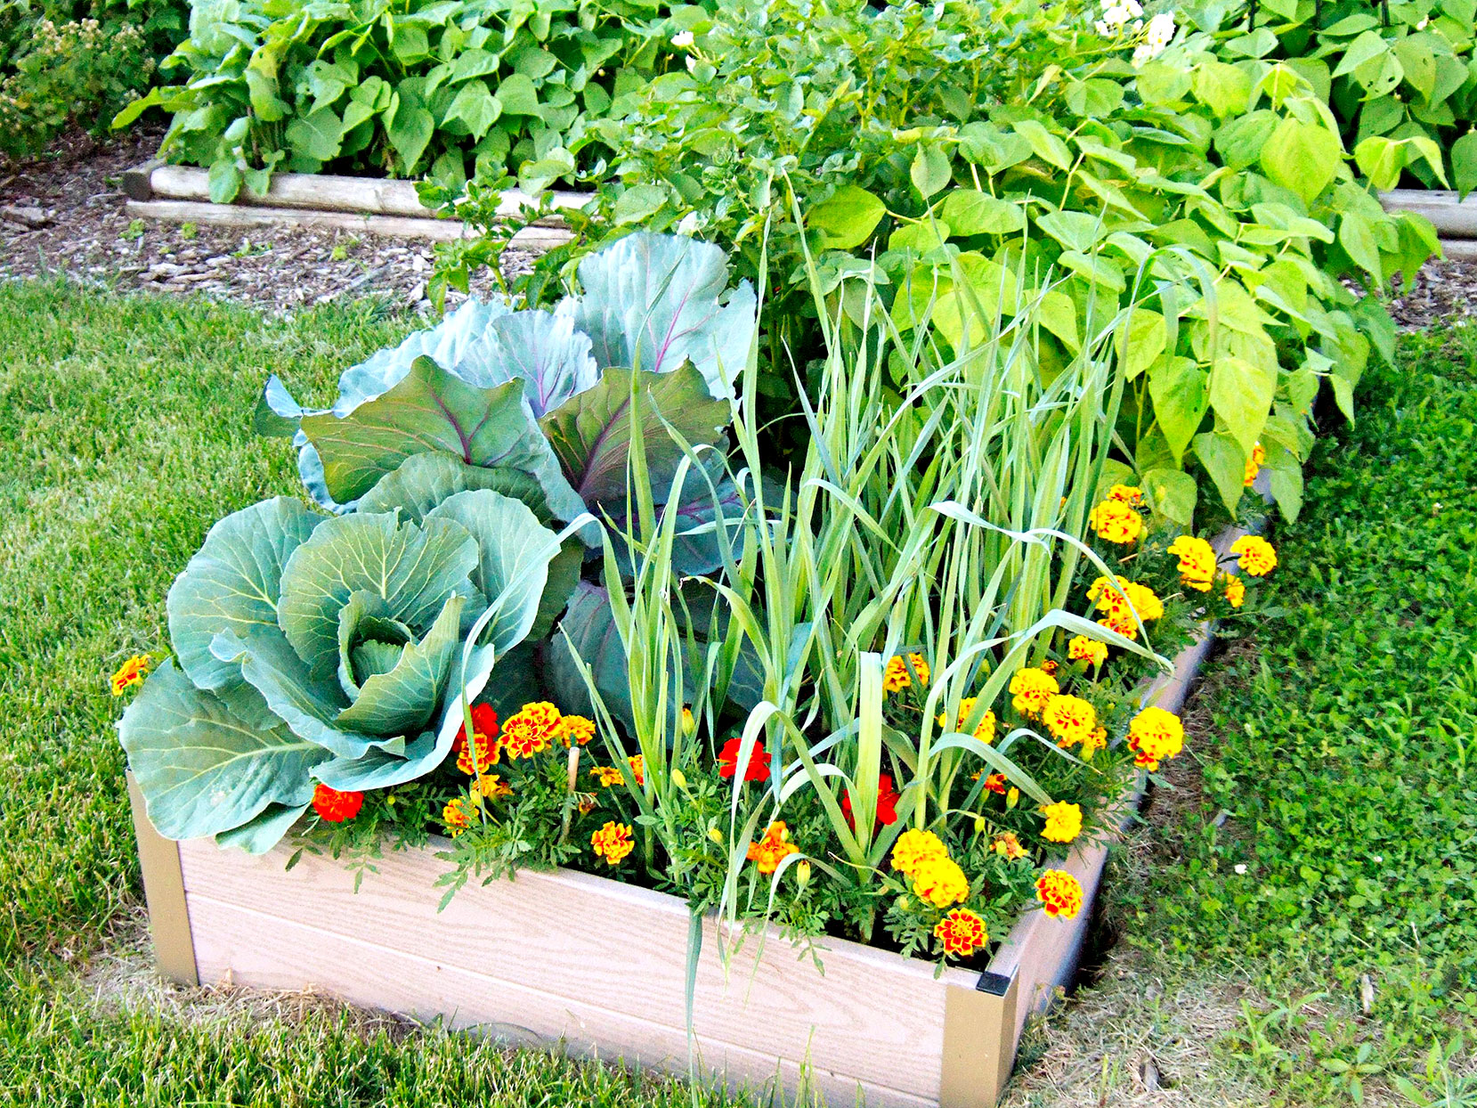  Characteristics of Effective  Teaching and Learning  Characteristics of Effective  Teaching and Learning  Playing and Exploring – engagement  Finding out and exploring  Playing with what they know  Being willing to ‘have a go’  Active Learning - motivation  Being involved and concentrating  Keep on trying  Enjoying achieving what they set out to do  Creating and Thinking Critically  Having their own ideas  Making links  Choosing ways to do things | Literacy  - Phase 4 phonics learning to read and spell words containing adjacent consonant clusters  - Reading key words by sight  - Writing simple sentences including finger spaces between words, using a capital letter to start and a full stop to end.  - Exploring a range of texts including fiction, non-fiction and poetry  Maths  - Recognising and ordering numbers up to 20  - Number sense to 10 including learning addition and subtraction facts for numbers up to 7  - Subitising 1 to 6 using dotty patterns  - Counting in 2s up to 20  - Recognising more and fewer when comparing numbers and quantities of objects  - Exploring length, mass and capacity  - Understanding words related to time including knowing the days of the week.  - Identifying the value of coins, make amounts and finding the total of two items  Understanding the World  - Developing an understanding about plant growth by growing our own and taking care of these  - Naming different plants and labelling key parts  - Observing seasonal changes in Spring  - Exploring where in the world fruit and vegetables are grown and locate these on a map  - Explore similarities and differences within the local environment  Expressive Arts and Design  - Using materials and other resources to design and create  - Singing nursery rhymes and other songs  - Recreating stories and experiences using small world and when in the role play area
Supporting Learning at Home  - Learning Overview  An overview of learning will be sent home fortnightly, please read as this will give you a really good insight into what your child has been learning over a two-week period and how you can support at home. First overview will be sent Friday 29th April.  - Maths:  Key Instant Recall Facts (KIRFS) sent home during the autumn and spring terms and this week (also available on the website)  Mathletics: www.mathletics.co.uk  - Reading:  School reading scheme book – Every Monday your child will bring a book home to read with you. This book should be discussed and read more than once before for returning on Friday.  Every Friday, your child will choose a book from our Early Years sharing library – snuggle up and enjoy together!  Bug Club: www.activelearnprimary.co.uk  More books for your child to access. You can read one of these together at home over the weekend.  Word wallet – phase 4 words will be added once your child can read all phase 2 and the majority of phase 3. All words in the wallet must be practised and learnt by sight (not sounding out).  For more information about how to support your child at home with phonics and reading follow the link on the Foundation Stage page of the school website – Phonics slideshow for parents |  |  | Contact  For any queries or enquiries, please contact me using the email below:  Mrs Marshall  amarshall@pendragon.cambs.sch.uk  Please note that teachers will check their email up to 8.30am every morning, if you have an urgent message, please contact the office instead via phone or email so that they can pass the message on to the class teacher.  Entry and exit procedures.  When dropping off, please say goodbye to your child at the Foundation Stage entrance gate. On collection, once the gate has been unlocked, you will need to wait in the Foundation Stage outdoor area and exit via the same gate as you entered. |  |  | PE is on Monday and Wednesday  Please ensure that your child comes in to school wearing their PE kit, ready for PE on the PE days above.  If your child has long hair, please ensure it is tied back for PE. If your child has their ears pierced and is unable to remove their own stud earrings, these should be removed at home on PE days or micropore tape provided so they can cover them.  The Haven and wellies  We will continue to visit the Haven (our environmental area) every week. Your child will need a pair of wellies that can stay in school during term time.  Foundation Stage also love to play in mud, splash in puddles and sledge down hills on snowy days so wellies are an essential item to have in school.  Tuesday carousel  A morning of creative and investigative activities which may include cooking! Therefore, if your child has long hair please ensure it is tied up.  Recycling  The children are encouraged to make models and we need quite a bit of junk for them to do that, so we would be very grateful for any clean cereal boxes, small food packaging boxes and tubes to keep them going. (no toilet rolls or egg boxes please)  Personal belongings in school  Your child should only come into school each day with their packed lunch (if they are not having a school meal), water bottle and reading record and book. All other resources that the children should require for their learning will be provided by the school.  No water bottles in book bags please, some books have been damaged due to this!

