At the end of each unit, children write an extended essay or ‘double-page spread to showcase their learning.

Those children for whom writing presents a barrier can represent their knowledge in other ways e.g. diagrams or their ideas can be scribed.

End of unit quiz – recap all questions from sequence of 6 lessons

Repeat the following half term (at end of year new teacher repeats in September)

Double-page spread - This ensures that pupils are able to synthesise (combine their knowledge into a whole) and elaborate on all of the knowledge that they have acquired throughout the unit. Essays strengthen the storage strength of the material learnt, whilst helping knowledge to move from inflexible status to being more flexible.

The double-page spreads allow the children to become the experts/ the informers , to tie their learning back to the beginning and to share and celebrate their achievements with parents, peers and the community

Children’s progress through the curriculum towards a milestone (curriculum-related expectations) is monitored and supported as an ongoing, live process. **Curriculum-related expectations** helps us to specify, teach and assess the knowledge we expect children to acquire.  We expect children to have met these expectations because they are directly connected to what has been taught. Opportunities for deeper thinking and application of skills and knowledge to new contexts are an integral part of the curriculum. At the end of the year a judgement can be made as to whether or not the child has met the curriculum related expectations in each subject and this is reported to parents via the end of year report.

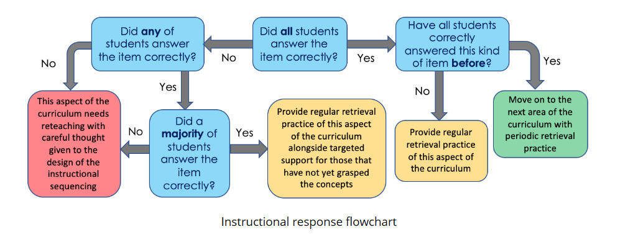

Keep an especially careful eye on children that failed to answer questions correctly in previous assessments. This should not mean that we give such children a less challenging route though curriculum, or proceed at a slower pace. Instead we should keep scaffolding in place for longer whilst maintaining our high standards that they can master the essential elements of the curriculum.