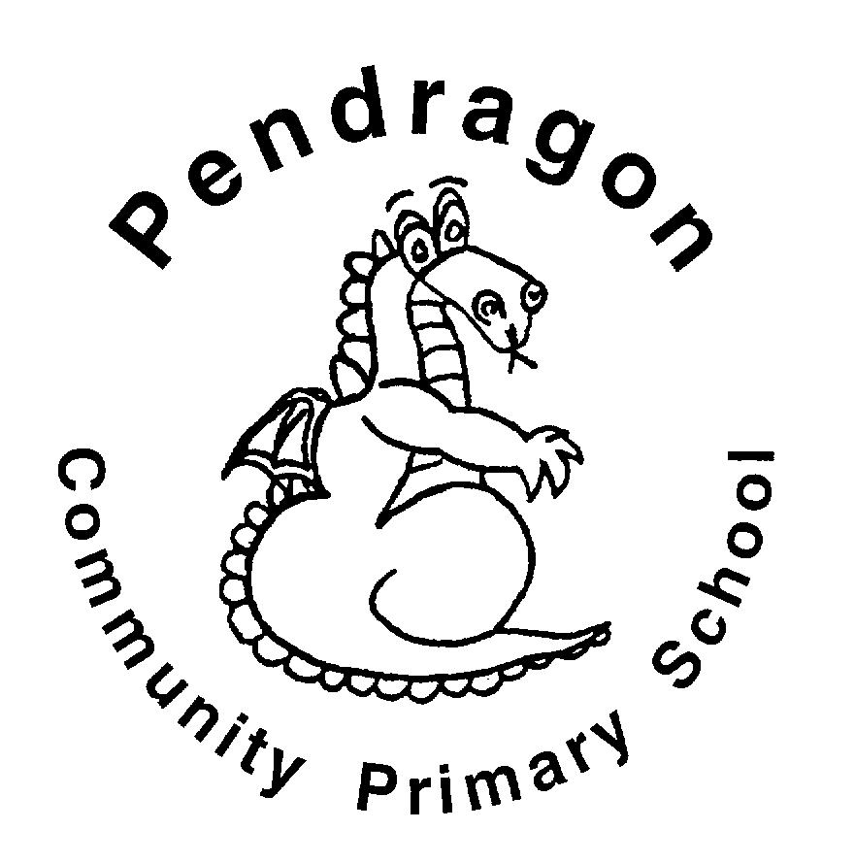 | Pendragon Community Primary School  Snow Leopards Class- Mrs Ruffle |  |  | 
National Curriculum
As Readers we will study books to help us learn about the Mayans and science. We will also study some of the works of Shakespeare. |  | As Mathematicians we will be able to understand the number system and place value including larger numbers and make connections between multiplication, division, fractions, percentages and ratio. We will use fluent written methods to solve increasingly difficult problems. We will use the language of algebra and classify shapes using more complex vocabulary. We will also study maths in nature and the world around us. | As Writers we will write and perform adverts for products to sell. From studying Shakespeare, we will write our own stories and plays using Shakespearian language. Based on learning in other subjects, we will plan and write texts of our own choice in Pendragon Writer’s Club.
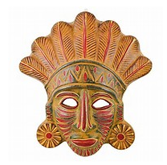 |  |  | As Scientists we will identify and name the main parts of the human circulatory system, and describe the functions of the heart, blood vessels and blood. We will recognise the impact of diet, exercise, drugs and lifestyle on the way bodies function. We will also learn about evolution and inheritance.  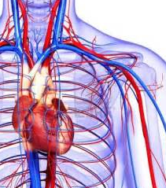
Year 6
SUMMER TERM
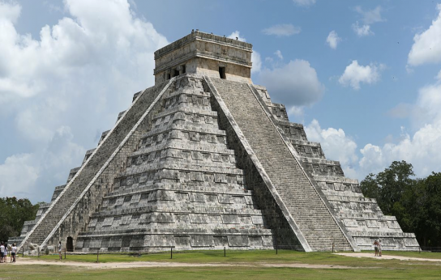

Outdoor learning
This term we will be exploring our local environment: we will identify areas in the school grounds that need improvements and we will be developing our skills of listening and teamwork to carry out tasks together.

In Computing we will learn about e-safety (staying safe online), develop our understanding of technology and digital literacy using a range of programmes, including Starz. We will use ‘Scratch’ to create a maths game.
In Art and DT we will use Mayan art to inspire masks, ceramics and design. |  |  | In RE we will learn about caring for creation and stewardship.    In PSHCE we will think about economic well-being. We will also study sex and relationships education.  In PE we will develop skills in tennis, athletics and rounders.
As Musicians we will work on the songs and music for our summer performance.

As Historians we will study the ancient Aztec and Mayan civilization to develop an understanding of what was happening in central America during the same era as other ancient civilisations studied.

Curriculum Drivers
Enquiry and Risk Taking | Emotional Awareness | Ambition | Community and Diversity
As people with enquiring minds we will: | As emotionally aware people we will: | As people with ambition we will: | As members of a diverse community we will:
- Use questions as the starting point for our learning e.g. what was life like for the Mayans?  - Ask and answer our own questions about the world e.g. what was is the best way to have a healthy life?  - Consider how the risks we take affect ourselves and others. | - Explore the feelings of characters from history, to consider what life was like in the past.  - Think about what can be done in a peer pressure situation.  - Explore how budgeting and money sense can improve our emotional well-being.  - Consider what the impact is of an unhealthy life on how we feel. | - Know that we can succeed and begin to know what we need to do to achieve goals (next steps).  - Take responsibility for our own learning and work hard.  - Try new things, express our doubts and fears and learn from our mistakes.  - Find out how others have challenged themselves to achieve their ambitions. | - Consider how the Mayans celebrated their culture.  - Study how the Mayans lived as a community and make comparisons with our civilisation.  - Think about how the lives of others are affected by their financial decisions.  - Use our skills to work as a team to produce our end of year performance.
← ← ← ← Use of our environment and the acquisition of knowledge of the world → → → →

Supporting Learning at Home  - Maths  Work will be provided to practise what has been learned in class on Mathletics:www.mathletics.co.uk  - Spelling.  Children will be provided with a spelling activity to complete at home. This will be sent on Friday and should be returned on Monday.  - Reading book  Ideally read daily for at least 10-15mins.  - Library Books  Our Library session, when library books can be changed, is Monday.  - Bug club: www.activelearnprimary.co.uk  After SATs, homework will vary, for example learning lines and songs for the end of year production. | SATs tests  These take place during the week of May 14th. Please try to avoid taking any time off this week.  Endeavour Cup  Children can enter a project of their own choice to be considered for the Endeavour cup. More details to follow after SATs.  Contact  Please feel free to come and talk to me about any concerns you may have. You can catch me for quick question before and after school, or make an appointment by contacting the office or e-mailing directly.  Mrs Ruffle  hruffle@pendragon.sch.cambs.uk | PE Lessons  Please ensure that PE kit is in all week, as the days may change to accommodate the weather.  Outdoor PE is on Tuesday and Thursday. Initially we will continue walking over to the tennis courts for lessons on Tuesday morning. All uniform and kit must be named or it is impossible to reunite it with your child if it gets muddled up. If your child has long hair, please ensure they have a hair band, as long hair must be tied back for PE. It is expected that all children can remove watches/earrings for PE. If your child is unable to remove their own stud earrings these should be removed at home on PE days or micropore tape provided so they can cover them.  Thank you for your support with this.

