
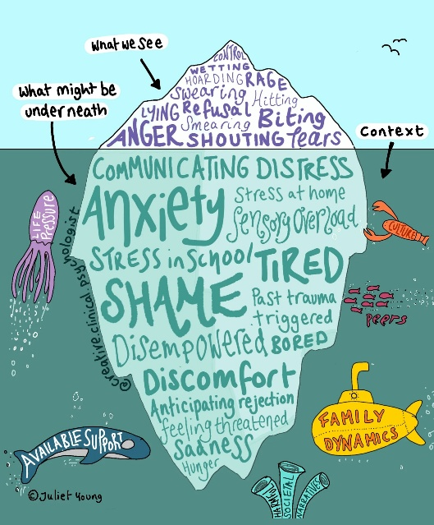
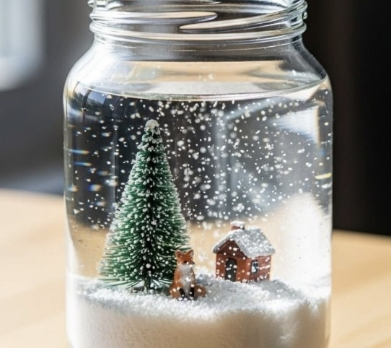



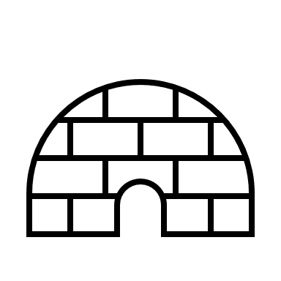


A Bit About Me
Hi, my name is Jane Rogers I’m your school’s link EIFA. I offer advice and strategies to parents and carers with a primary school aged child, who may be experiencing challenges such as sleep, sibling rivalry, challenging behaviour, worries or self-esteem.
You can contact me here:
Janeelizabeth.rogers@cambridgeshire.gov.uk
.

Does your child have, or potentially have, an additional need or disability? Pinpoint (www.pinpoint-cambs.org.uk) have lots of information, advice and tips. For Cambridgeshire’s Local Offer go to www.cambridgeshire.gov.uk/residents/children-and-families/local-offer

Online relationship support for parents
- Arguing better – for anyone looking to learn how to cope better with stress and deal with arguments in a healthy way.
- Me, You and Baby Too – to help new and expecting parents navigate the changes that happen in their relationship when a baby arrives.
- Getting it right for children – to help separated or separating parents learn to manage conflict and minimise the impact it has on their children.
There’s also some helpful advice about the impact of debt on relationships
Reducing Parental Conflict Programme | Cambridgeshire County Council
Activity Idea – Winter Globe
1: Glue the base of your decoration to the inside of your jam-jar lid
2: Add water – don’t fill it right to the top, because you’ll need room for the
decoration that you’ve stuck onto the lid!
3: Add a small amount of glycerine or light corn syrup - The more of this you put
in, the slower your glitter will fall. The glycerine or syrup makes the liquid more
‘viscous’. The higher the viscosity, the ‘thicker’ it is.
Substitutes to glycerine/light corn syrup - golden syrup, maple syrup or light honey.
4: Add some sparkle (glitter) - If you add too much, your glitter will clump together.
5: Secure the lid
· Add waterproof glue around rim of the jam jar, then tightly attach the lid and leave for five minutes.
· Make sure you’ve created a watertight seal (turn the jam jar upside down in a bowl to check for leaks).
Enjoy

Parenting Top Tip
The key is to imagine behaviour as if it is an iceberg
What You See (Above the Water)
- Actions: What your child does (e.g. shouting, withdrawing, refusing).
- Body language: Facial expressions, posture, tone of voice.
- Words: What they say and how they say it.
What’s Hidden (Below the Water)
- Thoughts: What they’re thinking but not saying.
- Feelings: Emotions like sadness, fear, frustration, or excitement.
- Values & Beliefs: What they believe is right or fair, and what matters to them.
- Motivations: The reasons behind their behaviour (e.g. needing attention, feeling unsafe, wanting control).
What you can do
With behaviour, it’s easy to focus on what you see. But real understanding comes from gently exploring what’s underneath, their feelings, worries, or unmet needs.
- Pause and reflect: Ask yourself, “What might be going on beneath the surface?”
- Stay curious: Instead of reacting to behaviour, try to understand the emotion or need behind it.
- Talk it through: Help your child/young person name their feelings and thoughts. This builds trust and emotional awareness.

Education Inclusion Family Advisor Newsletter
December 2025

