PARENTS GUIDE TO
LEARNING TIMES TABLES

Learning Times Tables

The key to learning times tables is frequent repetition, regular revision. 5 to 10 minutes every day is better than an hour a week. Here are some ideas to help your child memorise their multiplication and division facts.
1. Chanting
When beginning to learn a times table this is key. Repeatedly reading a times table out aloud will help your child become familiar with the multiples for that times table. Try and keep a rhythm, changing vocabulary regularly (two times three is six, two threes are six, two lots of three are six etc.) Clapping or marching may help with keeping the rhythm going.
2. Flash Cards
Make a set of cards for the times table being learnt by putting a question on one side of the card (6 x 5 =) and the answer on the reverse (30). Go through the cards reading the question and then turning over to see the answer. Try and say the answer before you turn over. When familiar with the multiplication table, the cards can then be shuffled and used in a random order.
3. Testing and Timing
Make this fun. When your child has become more confident at learning a particular times table, ask them questions on it and see how many they can get correct in a particular time. Alternatively write some questions out of order and get them to time how long it takes to complete the questions. Can they beat their time and score?
(see http://www.online-stopwatch.com) for a variety of different timers.
4. Using a multiplication Square
A multiplication square is particularly useful for establishing the link between multiplication and division facts but can also be used instead of a times table list. When children are more confident with their times table knowledge, a blank multiplication square can be filled in. Time your child to complete their square, or see how many multiples they can complete in a set time. Can they beat their score and time?
5. Times Tables Games
Bingo is a great way of learning times tables as a family. Write 6 multiples from a particular times table down in a grid and the caller reads out questions from the same multiplication table.
Rolling dice and multiplying the numbers together is a good way to compete with each other to get the correct answer first. Two dice can be rolled at once to create all questions up to 12 x 12. A similar game can be created with playing cards where two cards are chosen and their values multiplied together. The Jack, Queen and King need to be 11, 12 and 0. To help with division, each player chooses and writes down five of the following numbers: 5, 6, 8, 9, 12, 15, 20, 30, 40 and 50. Take it in turns to roll a dice and if the number you roll is a factor of one of your numbers, cross it out. E.g. if a 4 is rolled it goes into 8 so cross out 8. If 1 is rolled, you miss a go; if 6 is rolled you get an extra turn. The winner crosses all of their numbers out first.
6. Online Resources
There are many free multiplication and division games available online. Just use the search engine to uncover them all. Here are a few places to get you started:
www.multiplication.com
www.coolmath-games.com
http://www.oswego.org/ocsd-web/games/Mathmagician/mathsmulti.html
http://www.transum.org/Tables/Times_Tables.asp
www.tablestest.com
www.mathletics.co.uk
Many apps also exist for smart phones and tablets. Many of these are free to download. Search in the App store or on Google Play. ibooks can also be helpful such as Carol Vorderman Maths Made Easy Times Tables.
Songs can be accessed on Mathletics (Times Tables Toons) or can be
downloaded at a cost. For example Times Tables Challenge by Kidzone, available through Amazon MP3.
These online resources are good but are usually not enough in themselves for learning multiplication tables off by heart. They are best suited for consolidating times table knowledge and for increasing the speed of recall.
7. Quick Questions Anywhere!
A few questions here and there are much better than hundreds in one go e.g.
- on the way to school
- in advert breaks
- whilst getting dressed
- a few before bed

Top Times Table Hints

It may seem a daunting task to learn so many multiplication facts, but
because of the commutative property of multiplication, there are fewer facts than you may think. For example, 3 x 4 and 4 x 3 give the same answer so you need to only learn this once.
Zero Times Table
Anything multiplied by zero will always equal zero. Multiplication is
repeated addition so 3 x 0 is 0 + 0 + 0, which equals 0.
One Times table
Any number multiplied by one is itself.
Two Times Table
Any number multiplied by two is double the number.
7 x 2 =14 7 + 7 = 14 double 7 is 14
Three Times Table
Digits within this times table add up to multiples of 3. For example:
3, 6, 9, 12 (1+2=3), 15 (1+5=6), 18 (1+8=9) 21 (2+1=3), 24 (2+4=6) etc.
The numbers also follow the pattern of: odd, even, odd, even (3, 6, 9, 12).
Four Times Table
The four times table is double the two times table.
4 x 2 = 8, 4 x 4 = 16, 16 is double 8.
Alternatively the fours can be thought of as double double. So double 3 (6) and double again (12) is the same as 3 x 4 = 12.
Five Times Table
All multiples of 5 end in five or zero. For even numbers (e.g. 8 x 5) you can halve the number (4) and then put a zero after it (40). For odd numbers (e.g.7 x 5) you can subtract one from the number (6), halve it (3) and then put a 5 after it (35).
Any odd number times 5 ends in a 5. Any even number times 5 ends in 0.
Six Times Table
The six times table is double the three times table.
So 5 x 3 = 15, 5 x 6 = 30, 30 is double 15.
Seven Times Table
Combine the 5 and the 2 times table: 7 x 4 = 28 or (5x4) + (2x4) = 28
Eight Times Table
The eight times table is double the four times table.
So 7 x 4 = 28, 7 x 8 = 56, 56 is double 28.
The units in the multiples of eight also go down in twos.
8, 16, 24, 32, 40, 48, 56, 64, 72, 80 (8, 6, 4, 2, 0, 8, 6, 4, 2, 0).
Nine Times Tables
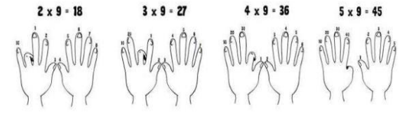
Fingers can be used to work out the nine times table up to 10 x 9. The
first finger is put down for 1 x 9 and the remaining fingers show 9 units (1 x 9 =9). Then the second finer is put down for 2 x 9 and the
remaining fingers show 1 ten (to the left) and 8 units (to the right)
which equals 18, and so on. For example:
The digits found in the multiples of nine when added together also
equal nine. For example: 9 = 9, 18 (1 + 8) = 9, 27 (2 + 7) = 9, 36 (3 + 6) = 9, 45 (4 + 5) = 9 etc.

Ten Times Table
All the digits in the ten times table end in zero.
Eleven Times Table
Most of the multiples in the eleven times table are recalled by putting two of the number side by side.
7 x 11 = 77, 8 x 11 =88.
Twelve Times Table
The units in the twelve times table go up in twos. 12, 24, 36, 48, 60, 72, 84, 96, 108, 120, 132, 144 (2, 4, 6, 8, 0, 2, 4, 6, 8, 0). The multiples of 12are also the multiples of 10 and the multiples of 2 combined.

Odd and Even Numbers

The following rules always apply:
E x E = E E x O = E O x E = E O x O = O
2 x 6 = 12 4 x 5 = 20 9 x 2 = 18 7 x 3 = 21
Therefore, the only time you get an odd answer is when two odd
numbers are multiplied together.

12 x 12 Multiplication Grid
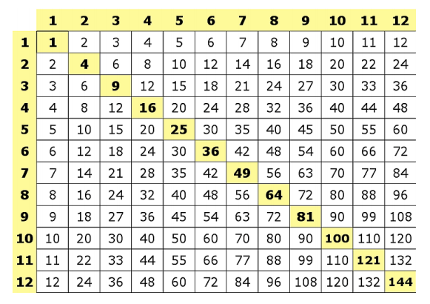
Notice the diagonally shaded numbers. These are square numbers.
The answer to a whole number multiplied by itself is a square number.
1 x 1 = 1 2 x 2 = 4 3 x 3 = 9 4 x 4 = 16 5 x 5 = 25 6 x 6 = 36
7 x 7 = 49 8 x 8 = 64 9 x 9 = 81 10 x 10 = 100 11 x 11 = 121
12 x 12 = 144

