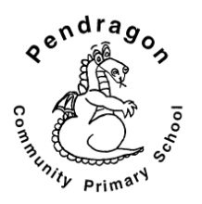 | Pendragon Community Primary School  Panther Class – Mrs Brown and Mrs Dell
National Curriculum
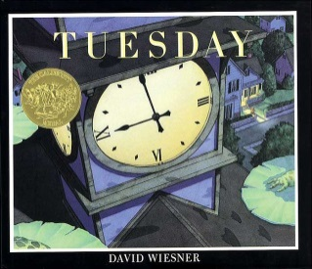  As Readers we will be reading a variety of texts again this term linked to our written tasks. We will read and recognise the features of explanatory texts, poetry, newspaper reports and persuasive texts. We will be using the picture book ‘Tuesday’ by David Wiesner to support our writing. |  | As Mathematicians we will be continue to explore measures, including money, in context. We will consolidate calculating with fractions and investigate negative numbers, angles, properties of shape, symmetry, co-ordinates and area. We will learn formal written multiplication and division methods.  Year 4  Summer Term | As Writers we will be exploring poetry styles and writing our own versions. We will also be reading a variety of explanation texts in order to write our own. These explanations will be linked to our technology and science work. We will also be writing persuasive texts and news reports.  We will plan and write texts of our own choice in Pendragon Writer’s Club.  As Musicians we will be learning through the online music scheme ‘Charanga’. Our Units this term are ‘Lean on Me’ and ‘Reflect, rewind, replay’.
As Linguists we will continue our French work with a focus weather, family and animals and pets.
In RE we will continue learning about Judaism in the first half term. Following that we will be looking at a unit of work entitled ‘Is it fair?’ discussing whether everyone should be treated the same and how some people work to make the world a fairer place. |  |  | As Scientists we will be learning about living things and their habitats in the first half term. We will use classification keys to group, identify and name a variety of living things and recognise that environments can change, which can sometimes pose danger to living things.  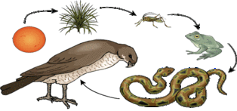  In the second half term we will be looking at animals including humans where we will learn about the digestive system, teeth and food chains.
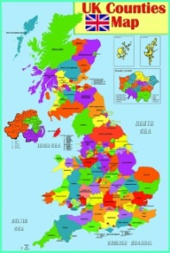  As Geographers we will be comparing geographical features and landmarks of the UK to those of North America.  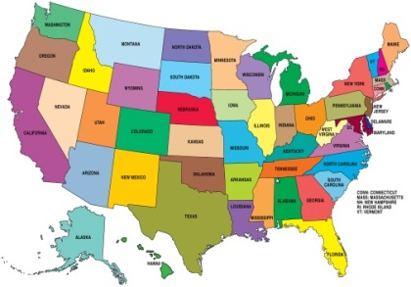 |  | In DT we will explore bridges and structures. We will be making bridges and testing them as well as researching famous bridges around the world.  In Computing we will learn about e-safety (staying safe online), and our focus this term will be on programming: using Scratch to create a quiz and using filming to present information.  In PSHE we will be focussing on the themes of Healthy and safer Lifestyles with a link to drug education. We will also be discussing our friendships and relationships and how we manage change.
As Artists we will be learning about silk painting linked to our science topic on living things. |  |  | In PE we will be focus on balance in gymnastics and also dance with a Rugby Haka theme. Our outdoor PE will have a focus on Athletics and pentathlon.

Curriculum Drivers
Enquiry and Risk Taking | Emotional Awareness | Ambition | Community and Diversity
As people with enquiring minds we will: | As emotionally aware people we will: | As people with ambition we will: | As members of a diverse community we will:
- Use questions as the starting point for our learning e.g. how do places in the UK differ to those in North America?  - Ask and answer our own questions about the world.  - Consider what is fair and discuss whether everyone should be treated the same. | - Think about what is fair.  - Consider how some people work to make the world a fairer place.  - Discuss our friendships and relationships.  - Think about how we manage change in our lives. | - Know that we can succeed and begin to know what we need to do to achieve goals (next steps).  - Take responsibility for our own learning and work hard.  - Try new things, express our doubts and fears and learn from our mistakes.  - Find out how others have challenged themselves to achieve their ambitions. | - Consider how we treat others and whether everyone should be treated the same.  - Think about how we feel as part of our local and British community and how this might be similar or different to other places in the world e.g. North America and France.
Use of our environment and the acquisition of knowledge of the world

Supporting Learning at Home  - Mathletics:www.mathletics.co.uk – set on Tuesday and due in the following Monday  - Times Tables  A target for the end of Year 4 is for children to know their multiplication tables up to 12 × 12. It is important for children to practise their tables regularly.  - Spelling.  Children will be provided with a spelling activity to complete at home. This will be sent home on Tuesday and should be returned on the following Monday  - Reading book  Ideally read daily for at least 10-15mins.  - Library Books  Our Library session, when library books can be changed is Monday.  - Bug club: www.activelearnprimary.co.uk School code: qkc7 | Contact  Please feel free to come and talk to us about any concerns you may have. You can catch us for a quick question before and after school, or make an appointment by contacting the office or e-mailing directly.  Mrs. Brown (Monday, Tuesday, Wednesday, Friday)  tbrown@pendragon.cambs.sch.uk  Mrs Dell (Tuesday, Wednesday, Thursday)  jdell@pendragon.cambs.sch.uk | PE Lessons  Please ensure that full indoor and outdoor PE kit is in all week, as the days may change to accommodate the weather.  Indoor PE is on Monday and Outdoor PE on Friday.  - All uniform and kit must be named or it is impossible to reunite it with your child if it gets muddled up!  - If your child has long hair, please ensure they have a hair band, as long hair must be tied back for PE.  - It is expected that all children can remove watches/earrings for PE. If your child is unable to remove their own stud earrings these should be removed at home on PE days or micropore tape provided so they can cover them.  - Thank you for your support with this.

